EAST LONGMEADOW RESILIENT MASTER PLAN
DRAFT 03/30/21

Table of Contents
INTRODUCTION 2
LAND USE 11
TRANSPORTATION 23
HOUSING 46
ECONOMIC DEVELOPMENT 54
OPEN SPACE AND NATURAL RESOURCES 65
HISTORIC AND CULTURAL RESOURCES 80
CLIMATE RESILIENCE AND SUSTAINABILITY 95
PUBLIC SERVICES AND FACILITIES 111
IMPLEMENTATION 123

Note on DRAFT

THANK YOU! For your interest in East Longmeadow’s resilient Master Plan. These 125 pages represent the first DRAFT of this work and there will be many changes to this draft in the final plan product. Please send your thoughts about this draft to Ken Comia at kcomia@pvpc.org or Catherine Ratte at cratte@pvpc.org or feel free to call Catherine at 413/285-1174. There is an implementation workshop for the plan on May 20 from 6-8 pm over Zoom—to attend see this link: East Longmeadow Flyer_Implementation.pdf (eastlongmeadowma.gov)

INTRODUCTION

There are four essential tools for community planning: a master plan, zoning bylaws, subdivision regulations, and a capital improvements plan. This master plan is one of East Longmeadow’s four essential planning tools. The Master Plan is East Longmeadow’s road map to its future. Communities plan for the same reason people plan—because they want to do things efficiently and effectively. If you know where you want to go, and you know if you have the tools and resources to get there, you are much more likely to arrive at your destination safely and also enjoy the trip.

The process of developing a community master plan is also worthwhile in and of itself as it brings members from all areas of the community together to think and work collaboratively toward a shared vision.

A Master Plan is structured in conformance with the state requirements outlined in Chapter 41, Section 81D which describes a Master Plan as “a statement through text, maps, illustrations, or other forms of communication that is designed to provide a basis for decision-making regarding the long-term physical development of the municipality...” and is comprised of seven specified elements:

- Land Use
- Housing
- Economic Development
- Natural and Cultural Resources
- Open Space and Recreation
- Public Services and Facilities
- Transportation

The statute requires goals and policies to convey the community’s visions and an implementation program that covers each of the topic areas listed above. Additionally, the community will be adopting elements that are not required per state law; however, will be included as an important component of this Master Plan to reflect East Longmeadow’s values and commitment to resiliency.

- Climate Adaptation and Sustainability

Master Plans are developed to guide a town’s policies and strategies over the next ten to twenty years. The Plan is a living document and often times is reviewed periodically and updated accordingly to be certain it reflects the ever-changing trends and evolving needs of the community. This Plan is not a bylaw, but instead a policy document, intended to be used to provide Town Boards and Commissions with a set of common goals and strategies which can be uniformly taken into consideration when making decisions.

The Town has conducted few planning efforts over the past 50+ years; however, with the current events described above, Town officials have determined that it is time to review and reformulate their economic development planning activities. Existing planning efforts include the following; though, it has been over forty years since a comprehensive master plan was completed:

- Open Space and Recreation Plan (2020)
- Hazard Mitigation Plan (2016)
- Community Development Plan (2004)
- Enhancing East Longmeadow Through Improved Business, Commercial and Industrial Zoning (1997)
- East Longmeadow Master Plan (1976)
- East Longmeadow Master Plan Document (1960)

This master plan was written to serve several functions:

- Provide detailed historic and current information about land use, housing, natural resources, open space, economic development and other topics that are currently important to East Longmeadow.
- Summarize the vision and goals for future development and preservation expressed by residents during the master planning process.
- Clearly state East Longmeadow’s priorities and strategies for moving forward to achieve those goals.

This master plan is a statement of policy and aspirations expressed by the community to help manage growth and change, and to help foster more predictable development. It is not a zoning or regulatory document; it has no legal effect. Rather, it is intended as a resource to help the people of East Longmeadow make decisions about the kinds of regulations and actions they would like to see in the future.

This master plan is the result of outreach and participation by residents and businesses of East Longmeadow, as well as detailed information and support supplied by nearly all town departments, elected boards and volunteer committees. The process was overseen by the members of the Master Plan Committee and involved more than 375 residents through a community survey, committee meetings, focus groups, and our community-wide visioning session and implementation workshop.

Multiple planning documents and communications of the committee, including recordings of meetings and draft chapters of the plan, were posted publicly online at eastlongmeadowmp.pvpc.org throughout the master planning process. The committee carefully considered and incorporated the community’s contributions throughout the development of the master plan. The plan was adopted by the Planning Board and Town Council in 2021.

COMMUNITY ENGAGEMENT

In order to solicit public input and encourage community participation in the process of developing the town’s Resilient Master Plan, the Pioneer Valley Planning Commission, engagement consultant Barrett Planning Group, and the Resilient Master Plan Committee, developed a public participation strategy which helped to understand the concerns and sentiment of the residents.

Public participation included a town-wide community survey, interviews with interested residents, focus groups, meetings of the Resilient Master Plan Committee, and facilitation of a community-wide visioning session and implementation workshop. The focus groups, meetings of the committee, and community-wide meetings were held remotely as the timing of the master planning process was framed within the worldwide COVID-19 pandemic.

Community Survey

- A community survey was developed and posted on Survey Gizmo.
- The survey was available from August 14 – October 14, 2020.
- A notice with the survey link was posted to the project website, Town’s website and through other social media.
- Hard copies were available by request at the East Longmeadow Public Library and Town Hall.

Who responded?

302 Total Respondents

- The largest amount of responses came from those ages 35-44 (26.1%), followed by ages 55-64 (15.8%)
- 53.4% are working full-time, followed by 25.3% who identify as retired
- 299 of the 302 responses represented residents of East Longmeadow.

General development goals for East Longmeadow’s future

Top 3 General development goals identified as very important important
- Preserve air and water quality (85%)
- Protect the natural environment (72%)
- Improve internet access and speeds (69%)

Other goals shared in the free response section:

- Retain small town vibe
  - No big box, no fast food options
  - Planning for reduced growth
- Better internet options
- Improve school buildings, especially high school
- Develop vacant/blighted properties
- Mixed Use Development
  - Economic development in center of town
  - Possibilities with new rezoning
- Roadway maintenance
- Expanding sidewalks
- Housing access
- Increase service/volunteer opportunities to build civic pride

Housing

Top 3 Preferred Types of Residential Growth
- Single Family homes with larger yards (3/4+ acre) (49%)
- Housing that is accessible for people with disabilities (45%)
- Senior housing and assisted living facilities (28%)

- 62 percent of respondents could hypothetically afford to buy the home in which they currently live at its market value.

Other comments regarding residential growth shared in the free response section:

- Be mindful of impacts to town services with increased residential growth
- In-law and shared family spaces within main house
- Blighted properties for redevelopment

One respondent commented “there’s enough housing in East Longmeadow.”

Economic Development

Top 3 Types of commercial growth preferred in East Longmeadow

- More small, locally owned stores (80%)
- More restaurants and food stores (51%)
- More farms and agricultural business (47%)

Other comments regarding residential growth shared in the free response section:

- Allow for drive-thrus
- Manage current, empty businesses
- Providing recreational activities, dance classes, etc.
- Encouraging locally owned development in the Town center

Town Issues & Priorities

Top 3 Issues that need immediate attention in East Longmeadow
- Safety of pedestrians and bicyclists (54%)
- Quality of public schools (53%)
Traffic safety, cut-throughs, speeding (53%)
- Produce more electricity from solar, wind or hydro

Top 3 Issues that need attention in the longer term (needing attention in 1-2 years and in the long-term)
- Maintenance and repair of Town buildings (47%)
- More energy efficiency in Town Buildings and vehicles (44%)
- Protection of wetlands and streams (41%)

Top 3 Issues that does not need attention
- Making it easier to live and get to work without a car (31%)
- Quality of Police, Fire, EMS (29%)
- Health concerns, such as obesity, asthma, diabetes, cancer (19%)

Other comments regarding town issues and priorities shared in the free response section:

- Accessibility to facilities and services for mental and physical disabilities
- Mixed use recreation on the farm property
- Maintenance of stormwater
- Maintain and expand trails
- Sidewalks
- Town buildings should have solar
- Water quality
- Friendly for all generations

Community Visioning Session

February 13, 2021
10:00 AM – 12:00 PM
Virtual Zoom Visioning Session
Attendance: 60 people

A Notice of the Virtual Zoom Visioning Session was:
- Posted on the project website homepage and Town’s website
- Posters placed throughout town at the Town Hall (not open to the public), other meeting spaces with heavy traffic
- Reminders to participate in the visioning session were also communicated through short, fun TikTok videos.
- Article written and published in The Reminder

The Visioning Session was facilitated by the Pioneer Valley Planning Commission and assisted by Barrett Planning Group. A short presentation was provided at the beginning of the session to describe the Master Plan process, the importance of visioning, and how the primary process and implementation phases will be conducted. Additional context for the attendees was provided in that there have been completed planning processes in town that are also drawn into the Master Plan. An initial polling exercise allowed for interactive input prior to breaking up into groups to do a deeper dive. The polling summary is below.

** Insert polling summary here.

There were five breakout group sessions with 12 people per group to go through a Strengths, Weaknesses, Opportunities, and Threats (SWOT) exercise.

General comments included those shared in the community survey as well as committee meetings, like “rotary is difficult to navigate by foot or car,” “the school system is a strength, however, the high school needs to be repaired,” and “we could have more affordable condos and some nice apartments for singles, seniors, and small families.”

** Inset padlet graphic here.

The Visioning Summary can be found in the Appendix.

Focus Groups

Focus groups were conducted over a span of two days virtually over Zoom, March 9 and 10, 2021.

The focus groups were conducted to invite stakeholders, interested residents, and staff and were completed in four sessions:

- Cultural, Historic, Natural, Open Space Resources on March 9, 2021
- Transportation and Public Facilities & Services on March 10, 2021
- Climate Change Resilience and Clean Energy on March 10, 2021
- Housing and Economic Development on March 10, 2021

Cultural, Historic, Natural, Open Space Resources

- Some highlights presented in this focus group include:
- Center of town is unique
- Three historic buildings surrounding the Depot have been renovated over the years, still accessibility issues
- Historic significance of the Depot and surrounding that could provide future programming for itself and surrounding historic buildings
- Center Field is an underutilized amenity
- Farms are historical and need to be preserved and prioritized § Bridge gap between history and economic development
- Recreation spaces doing well (pandemic-related)
- Publicize and communicate the open space and recreation opportunities
- CPA funds have been utilized to increase recreation opportunity at Pine Knoll § Get non-profits and committees to support work and fundraising
- Intergenerational activities for residents

Transportation and Public Facilities & Services

- Some highlights presented in this focus group include:
- Low-lying areas in town which can be impacted by ongoing and more severe weather events
- Locations with safety problems
  - Rotary, Prospect and Chestnut intersection, Mapleshade and Porter intersection
- Sidewalks!
- Town applied for Complete Streets program § Biking demand up 400 percent
- Rail Trail upgrades
- DPW recently hired a grant writer to manage town grant programs
- Library services have been successful during the pandemic, needs uncovered like teen/tween programming
- Many accomplishments in DPW facilities and services, school department, Health and Fire Department
- Regulatory needs are challenging – Stormwater MS4 permit
- More coordination among town departments needed
- Town facilities need improvements
  - Police and fire stations, Town Hall

Housing and Economic Development

Some highlights presented in this focus group include:
- Variety and balance of housing types
- Housing market is hot!
- Passage of Mixed-Use Village District will open new opportunities – just need a developer!
  - Housing for singles/younger families
- Training and education opportunities to keep people in East Longmeadow
- People are leaving because housing costs and taxes are going up
- Seamless municipal permitting processes to open businesses
- Center Square is going to be a nice draw
- Putting out the welcome mat for businesses and keeping that communication open
- Permit fees and documentation can be a roadblock
- Walkable downtown, foot traffic for amenities and other businesses
- Take a look at home businesses and permitting those uses
- Privatize internet? There seems to be infrastructure.
- Proud of industrial parks and zoning standards in the Industrial Zoning District

Climate Change and Clean Energy

Some highlights presented in this focus group include:
- Opportunities for high school seniors to do public service like tree planting programs, research projects for science students
- Culvert repair, stormwater and sidewalk connections top priorities
- Solar panels on roofs
- Ground-mounted solar facilities as an opportunity and threat
- Reengage in trying to receive Green Communities designation
- Retrofits to school and police department to assist with energy costs
- Stormwater retrofit coming in year 5 of the MS4 permit, like bioretention basisn
- Explore full assessment for all town buildings, electronic vehicle fleet
- MassSave is still an opportunity for residents at the moment
- Majority of town is prone to flooding
- Forward and lift low impact development as an opportunity for town to be resilient

Additional comments can be found in the Appendix section of this Plan.

Vision + Goals

Vision

We envision a vibrant future for East Longmeadow — one in which we value and include all members of our community, plan for managed and sustainable growth, and cultivate the Town’s identity as a charming, welcoming, and safe place to call home. We are poised to flourish as a presence within the region, and the East Longmeadow Resilient Master Plan provides a lasting framework that will enable us to fulfill this vision.

Plan Objectives
By balancing development opportunities with sensible fiscal management and natural resource conservation, we will:
- Establish a strong local economic base;
- Welcome cultural, agricultural, commercial, and recreational options that enrich our community’s sense of place;
- Explore diverse opportunities for the Town’s developable land;
- Align zoning policies to community needs and wants;
- Invest in the redevelopment of our Town Center and industrial zones;
- Diversify our housing stock to meet the needs of present and future residents;
- Promote our agricultural heritage and history as a quarry town;
- Continue to support passive and active recreation opportunities and the departments that oversee them;
- Provide programming, accessible facilities, and resources that meet the needs of families, seniors, disabled residents, and youth;
- Improve accessibility for disabled individuals and families;
- Sustain a high level of professional staffing and municipal operations in the long-term, including our qualified public safety staff;
- Maintain the excellence of our educational system by supporting our schools’ needs;
- Promote local volunteerism and community involvement with Town initiatives;
- Plan for energy efficiency, green initiatives, and resiliency to climate change;
- Improve mobility through street improvements, traffic safety measures, and expansion of accessible pedestrian and cyclist infrastructure;
- Support the Town’s existing agriculture to ensure the availability of fresh, local food; and
- Maintain East Longmeadow as a safe and inclusive community for all.

Plan Goals

Towards these ends, the Plan’s recommendations address the following GOALS:

** One finalized those goals would go here.

LAND USE

The past, present, and future of a community is, in large measure, determined by its geographical location and physical characteristics. This is true for East Longmeadow as well, which has been shaped by natural forces, and the ability of East Longmeadow to harness this power.

The land use element of a master plan provides a framework for growth management and an understanding of the kinds of development the community wants balanced with the existing physical and regulatory environment. A community’s land use pattern is the physical arrangement and intensity of residential, commercial, industrial and institutional development, open land, natural resources and roadways. Land use is the hub of a master plan, with the other elements acting as critical spokes. All are important, and land use is the element that ties them all together.

Additionally, land use is often equated with zoning because a master plan’s future land use map forms the basis for the town’s key zoning policies. Land is divided into zones for specific uses and is managed and administered by the municipal land use regulations, policies and procedures. Today, the basis for logical land use planning, which protects valuable natural resources while promoting economic development, still exists.

Defining East Longmeadow’s Landscape

East Longmeadow is a suburban town of 13 square miles located in the Connecticut River Valley. It is a part of the Springfield-Chicopee-Holyoke Metropolitan Area and falls within the Connecticut River watershed. It is bordered on the west by Longmeadow, on the north by Springfield, on the east by Wilbraham and Hampden, and on the south by Enfield and Somers, Connecticut.

There are thirteen use districts, Residence AA, Residence A, Residence B, Residence C, Commercial, Business, Industrial, Industrial Garden Park, Golf Recreational, Elderly Residential, Planned Adult Residential, Planned Unit Residential and Mixed-Use Village Districts, which govern the development throughout the town. Additionally, there are one overlay district, known as the Floodplain Overlay District, which encompasses floodplain areas within the town designated as Zone A or AE on the Hampden County Flood Insurance Rate Map. The town has experienced rapid growth of solar developments, as many communities in Western Massachusetts have had to contend with solar development over the past three years; and, other growth pressure is present, as the town has experienced a slow expansion in home building and recently adopted standards for the new Mixed Use Village Development District. Even so, it will be important to East Longmeadow to explore ways and regulations to protect the character of the community from inappropriate development.

East Longmeadow was originally settled as a farming community. The existing subdivisions in town occupy the same parcels that were originally farms. Outside of the town center, most of the older homes were originally farmhouses. The important quarry industry in East Longmeadow’s history, beginning in 1872, expanded and brought in an influx of Italian and French- Canadian immigrants to mine and dress the stone. The center of town was settled by the French Canadians and the Italians to the northwest. The few remaining, pre-existing, non-conforming, multi-family homes near the center of town are relics of this period. All of the future development was concentrated where water and sewer infrastructure were present, first occurring in the northeast and southeast quadrants in the mid-twentieth century, to town-wide later in the twentieth century. The southwest quadrant was last developed.

In 1894, the State Legislature granted a partition of the Longmeadow land, a 13 square mile tract to the new town of East Longmeadow. The town, relying on its quarrying industry to provide its economic backbone until the early 20th Century, shifted to become a suburban community for the nearby city of Springfield. Since 1990, the economic base has been expanded by industrial growth in the southwestern portion of the town.

Current development patterns are governed by available land which is mostly found in the southern half of town, in land area mostly zoned for one and 0.5-acre residential lots and the Industrial Garden Park. Most recent development consists of higher-end single-family housing. As mentioned previously, the town has unlocked mixed use development potential by introducing a new mixed use village district to provide opportunity of denser housing opportunities and variety of uses.

The purpose of this chapter is to provide an inventory of existing land use pattern, an analysis of zoning, regulations, as well as a summary of projected and future development trends; it will draw on other plan elements and identify opportunities to address growth and preservation. The conclusion of this section lays out recommendations for zoning changes, conservation efforts, management tools and other implementation techniques designed to assist East Longmeadow in implementing its vision for future land use.

INVENTORY & EXISTING CONDITIONS

Figure 2-1 is the most recent data for land use type prepared by MassGIS and mapped in Map 2-1 represented by the Property Type Classification Code associated with “use codes” from the Massachusetts Department of Revenue, along with custom use codes that the Assessors’ Office includes in their parcel data when submitted to the state. It is important to note from this data will continue to be collected and presented in this way to determine land use.

According to Figure 2-1, and a qualitative observation about development in town is that almost half of the land uses in town are residential with at least 4,011 acres according to the MassGIS analysis. About 13 percent makes up commercial and industrial land, taking into account the mixed use category, as determined in this analysis. Almost a third of land in East Longmeadow could be considered agriculture, open land – the lands the town wants to preserve, if not conserve more.

Figure 2-1 East Longmeadow Land Use

Land Use Type | Acres | Percent of Total (%)
Agriculture | 182.15 | 2.18
Commercial | 217.03 | 2.61
Water | 3.14 | 0.00
Industrial | 421.90 | 5.07
Mixed use (other, primarily commercial + residential) | 455.07 | 5.47
Open land | 1,814.21 | 21.79
Recreation | 21.50 | 0.03
Residential (other, multi-family + single family) | 4,011.80 | 48.19
Right-of-way | 726.20 | 8.72
Tax exempt | 464.14 | 5.58
Unknown | 8.10 | 0.01
TOTAL | 8,325.25 | 100
Source: Mass GIS

Another measurement to rely on to show how lands have been transformed by new residential and commercial development throughout the Commonwealth is through a report produced by Mass Audubon. The Sixth Version of Losing Ground analyzes changes every five years on the municipal scale, most recently in 2020. The table below provides specific land use measurements for East Longmeadow, and shows how the town ranks against other Massachusetts municipalities.

Figure 2-2 East Longmeadow Land Use, Recent Development, and Protection (2012-2017)

Land Use Measurement of Change | Acres | Percent of Total Land (%) | Rank in State  Out of 351 municipalities
Total area of newly developed land from 2012-2017 | 56 | 0.67 | 79
Total area of development | 4,046 | 48.55 | 90
Total area of natural land | 3,323 | 39.87 | 296
Total area of open land | 823 | 9.88 | 205
Total area of permanently conserved land | 448 | 5.38 | 328
Total area of newly conserved land from 2012-2019 | 21 | 0.25 | 346

Additional breakdowns of protected and permanently conserved land can be found in the Open Space and Natural Resources element.

Map 2-1 East Longmeadow Land Use Map

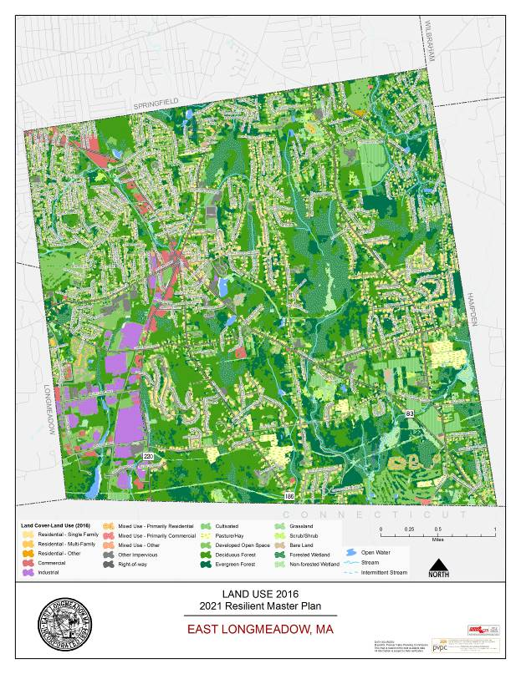
While the town maintains a small town feel according to its residents, there has been lost acreage to development over time, such as solar development and home building. With East Longmeadow’s population growing over the past few decades, from 12,905 people in 1980 to the 2020 projection of 16,485 residents and with a projection out to 2040 of 17,936 residents – a possible increase of 39 percent from 1980 to 2040. It will be important for the town to utilize its regulatory tools and efforts to preserve key parcels for the functioning farmland.

Any future land use change is limited to what is prescribed by the town zoning bylaw, as there is no state requirement for a comprehensive plan requiring a future land use map. By understanding the current conditions and future development trends, the town will be in a better position to plan for future land use changes and can work to shape what it wants preserved and what can be developed to enhance the opportunities for residents and business owners alike.

Zoning

Zoning regulations and other land use laws constitute a town’s “blueprint” for its future. These tools help the community shape the physical landscape through permitting and mapping where lands should be dedicated to various types of residential and non-residential uses, but it can also affect tax revenue generation for the town. Zoning regulations and districts are the primary land use tools that are used to manage development and direct growth to suitable and desired areas while also protecting critical resources and ensuring that development is in keeping with the town’s character all dictated by a community’s preference. Land use patterns over time will continue to look more and more like the town’s zoning map until the town is “built out” – that is, there is no more developable land left. In looking forward, it is important that the town focus not on the current use and physical build-out of today, but on its potential future uses and build-out allowed under the town’s zoning map and bylaws. This Master Plan captures community input on how to proactively study and prepare a land use framework to guide future growth advancing the Town’s vision.

East Longmeadow’s current zoning bylaw has been amended through 2020; most recently, the Town adopted the Mixed Use Development District. For the purposes of the Master Plan, the zoning assessment addresses pertinent zoning regulations and permitting procedures as they may relate to potential obstacles to achieving goals as outlined throughout this Master Plan. The zoning code can affect development and redevelopment potential based on where the town allows housing types and commercial and industrial activities throughout town. East Longmeadow has thirteen zoning use districts and one overlay district. The use districts are Residence AA, Residence A, Residence B, Residence C, Commercial, Business, Industrial, Industrial Garden Park, Golf Recreational, Elderly Residential, Planned Adult Residential, Planned Unit Residential and Mixed-Use Village Districts. See Map 2-2 for East Longmeadow’s current zoning map.

Residential Zoning Districts
Residence AA, Residence A, Residence B, Residence C, Elderly Residential, Planned Adult Residential, Planned Unit Residential

The Residence AA, A, B, and C Districts where those particular districts are for development of single family homes in the various parts of town, where densities have been measured as such:

Zone | Dwelling Units/Acre | Population/Dwelling Units | Population/Acre
Residence AA | 0.5 | 2.8 | 1.4
Residence A | 0.7 | 2.5 | 1.9
Residence B | 1.3 | 2.7 | 3.8
Residence C | 2.5 | 2.5 | 6.4

Most of the new residential development in town is located in Residence Zones A, AA, supplemented by ANR development elsewhere. This suggests new development consisting primarily of larger homes on larger lots with smaller homes as the infill development.

Brownstone Gardens is a senior living development that was built in the Elderly Residential Zoning District and offers density options for multi-family development. The Planned Unit Residential District and the newly approved Mixed-Use Village District also provides an opportunity for multi-family development with a Special Permit and Site Plan Review, however, a minimum of 40 acres is needed to develop within these zones.

The town adopted the Planned Unit Residential Development which in form and fashion serves similarly to Open Space Residential Development by allowing a mix of housing types on smaller lots and requires permanently protected open space as part of the development.

Commercial and Business Districts

The town currently has two districts specifically for commercial activity – the Business District and the Commercial. The Commercial District is intended for low-intensity commercial uses, like professional offices; whereas, the Business District permits higher-intensity commercial uses that have a higher number of employees and higher traffic volumes, like supermarkets or gas stations.

Industrial and Industrial Garden Park Districts

The Industrial and Industrial Garden Park Zoning Districts traverse the old railroad line and current Redstone Rail Trail. High-intensity commercial uses, such as retail and services, as well as low-intensity business uses are permitted by-right in the Industrial District. Industrial uses, like warehousing, construction supply, and open quarrying are permitted. Special permits would be required for non-industrial uses as identified in the town’s Schedule of Use Regulations – Table 3-1.

Golf Recreational District

The Golf Recreational Zoning District covers the two existing golf courses in town. This would allow for development of single family homes and multi-family dwellings on town property, among other types of uses allowed by-right.

Mixed-Use Village District

Adopted in 2020, the Mixed-Use Village District allows for development of a “mixture of residential, commercial and business uses and building types including single family dwellings, town houses, multi-family dwellings with or without attached business or commercial spaces, business and commercial buildings, recreation facility, and open space.” The district is intended to allow for greater integration of various types of housing and business and commercial uses within a walkable community.
Development of affordable housing units are identified in this new bylaw, with a requirement of 10 percent of total housing in the district being afforded to those who qualify under the limits by the U.S. Department of Housing and Urban Development.

Map 2-2 East Longmeadow Zoning Map

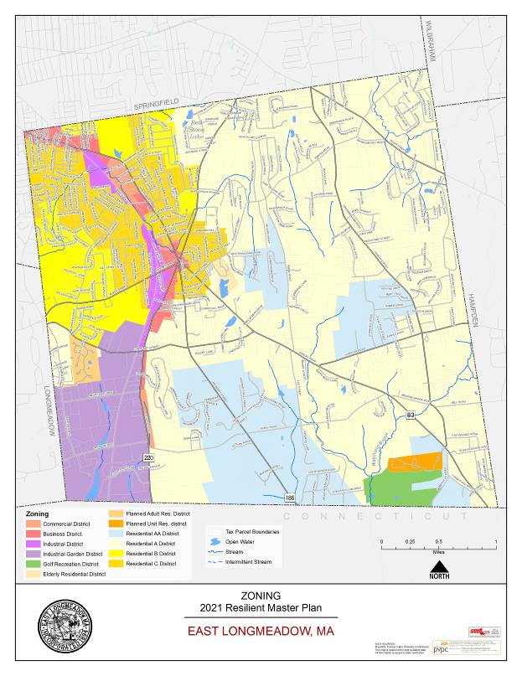

ISSUES & OPPORTUNITIES

The Master Plan process has provided the opportunity for residents to present comment and concerns about growth in East Longmeadow and the 302 survey respondents, along with committee members and focus group members, have affirmed the importance of the Town’s “small-town character and charm.” It was very important to survey takers (62.3%) that the town manage and guide commercial development – all of which can be addressed through its land use policies and regulations. Comments from the public and also affirm this perspective. The intention of this plan is to help East Longmeadow achieve the balance of planning and preservation of all that is treasured about the community. This requires supporting maximizing opportunities to preserve open space, where appropriate, and addressing development thoughtfully. The town could maintain the potential benefits of this balance by becoming more proactive in planning for growth and conservation, exploring targeted plans for key nodes and corridors, and subsequently implementing the recommended policies and regulations.

As with many other towns in western Massachusetts where there are large tracts of open land, solar developers are seeking to site large scale developments taking 20-30 acres of land per parcel, and that is no different in East Longmeadow. In creating consistency with the Open Space and Recreation Plan, the town’s documents will show where land should be preserved, like farmland and forestland. With limited financial resources, the Town must be strategic about which parcels provide the most benefit as protected open space and area of where the town can develop. The town can be more proactive about supporting the other economic development opportunities and its viabilities.

Encouraging Redevelopment

Seventy-one percent of survey respondents find it somewhat important or very important for the town to encourage more economic development. There are multiple corridors in town, in addition to the town center, which can support this development. The town center also provides the opportunities for walkability and access to services like the town offices, library, and multiple amenities in and around the Center Square complex.

The Town Center can continue to attract small businesses to support the local economy and offer a continuation of the types of structures and character the town seeks. A Village Center bylaw, or exploring an expansion of the Mixed Use Village District and those standards, could help the town advance the maintenance of appropriate development in the center. The bylaw can offer standards of which future development could be allowed, such as requiring any new or redeveloped buildings needing to demonstrate similar architectural features as the surrounding buildings, with an allowance for a smaller setback or frontage requirement, etc. The developer would need to demonstrate that the development can fit within the context of the neighborhood it is in. The town can even explore identifying more than one area where they could foresee this type of development.

Small Town Features

Urban design can help preserve historic small-town character, ensuring that new development complements the history surrounding it, and creating an accessible, pedestrian-friendly environment. By addressing fundamental site dimensions, like building height, width, coverage, and setbacks, design guidelines can also focus on elements such as signage, building materials, streetscape components, and landscaping.
To some extent we can maintain the remnants of East Longmeadow’s past by preserving roads, overarching trees, barns and other artifacts of the earlier times, as the town still has some visual characteristics of a New England town. More significant, however, could be the opportunity to revitalize the type of uses and activities that help support even a more town-adopted value-based small-town character:

- Preserving and supporting the expansion of the remaining working farms, including on public land, if appropriate;
- Providing an opportunities for those to assist with taking care of roadside trees, and planning new ones to replace those that have died;
- Centralizing activity with working greenbelts of gardens, farms and forest;
- Building more support for the strong values of recreation in town.

The approach to small-town economic development requires new demands and innovations, ending a “one-size-fits-all” approach. However, as this landscape continues to change and evolve, the town can take control and have its character preserved with a similar sense of predictability and beauty by creating specific standards and incorporating them into each of the zoning designations, in addition to exploring overlay districts to preserve qualities unique to specific neighborhoods.

Affordable Housing

East Longmeadow could support additional affordable housing in town by exploring an expansion to the inclusionary zoning component in the Mixed Use Village District. This would help support some of the comments in the visioning session and survey that could assist with varying housing types and affordable units. As described, new housing constructed under this zoning can require affordable units built on-site, payment in lieu of units, or donation of land that could support affordable housing development.

Many towns strive to achieve a 10 percent subsidized housing inventory (SHI) threshold so they are not subject to development regulated under the State’s Chapter 40B laws. A Comprehensive Permit proceeding, as governed by Chapter 40B, bypasses many local review processes. As of November 2019, the State’s records show the town’s SHI at 7.4 percent, making the Town subject to Chapter 40B and housing development being permitted through the Zoning Board of Appeals.

Community Resilience

The Town’s ability to utilize its available resources (energy, communication, transportation, food, etc.) to withstand and recover from adverse situations is known as its community resilience. East Longmeadow’s resilience will rely on a proactive and planned approach to protect its resources and direct where development and redevelopment can occur.

The recommendations of the land use element meet these objectives in a number of ways including:

- Promoting the development of a town center that facilitates walkability and the efficient use of existing buildings and infrastructure. It also facilitates community building by formalizing a civic space and community programming, utilizing the town offices, the library, or Watson Park.
- Working to expand affordable housing opportunities would provide housing for those who want to remain in town and contribute to the success of East Longmeadow, while also offering opportunities for new residents who can contribute to the growth of East Longmeadow.
- Preserving the Town’s small-town character will help protect some of the natural resources and open spaces, which is a benefit to the existing ecosystem.

Land Use Goals & Recommendations

Goal 1. Maintain East Longmeadow’s Small-Town Feel and Appearance
- Review and revise existing zoning bylaws to further protect environmental resources and scenic viewsheds, along with maximize opportunities for smart growth, where development makes sense throughout town. The Board should be proactive in working with developers to assemble projects that area. Visual asset to the community and promote East Longmeadow’s small-town character.

Primary: Planning Board
Others: Conservation Commission
Priority/Timeframe:
Resources: Volunteer time, PVPC Best Practices Model Zoning

- Evaluate and promote Home Occupations and Cottage Industries: Work with residents to promote home occupations and cottage industries within their residential buildings, and providing adequate protections for neighbors as the zoning bylaw allows.

Primary: Planning Board
Others:
Priority/Timeframe:
Resources: Volunteer time, PVPC Best Practices Model Zoning

- Discuss Protection of East Longmeadow’s Scenic VIstas: Some of the town’s appearance is the result of the many undeveloped lands that provide vast scenic vistas. This includes areas of concentrated farmlands and viewsheds. By not only protecting the viewsheds, the town could preserve the active, productive farmland.

Primary: Planning Board
Others: Conservation Commission, Agricultural Commission
Priority/Timeframe:
Resources: Volunteer time, PVPC Best Practices Model Bylaw

Goal 2. Protect, Enhance and Strengthen Open Spaces and Natural Resources
- Review and revise Subdivision Rules and Regulations and planned unit residential development zoning to promote permanently preserved open spaces, agricultural lands, forest lands, and other natural resources, clustering housing development where least impactful to those resources. Additionally, many low impact development features can be incorporated into subdivision rules and requirements.

Primary: Planning Board
Others:
Priority/Timeframe:
Resources: Volunteer time, PVPC Best Practices Model Zoning and Subdivision Regulations

- Investigate protection of scenic roads and roadway trees through passage of the Scenic Roads Act.

Primary: Planning Board
Others: Tree Warden, Select Board
Priority/Timeframe:
Resources: Volunteer time, PVPC Best Practices Model Zoning

- Transfer of Development Rights. Create mechanisms for transfers of development development rights (TDRs) from the key resource areas and existing agricultural lands to village centers, the town center, and other specific areas of town where denser development may be more appropriate.

Primary: Planning Board
Others: Conservation Commission, Agricultural Commission
Priority/Timeframe:
Resources: Volunteer time, PVPC Best Practices Model Bylaw

Goal 3. Enhance Town Centers as a Livable, Workable, and Walkable Neighborhoods
- Discuss promoting mixed use town center development. Build upon the mixed-use concept adopted in the Mixed Use Village District by exploring similar standards for the established town center creating incentives for mixed use development, including business, retail, residential and civic uses. Other components of town center mixed use development include smaller frontage, setback, lot size, and an enhanced site plan review.

Primary: Planning Board
Others:
Priority/Timeframe:
Resources: Volunteer time, PVPC Best Practices Model Zoning

- Change zoning to allow denser residential occupancy near existing services and public transit.

Primary: Planning Board
Others:
Priority/Timeframe:
Resources: Volunteer time

TRANSPORTATION

Overview

This Transportation chapter includes a brief review of the existing transportation network in the Town of East Longmeadow. All transportation components were reviewed in order to identify travel patterns throughout the Town. This chapter also provides an outlook of the existing safety concerns and takes into consideration public input provided during the master plan survey process, Visioning Session and Focus Groups to shape goals and strategies that can improve future transportation conditions.

Existing Transportation System

Roadway miles and ownership
East Longmeadow has a roadway network of 100.79 centerline miles based on information from the MassDOT 2018 Road Inventory Year End Report. All roadway miles are locally maintained by the East Longmeadow Department of Public Works. Approximately 30.8 miles of road are eligible for federal aid. The entire town is considered an urbanized area based on population density from the 2010 U.S. Census. Figure 1 highlights the existing functionally classified transportation infrastructure in East Longmeadow.

Functional Classification is a system used to identify the intended level of service a roadway is expected to provide. There are seven distinct classes of Functional Class for roadways. Four of these classes are present in East Longmeadow as follows:

- Rural Minor Arterial/Urban Extension- Those roads that provide service to cities, towns and other traffic generators not served by the arterial system; roads that link these places with the arterial system; and roads that serve the more important intracounty travel corridors. Route 83 is an example of this class of road in East Longmeadow.
- Urban Major Collectors - Roads that bring traffic from local roads to higher classified road. These roads provide service to within the community and link to local traffic generators. Route 186 is an example of this class of road in East Longmeadow.
- Urban Minor Collectors – Provide a similar service as an Urban Major Collector but typically carry lower volumes of traffic. Pease Road is an example of this class of road in East Longmeadow.
- Local Roads - Roads that provide access to adjacent land and that provide service to relatively short distance trips.

Figure 1 – Functionally Classified Roads
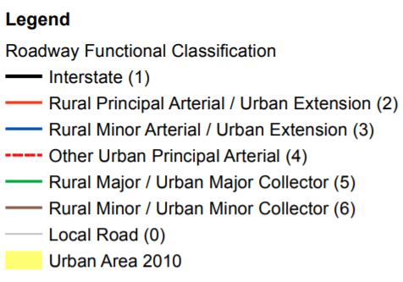
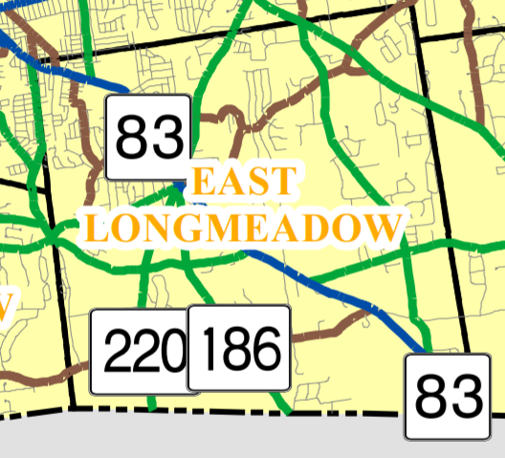

Non-motorist Infrastructure

Non-motorist infrastructure includes accommodations for pedestrians, bicyclists and transit riders. A summary of existing non-motorists infrastructure in East Longmeadow is shown on Figure 2. In 2019 MassDOT released The Statewide Bicycle Plan and The Statewide Pedestrian Plan. These plans include guides introducing Cities and Towns to core concepts as well as provide additional resources to improve bicycle and pedestrian infrastructure. The objective of these plans is to improve safety, reduce fatalities, and increase the use of non-motorized modes of transportation for short trips.

Sidewalks
There is an existing network of sidewalks, primarily in the northern section of town that provides pedestrian connections from major clusters and activity centers to the center of town. Many lower volume roadways do not currently have sidewalks. Similarly, it is unclear if the entire existing sidewalk network meets current Americans with Disabilities Act (ADA) requirements.

The town has a Sidewalk Master Plan that identifies a number of proposed areas for the construction of new sidewalks. This plan is developed by the East Longmeadow Department of Public Works in consultation with key departments such as the School and Police Departments.

Bike lanes
East Longmeadow does not have any designated on-road bicycle amenities. In general, many roads such as Benton Drive have unmarked paved shoulders that could be used by more advance cyclists. The 2020 Complete Streets Prioritization Plan for the town (discussed in greater detail later in this chapter) identifies a number of areas for providing bicycle accommodations on roadways that provide access to key areas.

Redstone Rail Trail
The Redstone Rail Trail is an off road shared use path for bicycles and pedestrians that follows the former Armory Branch of the New York, New Haven & Hartford Railroad. Completed in September of 2010, the rail trail runs in a general north/south direction from Maple Street to Denslow Road for a total length of 1.57 miles. Terrain along the trail is generally flat and is considered suitable for all ability levels.

The trail is accessible from Maple Street with parking available in the municipal parking lot adjacent to the East Longmeadow Library and Town Hall. The trail is also accessible to restaurants and retail establishments in the central business district and along Shaker Road including Family Bike. The Redstone Rail Trail is used frequently by workers from the industrial park including major employers such as American Saw and Cartamundi. There are several commercial fitness centers that utilize the rail trail and the East Longmeadow High School athletic teams use the trail daily for training runs. The Chestnut Street crossing has push-button activated rectangular rapid flashing warning beacons to assist pedestrians and bicyclists in crossing the road. The trail currently terminates at the parking area on Denslow Road near Bay Path University. Expansion of the trail north of Maple Street to the Pleasantview Senior Center and Heritage Park is identified as the top priority in the 2019 Open Space Plan. Trail expansion also was highlighted as a future goal during the Visioning Session for the Master Plan and during the Transportation Focus Group.

Walking Clubs
The East Longmeadow Senior Center's Morning Glory Walkers have been organizing local walks three days a week since 1987. As one of 161 clubs across the state, the walking program gives people over 50 an opportunity to be active and social. Participants in the walking club are also engaged in raising awareness. Recently, organizers brought attention to unsafe sidewalks around the rotary and also identified a crossing signal issue at the intersection of North Main Street with Mapleshade Avenue that makes it difficult for those living with a disability to walk to and from the Senior Center to the center of town.

Safe Routes to School
The Massachusetts Safe Routes to School (SRTS) Program works to increase safe biking and walking among elementary and middle school students by using a collaborative, community-focused approach that bridges the gap between health and transportation. Mountain View School in East Longmeadow received an award from the Massachusetts Safe Routes to School Program in 2017. Mapleshade Elementary is also a "SRTS" partner.

Shared Streets Program
East Longmeadow received $117,573.50 as part of the MassDOT Shared Streets and Spaces Program. This award was used to construct 180 feet of new asphalt trail from the northern terminus of the Redstone Rail Trail to Maple Court, install new traffic calming measures to create a shared street on Maple Court and establish outdoor dining areas. The project also includes public art to be designed and implemented by local business owners and other abutters.

Traffic calming measures on Maple Court established a "shared street" where posted speeds were reduced to 10 mph and painted chicanes reduced the 2-way road to one shared lane for pedestrians, cars, and bicyclists.

Figure 2 – Non-motorized Transportation Network

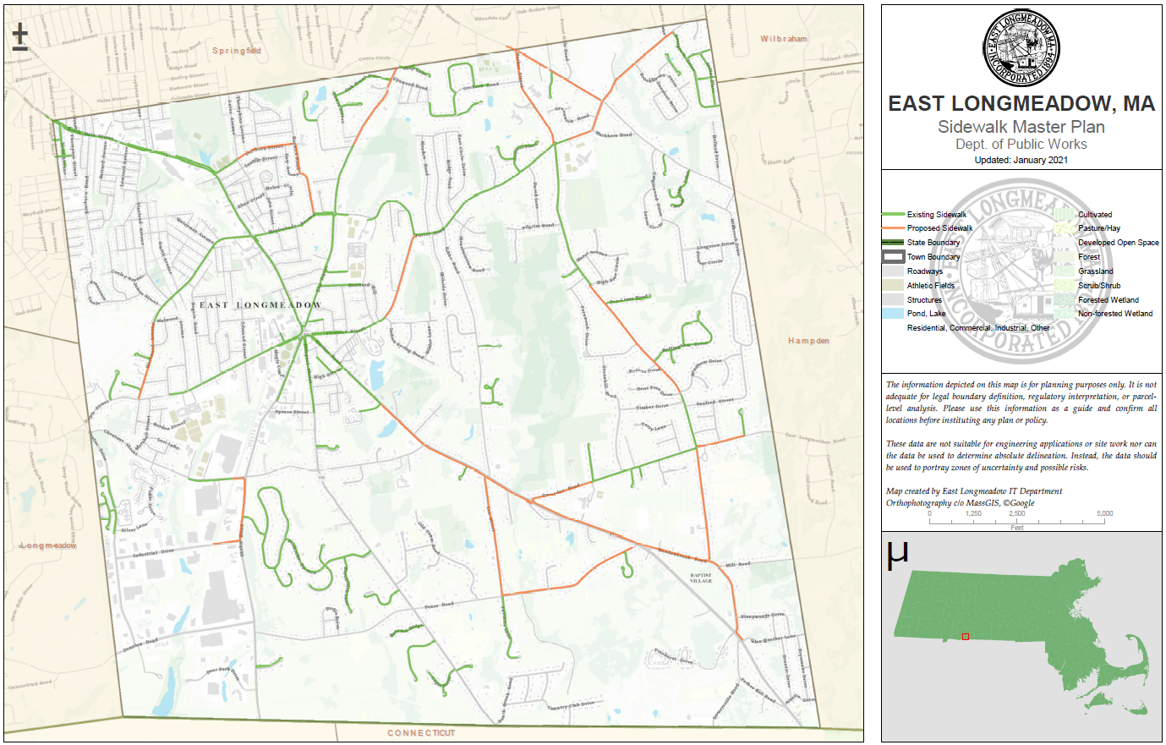

PVTA Transit Service
Existing Service:

PVTA operates two fixed-route bus lines in East Longmeadow, route G2 and route X90. Route G2 operates two branches within East Longmeadow, with one operating on North Main Street between Big Y/Stop & Shop and the Springfield city line, and the other operating on Benton Drive between Redstone Nursing Home and the Longmeadow Town Line (select trips extend further south to Industrial Drive). Route X90 operates on North Main Street between Big Y/Stop & Shop and the Springfield city line.
Route G2 provides connections to downtown Springfield via Belmont Ave and Main Street, and beyond to East Springfield via Carew Street and Page Boulevard. Route X90 provides connections to STCC via White & Walnut Streets, and beyond to Springfield Plaza, Chicopee Falls, South Hadley, and Holyoke. During the 2019 fiscal year, G2 carried 699,134 passengers while X90 carried 274,094 passengers. Of these, 39,833 boarded at bus stops in East Longmeadow, with slightly more riders using the X90 than the G2 (64.3 average daily riders on the G2 vs 65.8 average daily riders on the X90).

Historic Ridership:

Prior to August 2014, service in East Longmeadow was provided by the G2 and B13, with the latter extending beyond Big Y to serve the town center and two apartment complexes (Brownstone Apartments and Quarry Hill Apartments). Service changes implemented in August 2014 replaced the B13 with the new route X90, curtailing service at Big Y. At first there was no negative impact on ridership, with an increase reported during 2015, but ridership has subsequently declined. A summary of ridership by stop (by calendar year, rather than fiscal year) is provided in the following table, with former B13 stops colored in red:

Noteworthy Trends:

- Ridership at the stops previously served by the B13 never exceeded 4% of the total ridership in East Longmeadow, however, this is partly attributable to the very infrequent service that these stops received at the time (most B13 trips terminated at Big Y, as the X90 does today).
- Big Y accounts for the clear majority of ridership in East Longmeadow, and reached an all-time high during 2019, despite a decline in overall ridership in East Longmeadow.
- Ridership at the industrial park declined considerably between 2014 and 2015, but never accounted for a large portion of ridership to begin with.
- Ridership during 2020 was severely impacted by the COVID-19 pandemic.

Table 1 – Historic Transit Ridership Data
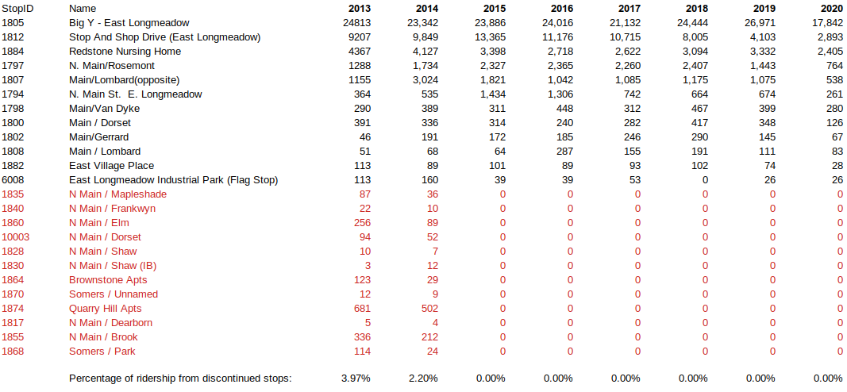

Potential Future Changes:

PVTA is investigating the potential of additional crosstown service: these are routes which bypass the Union Station bus terminal, connecting the “spokes” of PVTA’s network. One such corridor is a connection from East Longmeadow center to Ludlow Big Y, via Elm, Cooley, and Parker Streets. For this route to be most effective, PVTA would also need to extend either the G2 or X90 service beyond its current terminal to connect to East Longmeadow center. With that said, PVTA’s current budget would not allow such service changes without making cuts elsewhere in the system, so these remain at the conceptual stage for the time being. Should an appropriate grant or other funding source become available, PVTA will consider a pilot program for such service, depending on feedback from East Longmeadow and PVTA riders.

PVTA Paratransit Service

Paratransit is demand response door-to-door van service that is scheduled by the rider. PVTA’s fleet of vans are equipped with wheelchair lifts and other special equipment to insure the safety of disabled riders. PVTA provides paratransit service as follows:

- Americans with Disabilities Act (ADA) Service -- Federal law requires that public transit providers offer paratransit service that is comparable to their fixed route bus service to disabled customers who are unable to use regular buses. Customers must be eligible to use the service, and an application and approval process is required. Trips must be scheduled at least one day in advance. ADA paratransit service is available only within three-quarters of a mile of a fixed bus route, and the trip must start and be completed during the same hours that the nearest regular bus route operates. The fare ranges from $3.00 - $5.00 per ride, depending on pickup and drop off locations.
- Senior Dial-A-Ride Service -- PVTA also provides van service to people age 60 and over in its 24 member communities. This service is operated on a space-available basis Monday through Friday from 8:00 AM to 4:30 PM. The fare ranges from $3.00 - $5.00 per ride, depending on pickup and drop off locations. Tickets are available from local senior centers and the PVTA Information Center.

PVTA also offers Travel Training for seniors and people with mobility impairments who would like to learn how to safely and independently use the fixed route system. Training is provided free-of-charge except for the required bus fare while training is taking place. For more information visit: http://www.pvta.com/traveltraining.php

Senior Van Service

The East Longmeadow Council on Aging, located at the Pleasant View Senior Center provides transportation via the Tri-Town Trolley. This weekday service runs from 9:00 AM to 3:00 PM for the towns of East Longmeadow, Hampden and Longmeadow. The trolley provides transportation for residents to appointments in East Longmeadow, Hampden, Longmeadow, Ludlow, Springfield and West Springfield based on availability. A 48 – 72 hour notification is required to schedule a trip. The cost is $1 each way for in-town transportation and $2 each way for out-of-town transportation.

Traffic Volume

Traffic volumes can be used to evaluate the current performance characteristics of existing roadways, identify the need for additional transportation facilities to reduce existing congestion, and as a gage of the effectiveness of new businesses that rely on pass by traffic (i.e. convenience stores, gas stations, and retail establishments). While traffic volumes are not always an indication of the level of congestion or safety along a given roadway, they do provide important information on the use of the road such as direction of travel and peak travel periods. Historic traffic data also provides valuable information on the level of growth experienced over time.

Average Annual Daily Traffic (AADT)

AADT is the calculated traffic volume that represents the average for a typical day of the year. A limited amount of historic data is available for the Town of East Longmeadow. Unfortunately new traffic volume data was not collected as part of this Master Plan as a result of lower traffic volumes and different travel patterns experienced during the COVID 19 Pandemic. Table 2 shows the historic count data available for the Town. This data represents a 24 hour volume for both directions of travel on an average weekday. PVPC did perform traffic counts in 2020 at two locations as part of an ongoing program to monitor regional travel patterns during the pandemic and through the recovery period.

Table 2 – Historic Average Daily Traffic Volumes

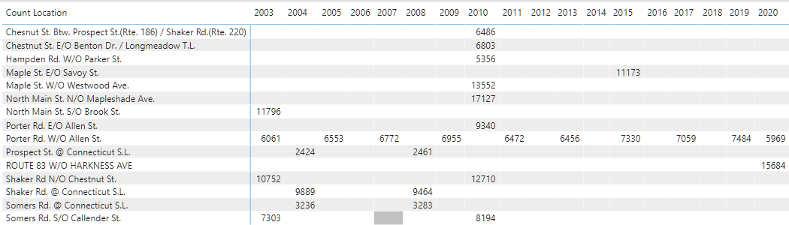

Traffic volume data is collected on a regular basis for MassDOT on Porter Road west of Allen Street. This information is used as part of the Federal Highway Performance Monitoring System (HPMS). HPMS data is the official Federal government source on the extent, condition, performance, use, and operating characteristics of the nation’s highways. It is used to assess and report on highway system performance. Historic data on Porter Road west of Allen Street from 2003 – 2020 is shown in Figure 3. Traffic volumes increased by 23.5% from 2003 to 2019. In 2020 traffic volumes in this area were over 20% lower than 2019 volumes.

Figure 3 – Historic Traffic Growth on Porter Road west of Allen Street

Truck Volumes
Trucks have much different operating characteristics than a traditional passenger vehicle, they require a wider turning radius and a longer distance to come to a complete stop. An assessment of the volume of truck traffic is useful for identifying the major corridor of freight travel as well as for future planning and design of roadways and intersections. Understanding the needs of the major freight generators can also help to reduce the desire for trucks to utilize residential areas to bypass freight bottlenecks and areas of congestion.

Vehicle classification data was reviewed for recent traffic counts on North Main Street and Porter Road. The 2020 traffic count on North Main Street west of Harkness Avenue revealed that less than 1% of all traffic was comprised of vehicles with three or more axles. This count was conducted over a 48 hour period in July of 2020. Truck volumes were also compared for the 2019 and 2020 counts performed on Porter Road west of Allen Street. Again, less than 1% of all traffic was comprised of vehicles with three or more axles. The percentage of truck traffic was observed to increase slightly from 2019 to 2020 on Porter Road although this is likely a result of the lower volumes of passenger vehicle traffic during the COVID-19 pandemic.

Redstone Rail Trail Volumes
PVPC reviewed historic usage data collected at a central location on the Redstone Rail Trail. Data is collected with a passive infra-red signal detector with a data logger to record time and date information. This device is not able to provide directional information or a breakdown of the type or trail user i.e. bicyclist, pedestrian, rollerblader, etc. A summary of the monthly ridership information is shown in Figure 4. Monthly data totals show a pattern of regular use that increases during warmer weather months. Trail use is significantly higher in 2020 than similar months in 2018.

Figure 4 – Monthly Ridership on the Redstone Rail Trail
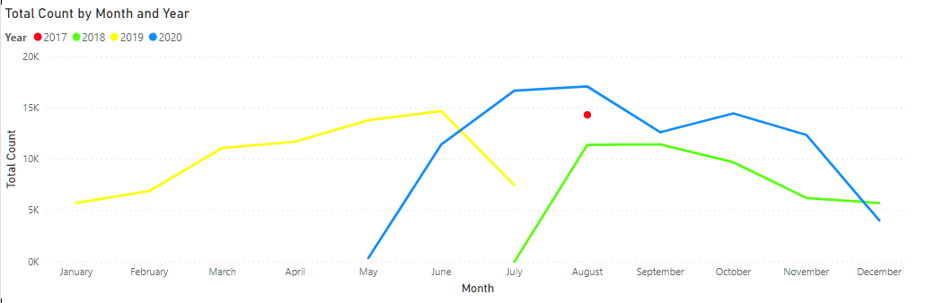

Safety
PVPC utilized crash data downloaded from the Impact Crash Data Portal (https://apps.impact.dot.state.ma.us/cdv/) developed by MassDOT. PVPC used the most recent three years of final data available (2015-2017) to identify the number of crashes that occurred in East Longmeadow. This information is summarized in Figures 5 and 6.

Crash data was ranked using the Equivalent Property Damage Only (EPDO) system. All fatal and injury crashes are weighted the same in this system as 21 while a property damage only crash is weighted as 1. This scoring places an emphasis on developing countermeasures to reduce the number of fatal and serious injury crashes. The sum of the EPDO for all crashes contained in an area was utilized to rank the top five locations in East Longmeadow. The East Longmeadow Rotary had the highest EPDO score of 580 with a total of 180 crashes over the three year period. The intersections of Shaker Road with Chestnut Street and North Main Street with Mapleshade Avenue and Westwood Avenue both operate under traffic signal control. The intersection of Allen Street with Porter Road operates under multi-way Stop sign control that is supplemented by an overhead flashing red warning beacon. Only 8 total crashes were reported at the intersection of Shaker Road with Pease Road from 2015 – 2017. The calculated EPDO, however, was 108 indicating a large percentage of the crashes resulted in an injury.

Figure 7 summarized the historic number of crashes with the fatal and injury crashes in East Longmeadow from 2002 – 2019. It should be noted that crash data from 2018 and 2019 had not yet been finalized by MassDOT and could still change. The total number of crashes in town have decreased over time. Crashes have fluctuated between 375 and 400 crashes from 2012 – 2017. The total crashes in 2018 and 2019 appear to be even lower.

Fatal and injury crashes have an average total of nearly 71/year from 2002 – 2019. This ranges from a high of 106 in 2003 to a low of 44 in 2018. The rate of fatal and injury crashes has decreased over the last ten years with an average total of nearly 61/year.

Tables 3 and 4 summarize the crash data for the East Longmeadow Rotary from 2015 – 2017. Angle crashes are the predominant crash type in the vicinity of the rotary. Just over 11 percent of all crashes at the rotary resulted in an injury. The total number of crashes remained fairly consistent from 2015 to 2016 but increased in 2017. It will be important to monitor crash data in this area over time to determine if it continues to increase.

The intersections of Chestnut Street with Prospect Street and Mapleshade Avenue with Porter Road and Pleasant Street both were identified as areas of concern for safety during the Transportation Focus Group. Chestnut Street intersects with Porter Street to form a four way intersection. Three of the four approaches operate under Stop sign control. Eastbound traffic on Chestnut Street has the right of way. There is a steep grade on Chestnut Street that contributes to visibility issues at this intersection. An overhead flashing warning beacon and parabolic mirror are located at this intersection to assist drivers.

Safety concerns at the intersection of Mapleshade Avenue with Porter Road are due to the high travel speeds on Porter Road and difficulties pedestrians have when attempting to cross the street. An existing guardrail on the corner of this intersection often requires replacement after being struck by a vehicle.

Figure 5 – East Longmeadow Crash Data 2015 - 2017
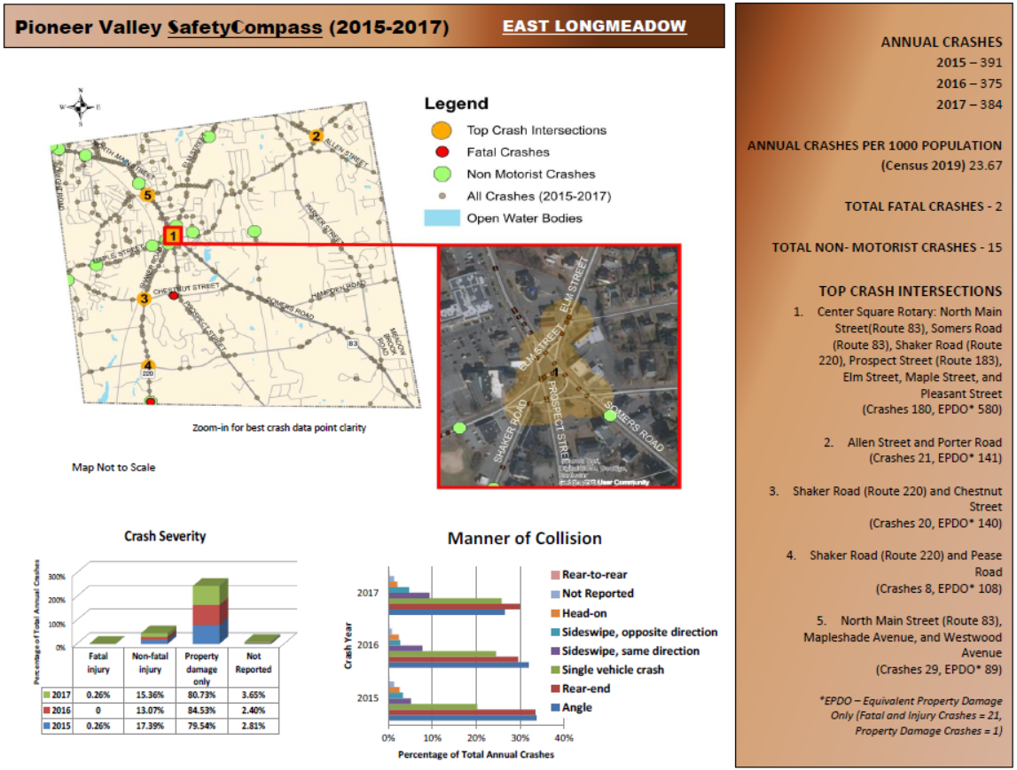

Figure 6 – Key Findings on East Longmeadow Crash Data
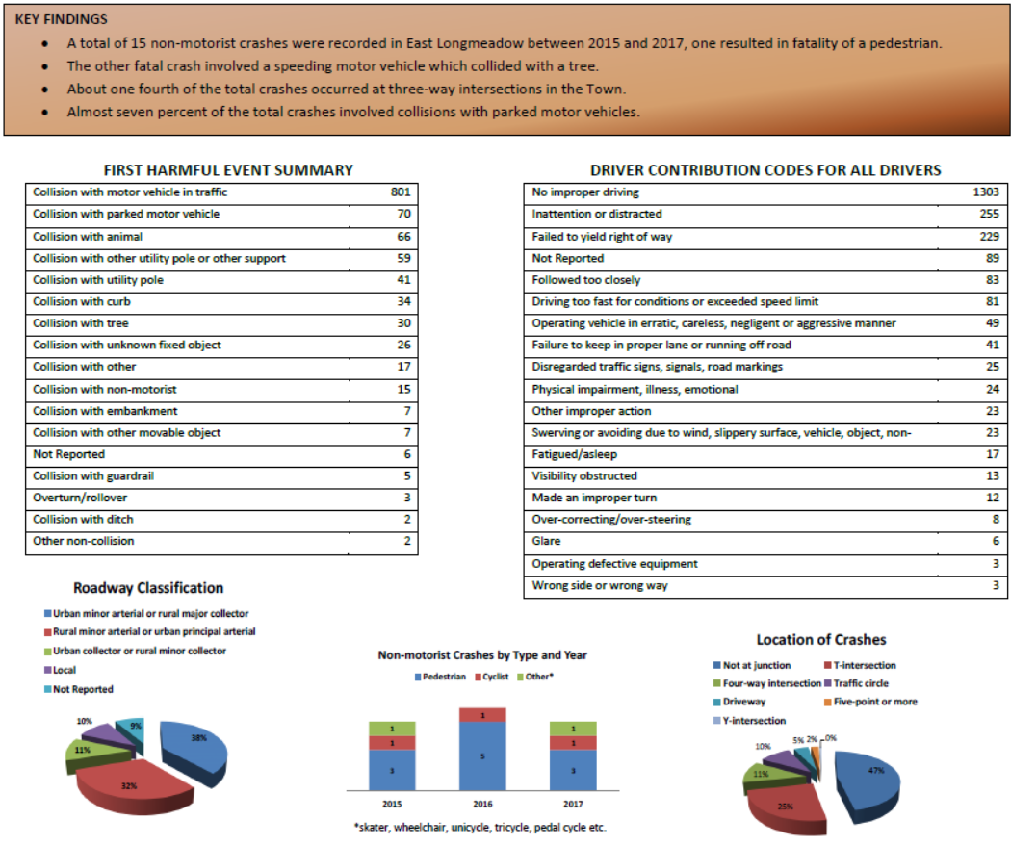

Figure 7

Table 3 – Total Crashes by Year and Type at the East Longmeadow Rotary
Crash Type | 2015 | 2016 | 2017 | Grand Total
Angle | 34 | 33 | 35 | 102
Head-on | 1 | 1 |  | 2
Rear-end | 14 | 6 | 8 | 28
Sideswipe, opposite direction |  | 1 | 3 | 4
Sideswipe, same direction | 6 | 12 | 13 | 31
Single vehicle crash | 2 | 1 | 8 | 11
Unknown |  | 1 | 1 | 2
Grand Total | 57 | 55 | 68 | 180

Table 4 – Crash Severity at the East Longmeadow Rotary
Crash Severity | 2015 | 2016 | 2017 | Grand Total
Non-fatal injury | 6 | 6 | 8 | 20
Property damage only | 51 | 49 | 60 | 160
Grand Total | 57 | 55 | 68 | 180

Congestion

Understanding where and why traffic congestion is happening is an important step toward reducing it. The Pioneer Valley Congestion Management Process (CMP) works toward identifying the major traffic congested locations within the Pioneer Valley Region. This information is essential in advancing future transportation improvements that will reduce traffic congestion and improve the overall safety and efficiency of our transportation network.

PVPC ranks congestion based on the Level of Travel Time Reliability (LOTTR) for a roadway. LOTTR is based on the amount of time it takes to drive the length of a roadway segment. A roadway segment is defined as “reliable” or “unreliable” if the calculated LOTTR falls below a certain threshold (currently 1.5). The following roadway segments currently rank as “unreliable” based on 2019 travel time data for the PM peak hour:

- Shaker Road (Route 220) in the vicinity of the East Longmeadow Rotary
- Maple Street in the vicinity of the East Longmeadow Rotary

The regional CMP also identifies Congestion Bottlenecks. A Congestion Bottleneck is defined by the Federal Highway Administration (FHWA) as a localized constriction of traffic flow that experiences reduced speeds and inherent delays due to recurring operational influence or a nonrecurring impacting event. The PVPC has identified the East Longmeadow Rotary as one of the top Congestion Bottlenecks based on 2019 travel time data for the PM peak hour.

Transportation Resiliency
FHWA defines resiliency as the ability to anticipate, prepare for, and adapt to changing conditions and withstand, respond to, and recover rapidly from disruptions. This consists of the identification of transportation features that need to be protected from manmade and natural disasters. PVPC identified pavement condition, bridges, culverts, evacuation routes and signalized intersections as the biggest threats for transportation resiliency in the Town of East Longmeadow.

Bridges and Culverts
MassDOT maintains the majority of bridges in Massachusetts, including the 3 structures located in East Longmeadow. Massachusetts General Laws (MGL) recognize structures having a span greater than 10 feet as bridges. Federal regulations define a bridge as a structure having a span greater than 20 feet. According to the MassDOT municipal data dashboard East Longmeadow has two bridges that are rated to be in “good” condition and one bridge rated to be in “fair” condition. While a bridge rated as fair is not considered to be in danger of failing, natural or other types of disasters could accelerate the rate of deterioration resulting in failure.

- North Main Street over the Pecousic Brook – Good Condition
- Somers Road between Michel Street and Hampden Road – Good Condition
- Meadowbrook Road over the Watchaug Brook – Fair Condition

Severe weather events can have negative impacts on structures such as culverts and bridges. In 2011, Tropical Storm Irene caused more than $25 million of roadway damage in the Pioneer Valley region, including many culvert wash outs. Culverts are usually built to carry a road, rail line or path over a small body of water. The PVPC mapped the location of all regional culverts as part of the update to the 2020 Regional Transportation Plan (RTP). The top 5% of culverts deemed most ecologically vulnerable or sensitive to extreme weather and heavy rain were prioritized in the RTP. A total of 45 culverts were identified in East Longmeadow as part of the RTP Update. No culverts in East Longmeadow were included as part of this vulnerability ranking. The East Longmeadow DPW identified three areas of potential concern for resiliency as part of the Transportation Focus Group:
- Pioneer Circle area - seasonal drainage issues.
- Porter Road Culvert – Project bid came in higher than expected and requires additional funding to advance to construction.
- Heritage Park Pond – requires redesign of the outfall.

Local Pavement Management
A Pavement Management System (PMS) is a systematic process that collects and analyzes roadway pavement information for use in selecting cost-effective strategies for providing and maintaining pavements in a serviceable condition. The principles of pavement management prioritize improvements to roadways in poor condition in combination with lower cost maintenance strategies for roadways in good condition. The Town of East Longmeadow hired a private consultant to assess all town roadways in 2017. PVPC reviews the condition of all federal aid eligible roadways in the region on a four year cycle. Pavement conditions in the Town of East Longmeadow were last reviewed in 2018.

PVPC uses the Cartegraph software to assess the condition of paved roadways. This software calculates the Overall Condition Index (OCI) which measures the serviceability of a road on a scale from 0 – 100. An OCI value approaching 100 indicates excellent pavement conditions where no improvements are warranted. A value in the range of 68 to 88 indicates good pavement conditions that may only require preventive maintenance treatments such as crack sealing. A “fair” pavement condition is indicated by an OCI with a value between 25 and 68. Roadways in this range begin to require more substantial improvements such as resurfacing to improve the roadway. An OCI below 25 indicates “failed” pavement conditions that will likely require the complete reconstruction of the roadway

The average OCI for federal aid eligible roadways in East Longmeadow was 83 in 2018 indicating that most roadways were estimated to be in good condition at this time. All total, nine roadway segments were found to be in Fair condition. These segments are shown in Table 5. The lowest rated segment was on Shaker Road between Maple Street and Chestnut Street. No segments were reported to be in Poor condition at the time of the 2018 assessment.

Figure 8 – Vulnerable Transportation Infrastructure

To be added
Table 5 – Federal Aid Eligible Roadway Segments with an OCI Under 68
Roadway | From | To | OCI* | Survey Date
Parker Street | Hampden Road | House #513 | 65 | 8/28/2018
Somers Road | Connecticut State Line | Meadowbrook Road | 65 | 8/28/2018
Parker Street | Meadowbrook Road | Hampden Road | 61 | 8/28/2018
Denslow Road | Shaker Road | Longmeadow Town Line | 57 | 8/28/2018
Prospect Street | Chestnut Street | Connecticut State Line | 57 | 6/28/2019
Shaker Road | Chestnut Street | Connecticut State Line | 56 | 6/28/2019
Vineland Avenue | Westwood Avenue | Kensington Avenue | 54 | 8/29/2018
Kensington Avenue | Lombard Avenue | Vineland Avenue | 50 | 8/29/2018
Shaker Road | Maple Street | Chestnut Street | 29 | 6/28/2019
* OCI = Overall Condition Index

Local Evacuation Routes
The Western Massachusetts Regional Evacuation Plan was completed in 2013 to provide emergency responders on the local, state, and federal levels with the resources necessary for conducting a regional evacuation in as efficient and effective a manner as possible. The plan provides maps and lists of evacuation routes, population centers, infrastructure, and other critical assets. Route 83 (North Main Street/Somers Road) is identified as the primary evacuation route for East Longmeadow. Other tertiary evacuation routes in town include Allen Street, Elm Street/Shaker Road and Maple Street. Tertiary routes are used to channel traffic towards secondary and primary evacuation routes that typically provide the most capacity and most direct route out of the region.

Traffic Control
There are several intersections that currently operate under a higher level of traffic control. All total there are eight intersections that operate under traffic signal control and six intersections that operate under multi-way Stop sign control. Many of these multi-way Stop controlled intersections also have supplemental flashing warning beacons.

Table 6 – Signalized and Multi-way Stop Controlled Intersections
Signalized Intersections | Multi-way Stop Sign Controlled Intersections
Allen Street at Parker Street | The East Longmeadow Rotary
Chestnut Street at Shaker Road | Chestnut Street at Prospect Street
Elm Street at Mapleshade Avenue | Parker Street at Hampden Road
North Main Street at Harkness Avenue | Porter Road at Allen Street
North Main Street at the Big Y | Porter Road at Parker Street
North Main Street at Stop & Shop | Prospect Street at Pease Road
North Main Street at Dearborn Street
North Main Street at Mapleshade Avenue and Westwood Avenue

Planned Transportation Improvements
This section outlines all planned or recommended transportation improvement projects in the Town of East Longmeadow. PVPC identified this information based on a review of previous studies and through discussions with the Department of Public Works.

Proposed Roadway Improvements
The Transportation Improvement Program for the Pioneer Valley (TIP) is a five-year schedule of priority highway, bridge, transit, and multimodal projects. The Town of East Longmeadow does not currently have any projects included as part of the current TIP or to be considered for funding as part of a future TIP. For more information on the Regional TIP Process please visit: http://www.pvpc.org/projects/transportation-improvement-program

The Town received a grant from MassDOT in 2019 for $240,000 to make improvements to the Porter Road Culvert. Unfortunately bids received for this project exceeded this total. The East Longmeadow DPW is currently working to identify additional funding for this project. The DPW has developed a list of paving projects for 2021 as well as candidates for paving in 2022 and 2023. This information is shown in Table 7.

Table 7 – Potential East Longmeadow Paving Projects
2021 Paving Projects | 2022/2023 Candidate Paving Projects
Denslow Road | Shaker Road (State Line to Chestnut)
Shaker Road (from Pease to Denslow) | North Main Street (Rotary to Harkness)
Maple Street | Marci Avenue
Dearborn Street | High Pine Circle
Gates Avenue (portion north of Dearborn) | Melwood Avenue
Westminster Street | Marshall Street
Somerset Street
Shawmut Street
Hedgerow Lane
Maryland Street
Auburn Street
Thompkins Avenue
Quarry Hill
Woodbridge Drive
Winding Brook Lane
Sturbridge Lane
Chatham Circle
Patience Way

Sidewalk Plan
The East Longmeadow Sidewalk Plan identifies a number of proposed new sidewalks as well as locations for the maintenance of existing sidewalks. Sidewalk improvements are funded via the Town General Fund. Recommended sidewalk improvements are shown in red on Figure 2.
Complete Streets Prioritization Plan
East Longmeadow completed a Complete Street Prioritization Plan in March, 2020. This plan is a requirement of the Massachusetts Complete Street Program. As part of this program, a community can apply for up to $400,000 in funding to implement projects included as part of an approved Prioritization Plan. The plan identifies a number of pedestrian improvements, bicycle improvements, safety improvements and transit improvements. It also includes a methodology to evaluate, score and rank each project included in the Plan. All total, 55 projects have been included in the Plan.

Table 8 – Top 20 Projects from the East Longmeadow Complete Streets Prioritization Plan
Rank | Project Description
1 | Maple Street corridor Phase I with new striping, bicycle lanes and signage, etc. from the Redstone Trailway to the entrance of the East Longmeadow High School
2 | Maple Street corridor Phase II with new striping, bicycle lanes and signage, etc. from entrance of the East Longmeadow High School to the East Longmeadow town line
3 | Street Lighting Mountain View Elementary School
4 | Chestnut Street Corridor Phase I with new striping, bike lanes, sharrows and signage, etc. from Shaker Road to Holly Drive
5 | Parker Street Corridor with new striping, sharrows and signage, etc. from Hampden Road to Porter Road
6 | Street Lighting Birchland Middle School
7 | Sidewalk Improvements Somers Road Phase I
8 | Street Lighting Meadow Brook Elementary School
9 | Denslow Road corridor with new striping, bicycle lanes and signage, etc. from East Longmeadow / Longmeadow town line to Shaker Road
10 | Repaint Crosswalks – Various Locations
11 | Wayfinding / Signage Improvements at the East Longmeadow Rotary
12 | Shared Lane Markings Chestnut Street Phase II from Holly Drive to Benton Drive;
13 | Rectangular Rapid Flashing Beacon/ RRFB and crosswalk enhancements at Maple Street
14 | Replace Flashing Beacon - Porter Road at Allen Street
15 | North Main Street corridor with new striping, new bicycle lanes and signage from Westwood Avenue to Center Square
16 | Sidewalk Improvements Somers Road Phase II
17 | Intersection Improvements - Hanward Hill and Birchland Avenue
18 | Intersection Improvements at Park Place and Somers Road
19 | Rectangular Rapid Flashing Beacon/ RRFB and crosswalk enhancements at Industrial Drive
20 | Industrial Drive corridor with new striping, new bicycle lanes and signage from Shaker Road to Benton Drive

Transportation Goals & Recommendations

Goal 1. Continue to collect necessary data to keep the local transportation system in a state of good
repair.

- Continue to monitor pavement condition in the Town of East Longmeadow. Advance pavement maintenance and improvement projects based on the results of the 2017 Local Pavement Management Study. Collect data on a regular basis to update the condition of all paved roadway segments in Town.

Primary: East Longmeadow DPW
Others: PVPC
Priority/Timeframe: Ongoing
Resources: East Longmeadow 2017 Pavement Management Report/PVPC 2018
Pavement Management data

- Perform regular traffic data collection to assess existing travel speeds, pedestrian volume, bicycle volume, vehicle volume and truck volume at key locations in the Town. The Pioneer Valley Planning Commission (PVPC) collects daily traffic count information at sample locations across the region. PVPC member communities can request up to 2 free counts per calendar year.

Primary: East Longmeadow DPW
Others: PVPC
Priority/Timeframe: Ongoing
Resources: http://www.pvpc.org/projects/traffic-counting-system

- Consider an in depth study of all existing traffic signals and multi-way Stop sign controlled intersections in Town. Identify opportunities to fund the design and construction of intersection improvements.

Primary: East Longmeadow DPW
Others: MassDOT
Priority/Timeframe: 3-10 years
Resource: Pioneer Valley Transportation Improvement Program

- Identify opportunities to identify funds for the rehabilitation of the Porter Road Culvert. Continue to monitor the state of bridges and culverts in town through the MassDOT municipal data dashboard.

Primary: MassDOT
Others: East Longmeadow DPW
Priority/Timeframe: Immediate
Resources: https://gis.massdot.state.ma.us/DataViewers/MunicipalDashboard/

Goal 2. Identify opportunities to expand the non-motorized transportation system.

- Identify opportunities to extend the Redstone Rail Trail to the north. Coordinate with the PVPC and City of Springfield to identify future opportunities to connect with existing and planned bicycle facilities.

Primary: Town of East Longmeadow
Others: MassDOT / PVPC
Priority/Timeframe: 3 – 10 years
Resource:

- Continue to implement projects from the Sidewalk Master Plan and Complete Streets Prioritization Plan.

Primary: Town of East Longmeadow
Others: MassDOT
Priority/Timeframe: Ongoing
Resources: Sidewalk Master Plan, Complete Streets Prioritization Plan Project List

- Coordinate with the PVTA on the potential of future crosstown fixed-route transit service connecting East Longmeadow center to the Ludlow Big Y, via Elm, Cooley, and Parker Streets.

Primary: PVTA
Others: Town of East Longmeadow
Priority/Timeframe: 1-3 years
Resource:

Goal 3. Improve transportation safety for all modes of travel.

- Conduct assessments as necessary to ensure the transportation infrastructure complies with ADA Accessibility requirements.

Primary: East Longmeadow DPW
Others: Council on Aging
Priority/Timeframe: Ongoing
Resource:

- Continue to participate in and advance improvement projects as part of the Massachusetts Safe Routes to School Program.

Primary: East Longmeadow School Department
Others: East Longmeadow Police Department, East Longmeadow DPW
Priority/Timeframe: Ongoing
Resources: https://www.mass.gov/safe-routes-to-school

- Review local crash data and advance in-depth safety studies for high crash areas in East Longmeadow

Primary: East Longmeadow DPW
Others: East Longmeadow Police Department, MassDOT, PVPC
Priority/Timeframe: Ongoing
Resources: https://apps.impact.dot.state.ma.us/cdp/home

HOUSING

Overview

The Housing element of the East Longmeadow Master Plan provides an overview of housing conditions and issues facing the Town of East Longmeadow and its residents.

With this chapter being an update to the Town’s Master Plan, and incorporating its commonalities to other Town goals and policies, successful housing policies and outcomes can:

- Consider pattern of residential development in determining what types of housing stock is needed and where it might best be constructed and concentrated in the future;
- Assess the local and regional area to determine how future market forces may influence the development and affordability of housing in the community.

Inventory and Existing Conditions

Covering about 13.4 square miles, the Town of East Longmeadow is located in Hampden County south of the City of Springfield on the Connecticut border in western Massachusetts. East Longmeadow is situated due east of the Connecticut River in the Pioneer Valley. It is bordered by the towns of Wilbraham to the northeast, Hampden to the east, Enfield, Connecticut to the south and southwest, Springfield to the north and northwest, and Longmeadow to the west.

The Town of East Longmeadow in its storied evolution, has been able to maintain a mix of rural, suburban, industrial and urban elements which form a quilt of a vibrant community, which will continue to grow and evolve. East Longmeadow’s location within 7 miles of the City of Springfield and within easy access to Interstate 91, has contributed to its development. The Town’s estimated population in 2020 was 16,739 people, resulting in a population density of 1,249 persons per square mile. Since 2010, the population grew about 6.5 percent.

The high cost of housing and lack of affordable or attractive options for households is a reality, as Massachusetts Governor Baker has identified a crisis on the affordability of housing and lack thereof. The supply and cost of housing play a major role in who gets to live in town. Communities, through their policies, can influence and play a role on who lives in town – East Longmeadow is no exception. Sometimes zoning can limit the development of housing for a variety of different housing types, likely resulting in a homogeneous population. Residents have said they want the balance of housing types to be available to many different income levels and for many different ages and households; finding that balance is the challenge, adopting the regulations and exploring the non-regulatory ways to achieve these housing goals.

HOUSING STOCK

The size of the housing stock in East Longmeadow has grown consistently through time, although since the Great Recession at a smaller rate than between 2000 and 2010. The number of vacancies decreased dramatically between 2010 and 2017.

HOUSING STOCK
 | 2000 |  | 2010 |  | 2017
 | Number | Percentage | Number | Percentage | Number | Percentage
Total Units | 5,363 | 100% | 5,851 | 100% | 6,154 | 100%
Occupied Units | 5,248 | 97.8% | 4,984 | 85.2% | 5,978 | 97.1%
Vacant Units | 115 | 2.2% | 255 | 14.8% | 176 | 2.9%
Source: ACS 2013-2017, "Vacancy Status," B25004 & "Selected Housing Characteristics," DP04.

AGE OF HOUSING

According to the Donahue Institute, the distribution of housing units by age is important for at least three reasons. First, a housing stock with few units built since 2000 indicates that housing supply is growing slowly. Demand can remain stable or increase and this would result in housing price increases. Second, older housing units can be more expensive to occupy, due to higher heating and maintenance costs. Third, certain federal housing programs, such as Community Development Block Grants, track the percent of housing units by age, and in particular, the percent built before 1939.

In East Longmeadow, 9.4% of housing units are in buildings built before 1939. Construction since 2000 accounts for 14.3% of units.

BUILDING PERMITS

Owners or builders file building permits when they initiate any type of major construction or demolition in East Longmeadow. Permits for activities such as new construction, renovations, and demolitions are good indicators of the housing market in East Longmeadow. Single family construction in East Longmeadow in the past ten years has been consistent with the highest number of homes built in 2013 with 57. 2019 and 2018 represented the lowest amount of residential units built in the past ten years, although even in the middle of a pandemic in 2020, the number has returned to near the median value of the last ten years.

Year | Single Family Construction | Residential Condo (All 55+ units) | Total Residential Units
2020 (As of 12/11/20) | 25 | 6 | 31
2019 | 10 | 6 | 16
2018 | 12 | 5 | 17
2017 | 28 | 4 | 32
2016 | 31 | 0 | 31
2015 | 27 | 5 | 32
2014 | 32 | 10 | 42
2013 | 53 | 4 | 57
2012 | 36 | 9 | 45
2011 | 20 | 6 | 26
2010 | 38 | 9 | 47

HOUSING TENURE

According to estimates from the 2014-2018 American Community Survey, 82.2 percent of the occupied housing units in East Longmeadow are ownership units, while 17.8 percent are rental units. This is equal to about 4,899 ownership units, and 1,058 rental units.

HOUSING SALES

Median home sales price has seen a notable increase from $210,000 in 2015 to $260,000 in 2019.

HOME VALUES AND RENTS

Despite the increase in median sales prices, home values have fluctuated since 2010, with a decline in median value of homes from 2016-2018. This does not necessarily suggest a general decline in home values. The uptick in home sales and sale price, steadily increasing the total assessed value of residential property in East Longmeadow could possibly be the likelihood that much higher-valued housing has become

SUBSIDIZED HOUSING INVENTORY

As of November 2019, there were 452 units, or 7.44 percent of the year-round housing stock in East Longmeadow determined to be “affordable” as defined under Massachusetts General Law Chapter 40B.

Issues & Opportunities

Population and Household Growth

Based on the projected population and household growth in East Longmeadow, proactive planning is essential for accommodating new growth while maintaining the characteristics and qualities that make East Longmeadow great place to live and work. Population growth is to be around 11.5 percent between 2010 and 2030. This growth can affect transportation, public infrastructure, housing, and town services, like schools in which its planning is usually focused on residential growth.

Changes in population and households are not all bad. The growing number of residents between the ages of 35 and 54 years old are helping to support the local economy and fill the homes on the market. This generates sales and property taxes that are reinvested back into the community. While homeowners and renters in this age group do contribute substantially to the vitality of the community, they also rely on town services such as schools, recreation facilities, and the library. The Town needs to plan for the changing demographics and the shifts in age groups to continue to provide a high quality of life for its residents. Like many other communities, seniors are likely to present challenges to the town of East Longmeadow. Seniors have unique needs and often require increased service provisions. Transportation services, grocery delivery, and programming to maintain social interconnectedness are all important pieces in maintaining the general health and well-being of seniors.

East Longmeadow needs to carefully consider future residential growth scenarios with its current zoning. As more low-density housing is built, the proportion of open space will decrease, and the burden on local finances will increase. As the American Farmland Trust has found through its Cost of Community Services studies (https://farmlandinfo.org/publications/cost-of-community-services-studies-making-the-case-for-conservation/ ):

“…although working agriculture and open space lands may generate less revenue than residential, commercial or industrial property, they require less public infrastructure and fewer community services. Cost of Community Services studies from 25 states show that, on average, the median cost per dollar of revenue raised to provide public services for commercial and industrial lands was $0.30, for working and open space lands was $0.37, and for residential lands was $1.16.”

Housing Affordability

Chapter 40B authorizes a housing agency or developer to obtain a single comprehensive permit for the construction of subsidized low or moderate-income housing if less than 10% of its total year-round housing in the community is subsidized low or moderate-income housing. Because East Longmeadow is below this threshold, it is vulnerable to a Comprehensive Permit application. A Comprehensive Permit puts local permitting in the hands of the Zoning Board of Appeal.

One of the primary purposes of M.G.L Chapter 40B is to assure that no city or town shouldered a disproportionate amount of low- and moderate-income housing in any region of the state. To this end, a 10 percent statutory minimum was established as an indicator that suburbs and small towns were providing their “fair share” of affordable housing. East Longmeadow does not currently meet this statutory minimum, and a need for more affordable housing choices can further be seen in the increased share of household incomes going toward housing costs.

More than 50 percent responded that the town should work immediately or within the next 1-2 years on varying selection and price of homes so life-long residents and working people can afford to stay in East Longmeadow. Some free responses to this question included similar sentiments like more affordable options for life-long residents to retire with a garage and no more large homes occupying large property areas at high values.

Housing Choice Types
Housing can be a controversial subject in most towns. It has been shared that there have been challenges in trying to get policies passed through Town Meeting in the past, and Town Council currently with regards to housing and providing increased access to various types. Opinions about housing, taxes, taxing the town's infrastructure, and loss of open space often led to many land use policy decisions and sometimes at the expense of sound planning and social fairness. Lack of housing options including smaller, rental, accessible, and affordable units can create barriers for residents in various stages of life to thrive in East Longmeadow and achieve greater socioeconomic diversity in the population.

It is an important policy question for East Longmeadow whether or not the local regulations and zoning provide for a good balance of housing opportunities or create barriers to fair and affordable housing.

Coronavirus Pandemic

East Longmeadow is in a different place in December 2020 than it was even in January 2020. Retailers, restaurants and many businesses in the Commonwealth closed for many weeks, sometimes reverting to online shopping once it was safe to do so. Virtual learning was commonplace the last quarter of the 2019-2020 School Year. In November 2020, the state is again addressing mitigation for the rise in cases in the Pioneer Valley and throughout the Commonwealth, which include social distancing, consumers in face-masks and hand sanitizer at entrances. Meanwhile, many service-based businesses have acclimated to telecommuting or a hybrid work environment, drawing attention to whether many of these-service based businesses may still need to keep their office spaces. The Town and its economy will have these norms to weather as the world continues to wait for a vaccine and therapeutics.

While the pandemic cannot determine the Town’s long-term economic health, its influence will be present in the coming years as revenues, municipal and school services are discussed to address how COVID-19 has changed the traditional workplace possibly for good, possibly resulting in a change of household. Moreover, for the time being, the Town’s ability to navigate these initiatives explored in this plan may be tested, as the work will involve all aspects of municipal government. Perhaps this Master Plan element update is the key to guide the Town’s growth as it examines its future – opportunities for jobs and amenities for current and future residents.

Inclusionary Housing

The town’s Inclusionary Housing policy is found in its proposed Mixed Use Village District Zoning Bylaw, which limits those who would match income limits to live in those future developed properties. As housing values begin to rise in East Longmeadow, the need for affordable housing becomes more pressing for all income levels, individuals and families of all ages. A town-wide inclusionary housing zoning bylaw can be explored.

Community Resilience

A resilient community, not only one that bounces back after a hardship or disaster, is one that also is able to provide a wide range of housing types that accommodate all stages in a person’s lifecycle. This is an ongoing conversation around housing that should continue to be explored, particularly with a variety of housing types that are built sustainably and in the context of climate risk. New home building and design can be strategic and cost-effective policies that will lead to more energy efficient homes. Exploration of design guidelines is an opportunity to take advantage of this conversation.

Housing Goals & Recommendations

Goal 1. Maintain and encourage a mix of housing types including those that are accessible to
persons and households of various ages, abilities, and levels.

- Plan for Affordable Housing with creation of Housing Production Plan and submit to the Massachusetts Department of Housing and Community Development for approval.

Primary: Housing Committee
Others: Planning Department, Planning Board
Priority/Timeframe:
Resources: Volunteer time, staff time

- Explore increased density in appropriate areas, integrating additional density into context of existing neighborhoods.

Primary: Housing Committee
Others: Planning Department, Planning Board
Priority/Timeframe:
Resources: Volunteer time, staff time, consultant

- Support mixed-use housing development where appropriate and in accordance with the neighborhood character, not to detract from the local economy or amenities.

Primary: Planning Department
Others: Planning Board
Priority/Timeframe:
Resources: Volunteer time, staff time, consultant

Goal 2. Pursue housing development strategies balancing growth with Town provisions for
service and infrastructure, natural resources, open space, and energy supplies protecting and restoring the natural environment and changing climate.

- Integrate housing development with the Town’s Open Space and Recreation Plan (OSRP) to ensure protection of the Town’s priority open space properties.

Primary: Planning Board
Others: Planning Department, Conservation Commission
Priority/Timeframe:
Resources: Volunteer time, staff time, consultant

- Pursue adoption of Open Space Residential Development Zoning Bylaw to better protect open space, natural resources and scenic vistas.

Primary: Planning Board
Others: Planning Department, Conservation Commission
Priority/Timeframe:
Resources: Volunteer time, staff time, consultant

- Utilize Town resources to meet local needs, understanding and educating the public about the Community Preservation Act and its possible uses.

Primary: Community Preservation Committee
Others: Town Council
Priority/Timeframe:
Resources: Volunteer time, staff time, consultant

- Adopt Low Impact Development standards for all new residential developments.

Primary: Planning Board
Others: Planning Department, Conservation Commission
Priority/Timeframe:
Resources: Volunteer time, staff time, consultant

Goal 3. Foster an aging-supportive community via housing choices that enable older adults to
age and thrive in place in East Longmeadow.

- Explore the benefits of adopting an Accessory Apartment (In-law) Zoning Bylaw

Primary: Planning Department
Others: Planning Board, Housing Committee
Priority/Timeframe:
Resources: Volunteer time, staff time, consultant

East Longmeadow Resilient Master Plan
DRAFT
Economic Development Chapter
INVENTORY AND EXISTING CONDITIONS
General Background
East Longmeadow was originally home to native peoples including the Agawam and Nonotuck Indians, who hunted, fished, and engaged in limited agriculture. Europeans settled the area as a farming community in the mid-1700s, and it also became a center of quarrying in the late 1800s due to the abundant red and brown sandstone. East Longmeadow officially became a town when it separated from Longmeadow in 1894. When the construction industry shifted to steel framing and concrete, stone quarrying was gradually abandoned, but the town has been a center of manufacturing for decades, with Pratt and Whitney opening an aircraft production facility during World War II, and two major companies moving to town from Springfield in the mid-1900s: American Saw & Manufacturing Company and Milton Bradley.
Employment and Wages
This history is evident in the following table that shows Manufacturing as a close second to Health Care and Social Assistance entities, which comprise the largest economic sector in East Longmeadow and throughout the Pioneer Valley region.
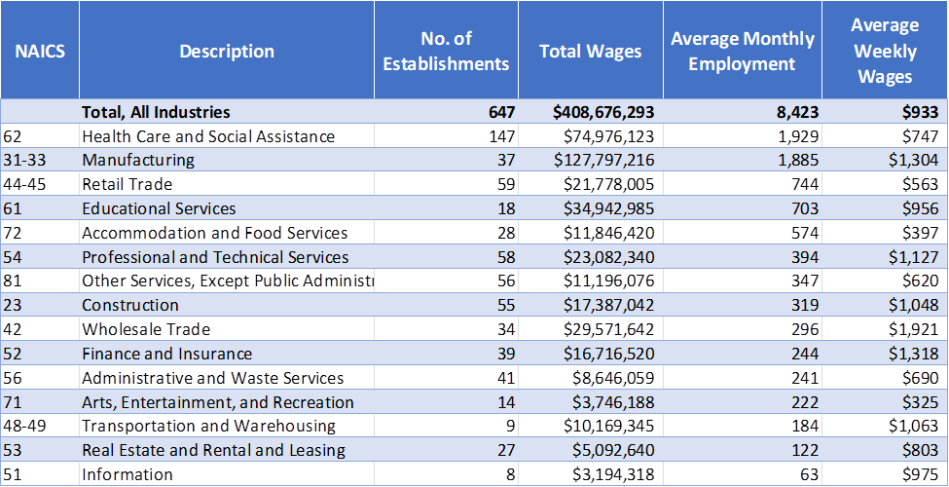
The town’s largest manufacturing employers have a long history in the region and East Longmeadow. Cartamundi is an international brand in game and toy manufacturing based in Belgium, but the company’s East Longmeadow site dates back to when the Milton Bradley Company, which was founded in 1860 in Springfield, relocated to the town. Milton Bradley was the inventor of many popular games and brought the well-known game of Candy Land to market, after a schoolteacher created it for children quarantined with polio in the 1940s. Milton Bradley moved to East Longmeadow in 1965, where it became a division of Hasbro Games in 1984; and in 1998 Hasbro also acquired Monopoly-maker Parker Brothers. Cartamundi bought the facility in 2015 and is now producing an even wider range of cards and games there. Lenox was as founded in 1915 as the American Saw and Manufacturing Company to produce hacksaw blades (also originally in Springfield) and has evolved to become part of the Stanley Black & Decker family of products.
Largest Employers in East Longmeadow:
Company name | Address | Number of employees | NAICS Code | NAICS Category
Cartamundi | Shaker Rd | 900-1,000 | 3399 | Doll, Toy and Game Manufacturing
Lenox | Chestnut St | 640-650 | 3322 | Saw Blade and Hand Tool Manufacturing
Con-Test Analytical Lab | Spruce St | 100-249 | 5413 | Environmental & Industrial Hygiene Analytic Services
East Longmeadow Skilled Nursing | Maple St | 100-249 | 6231 | Skilled Nursing Care Facilities
Meadow Brook School | Parker St | 100-249 | 6111 | Elementary and Secondary Schools
Springfield Division | Benton Dr | 100-249 | 5418 | Advertising and Related Services
US Post Office | Industrial Dr | 100-249 | 4911 | Postal Service
Maybury Material Handling | Denslow Rd | 80+ | 4238 | Industrial Machinery and Equipment Merchant Wholesalers
Big Y | N Main St | 50-99 | 4451 | Grocery Stores
Birchland Park Middle School | Hanward Hill | 50-99 | 6111 | Elementary and Secondary Schools
Capuano Care | Benton Dr # 201 | 50-99 | 6216 | Home Health Care Services
Carr Property Management Inc | Deer Park Dr | 50-99 | 5312 | Offices of Real Estate Agents and Brokers
Davis-Ulmer Sprinkler Co Inc | Shaker Rd | 50-99 | 2382 | Plumbing, Heating and Air Conditioning Contractors

Although East Longmeadow is home to a number of major employers, most East Longmeadow residents don’t work in town. Of 8,200 employed residents, only 14% work in town. Conversely, over 7,000 workers commute into East Longmeadow each day. The closest relationship is with the city of Springfield; about 27% of residents work there, and 24% of local employees live there.
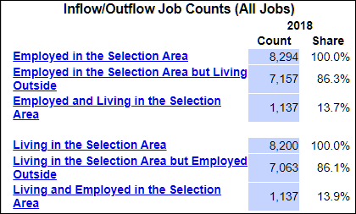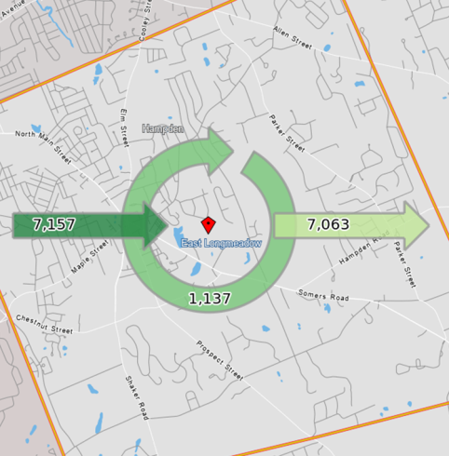
East Longmeadow residents travel to work in a wide number of locations, with around one quarter (26.9%) of residents commuting to Springfield, and nearly 60% to various locations in the Pioneer Valley, northern Connecticut, and even further afield.
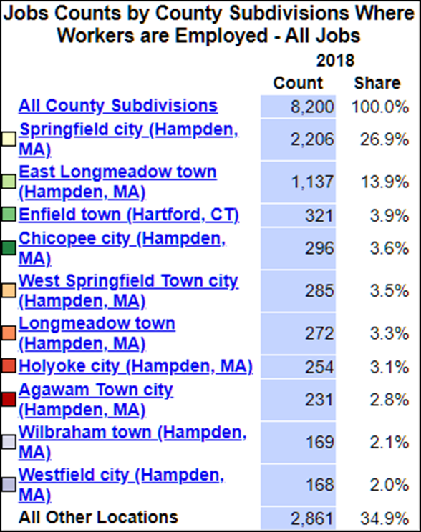
Tax Structure
The majority of East Longmeadow’s tax base is comprised of residential property taxes, with only about 14% coming from commercial and industrial taxes. The average single-family tax bill is comparable to other suburban towns in the region, and has been growing steadily for the past several decades. Commercial and industrial tax rates in town are the same as residential, making them relatively quite low for the region. This has undoubtedly been a draw for the light industrial uses in town and continues to be so for a new wave of medical office buildings.
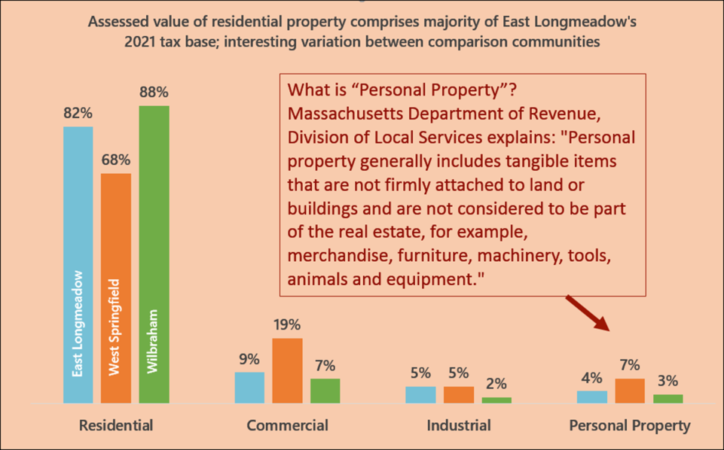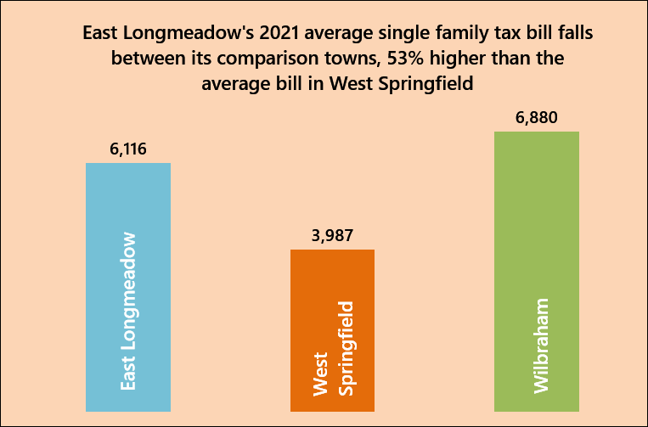

Major Economic Sectors
General Business Environment and Trends
The town is located in the Connecticut River Valley adjacent to the riverfront town of Longmeadow, of which it was once officially part. Along the river also run Interstate 91 and a major passenger and freight rail line. A branch connecting East Hartford and Springfield once ran through East Longmeadow, but this line was abandoned in the 1980s. However, the town retains very easy access to the interstate highway and major urban centers of the Northeast.
In East Longmeadow, approximately 420 acres are in industrial use, with about another 360 in commercial or “mixed use with primarily commercial,” and about 280 acres in agriculture. The industrial uses generally originated in the late 19th and early 20th centuries and are oriented along the former railroad line upon which they depended. Since that time, a formal industrial park zone, the Industrial Garden Park, has been established that encompasses a large area west of Rt. 220 (Shaker Road) in the southwestern quadrant of town. Other industrial zones are still located along the former rail line, near the center of town. Commercial businesses are generally located in a linear fashion along North Main Street (State Route 83) and Shaker Road (State Route 220), as well as in the vicinity of the Town Center at the rotary. Agricultural lands are primarily located in the eastern part of town, particularly in the southeast.
The town has a wide variety of commercial uses, providing goods and services primarily in small, locally-owned shops and businesses. Services available to residents include medical and healthcare providers, law firms, accounting firms, and personal services such as tailoring, bicycle repair, and catering. In recent years, there has been some growth in small retail shops and restaurants, demonstrating that East Longmeadow is a fertile ground for entrepreneurs; there is adequate space available; and there is a sufficient market for a growing number of goods and services. The shops have ranged from specialty foods to clothing boutiques. Home occupations are allowed, as long as there are no clients or customers onsite. Trade occupations were once allowed to operate out of homes, but this is no longer allowed except for some that have been grandfathered in. Therefore a small number of repair shops, carpentry operations, plumbing and heating, and so on are operated as home businesses.
Industrial Economy
Lenox, Cartamundi, and Maybury Material Handling are three of the major companies that anchor successful industrial development in the southern section of town, bordering the state of Connecticut. The Westmass Area Development Corporation has established and continues to operate several industrial park properties in this area, including Deer Park, which has several dozen businesses. The Industrial Garden Park zone is nearly fully built out, partly because as new industrial development slowed down, landowners began building office condominiums on several of the remaining vacant parcels. The industrial areas in the northern parts of town are also built out, and any new uses would have to redevelop existing sites. There are also several vacant former industrial buildings which may be considered for redevelopment as other types of uses.
Health Care Sector
As indicated in the previous section, according to the U.S. Department of Labor there are nearly 150 health care and social assistance establishments in East Longmeadow. The largest of these is the East Longmeadow Skilled Nursing Center, which expanded in 2017 with construction of a new facility at the Longmeadow border. This was part of a major new development completed in 2020, with a new Baystate Health medical office building on the Longmeadow side of the site and significant intersection improvements at the intersection of Maple Street and Dwight, serving traffic coming in and out of East Longmeadow. The Benton Professional Park on Benton Drive is another new health care campus, with two of three planned buildings completed and occupied. Bay Path University’s new Philip H. Ryan Health Science Center on Denslow Road hosts several applied health science programs as well as other programs of study.
General Commercial and Retail Areas
1) East Longmeadow Town Center and Rotary
The East Longmeadow rotary is an intersection of seven streets that functions somewhat like a rotary but allows cross-traffic via lane markings and several stop signs. MassDOT data indicates that there have been an average of 60 crashes per year for the most recent three years of data, with seven (7) injuries per year. There are also a number of local business access driveways located very close to the rotary, creating an additional safety hazard. These are primarily auto-related businesses such as gas stations and repair shops, and there is virtually no pedestrian activity. The Town Hall also fronts on the rotary, but vehicular access is only possible in the rear of the building.
Built as a planned “town center” development the Center Square development is located adjacent to the rotary and anchored by the ca. 1882 Town Hall. It includes the 2004 Town Library (which replaces an older building), the Healthtrax Fitness and Wellness facility, and a number of retail stores, restaurants, and personal services. There is abundant parking, but minimal landscaping, sidewalks, or crosswalks. One small retail site has experienced frequent turnover in the past two decades, while most have been fairly stable.
2) Route 83 (North Main Street) Commercial Corridor
Heritage Park Plaza and the Big Y plaza anchor this section of commercial uses in the town’s northwest corner. Other than the two plazas, the corridor is primarily small commercial uses and is heavily traveled. Since the development of the shopping centers, the Town has put in place zoning bylaws that limit maximum square footage, in order to prevent further “big box” development. Along these lines, the Town has also prohibited drive-through services (except for banks).
3) Shaker Road
Another commercial corridor exists along Shaker Road (Route 220), beginning at the rotary and extending to Chestnut Street. This area is primarily small to medium-sized businesses serving the local community, although there are a few larger employers. A center turning lane in the road helps to keep traffic flowing, but also presents a safety hazard when not used properly.
Agricultural Economy
East Longmeadow was once primarily a farming community, and retains excellent soils. About eight farms are currently operating in town, mostly growing fruits and vegetables. The farms sell direct-to-consumer in some cases, at year-round stores or seasonal shops and farmstands, as well as to local supermarkets and other wholesale buyers. The largest is Meadowbrook Farm on Route 83 with 68 acres. The Apple Place is a destination site with ice cream shop, farm store, garden with sculptures, seasonal apple-picking and more.
Vacant Commercial Property
Several undeveloped and/or vacant commercial parcels remain in East Longmeadow. These properties are in commercially or industrially zoned areas, and some need environmental reclamation. One prime example is the former Carlin Combustion Technology site, just adjacent to the Redstone Rail-Trail on Maple Street. Although it is located within an industrial district based on former rail access, the site is located in the heart of the Town Center.
ISSUES AND OPPORTUNITIES
Town Center
A community’s town center can be an economic driver, with shops and services available to residents, workers and visitors as they conduct their daily business and utilize town buildings and services. In East Longmeadow, the town center is somewhat amorphous, as there is no traditional “Main Street,” and the civic and various commercial areas are separated by the rotary and its spokes. However, functionally, it is a diverse town center with many services and amenities, including the town hall and library, the Center Square development, Leahy Park and its ballfields and picnic area, the historic train station, and the bike path entrance and parking area.
In surveys and focus groups, residents and business owners said that the lack of “walkability” in the town center was a concern. They also felt that the current rotary was a weakness or even a threat. The rotary as it is currently laid out does not provide easy access to local businesses and may deter some drivers. Although many East Longmeadow residents are used to the configuration and comfortable navigating it, it remains a dangerous intersection and is not conducive to business access.
As far as pedestrian access, the crossing at Maple Street has recently been improved to facilitate pedestrian and bicycle access to the rail trail. But access to and between retail areas is more difficult; even in Center Square, there are not safe and clear pedestrian routes between the various complexes of buildings.
Pedestrian and landscaping improvements to the town center would greatly enhance its attractiveness and the flow of customers to local businesses. A major rotary improvement would further increase access, reduce accidents, and encourage visitors.
Commercial Corridors
Vehicular and pedestrian access is also a concern on the major commercial corridors along North Main Street and Shaker Road. On Shaker Road, the center turning lane is misunderstood by many drivers, resulting in accidents. Along North Main Street, many businesses have multiple entry and exit points and/or parking lots with no curb or separation from the street. Numerous side streets adjacent to these businesses results in high volumes of traffic entering, exiting and turning at multiple intersections, creating a safety hazard. Although sidewalks exist in some places, they are not maintained and there are large gaps.
Residents have identified the lack of drive-through restaurants and pharmacies as both a positive and a negative. It has also been a limitation for some businesses during the pandemic. This type of development could be accommodated if done very carefully and in limited locations. Excellent access, sufficient landscaping, and attractive buildings and signage could all make drive-through businesses feasible and appealing, as well as safe. These elements of landscaping and façade improvements would also be helpful for existing businesses along the commercial corridors.
Small Business and Entrepreneurship
Focus group participants talked about Issues for small businesses in working with town departments. For the most part, it is a positive experience, and in some cases much better than in other locales. However, concerns that came up included the amount of required paperwork, permitting fees, and overall communication. The Town should carefully assess the small business experience in working with local departments. One strategy to pursue would be a regular system of regular outreach to businesses, particularly small, locally-owned businesses, to see how they are doing. The town could also encourage businesses to create their own business association.
Agriculture
Residents named agricultural uses as a strength of the community and an opportunity, while the potential of losing farmland is considered a threat. Residents noted a lack of farmers’ markets and winter venues, as well. Two farms were identified by name, Meadowbrook and The Apple Place, and both are draws for local shoppers and CSA members. Most of the farmland in East Longmeadow is held by only two owners, which makes the land particularly vulnerable. However, one is very committed to farming and has already thought about succession planning. Farming in East Longmeadow will need significant support if it is to continue. The Town can help farmers find new ways to market their goods and preserve their land, and a Buy Local campaign that addresses all local goods but particularly farm products would be one option to pursue.
Future Development
The town’s significant supply of developable land near a major metropolitan area and interstate highway has helped East Longmeadow become not only a bedroom community, but an employment center for larger businesses that require greater land areas and fairly close highway access. In the past, this has resulted in a significant manufacturing presence; however, manufacturing is no longer growing in the region, and there is currently a trend toward development of medical office buildings. These health care-related businesses provide a range of employment options and a strong tax base, as well as convenient medical services for residents. In fact, residents cited this trend as an opportunity in the community outreach sessions.
Another strong trend is that toward home-based businesses, which will continue to grow in the next decade. The town may wish to consider allowing greater flexibility for home occupations in certain areas. Home occupations and home-based businesses allow for the formation of small businesses that are still unable to support a traditional business overhead. Many entrepreneurs launch their startups “under the radar,” out of the basement, garage, or even kitchen. When these businesses grow beyond this point and can support an increase in production, the startup moves into a traditional business space out of the home and may create jobs and/or contribute to the tax base. Entrepreneurship and home occupations are a key part of small business startups in the new economy and a means of fostering innovation.
Residents were also concerned about several vacant industrial buildings, specifically naming the Package Machinery and Carlin Combustion sites. The Carlin property has environmental contamination issues that need to be addressed, and without town ownership of the property, under current zoning regulations the property will likely remain vacant for some time. Some of the other industrially-zoned areas in the Town Center might be re-evaluated for mixed uses, including apartments, retail, and office. If this occurs, it would be highly desirable to require significant green space and landscaping, particularly if Leahy Field were to be redeveloped. The new Mixed Use Village District Bylaw will be an important tool to guide future development. It could be extremely useful as an overlay zone for the Town Center, as well as in other locations.
COVID-19 Vacancies and Closures
The pandemic has had an impact on local business over the past year (March 2020 to the present). The town has already taken steps to assist these businesses and will continue to find means to support them through the re-opening phase. Fortunately, East Longmeadow is participating in the Commonwealth’s new Local Rapid Recovery Program, intended to help businesses recover from the COVID-19 pandemic closures and restrictions. The specific area targeted under this program is the North Main Street business corridor, from Harkness Ave to the Springfield border. Over the course of 2021, five or more detailed, ready-to-go projects will be developed that can be implemented with grant funding. It is hoped and anticipated that current state funding programs (such as Shared Streets, Mass. Downtown Initiative, and Underutilized Properties Program) as well as some new funding sources from the American Rescue Plan will be available for implementation.
GOALS AND RECOMMENDATIONS
Goal 1. Enhance the Town Center as a Livable, Workable, and Walkable Community Center.
- Consider adopting a Town Center Overlay District using the new Mixed Use Village District bylaw to create incentives for desired town center uses such as office, commercial, retail, residential and civic uses.

Primary: Planning Board
Others: PVPC
Priority/
Timeframe: Short-term
Resources:

- Pursue rotary improvements to improve safe access to local businesses.

Primary: East Longmeadow DPW
Others: PVPC
Priority/
Timeframe; Ongoing
Resources:

- Improve sidewalks and crosswalks throughout the town center and along the streets leading to the rotary.

Primary: East Longmeadow DPW
Others: MassDOT
Priority/
Timeframe: Ongoing
Resource: Sidewalk Master Plan

Goal 2. Improve commercial corridor access and appearance.
- Study alternatives to the center-turn lane on Shaker Road.

Primary: East Longmeadow DPW
Others: MassDOT
Priority/
Timeframe: 3 – 10 years
Resource:

- Improve the streetscape within the right-of-way along North Main Street to allow safer vehicular and pedestrian access and improve corridor appearance.

Primary: Town of East Longmeadow
Others: MassDOT
Priority/
Timeframe: Ongoing
Resources: Sidewalk Master Plan, Complete Streets Prioritization Plan Project List

Goal 3. Create a welcoming environment for small businesses
- Conduct outreach to existing businesses to make sure they are thriving.

Primary: Town of East Longmeadow
Others: East of the River Chamber
Priority/
Timeframe: Ongoing
Resource:

- Establish a working partnership with East of the River Five Towns Chamber to assist aspiring entrepreneurs and existing small businesses.

Primary: Town of East Longmeadow
Others: East of the River Chamber
Priority/
Timeframe: Ongoing
Resources:

- Assess town permitting procedures to improve small business experience.

Primary: Town of East Longmeadow
Others: PVPC
Priority/
Timeframe: Ongoing
Resources:

Goal 4. Support and promote agricultural businesses
- Work with local farmers to establish locations for farmers’ markets, including a winter venue and conduct a “Buy Local” campaign.

Primary: Town of East Longmeadow
Others: East of the River Chamber
Priority/
Timeframe: Ongoing
Resource:

- Work with farmers to pursue land preservation strategies and succession planning as appropriate.

Primary: Town of East Longmeadow
Others: East of the River Chamber
Priority/
Timeframe: Ongoing
Resources:

Goal 5. Pursue new business development that is compatible with East Longmeadow’s character.
- Seek developers to revitalize vacant and blighted properties.

Primary: Town of East Longmeadow
Others:
Priority/
Timeframe: Ongoing
Resource:

- Create provisions that support and encourage medical office buildings and appropriate home occupations.

Primary: Town of East Longmeadow
Others: PVPC
Priority/
Timeframe: Ongoing
Resources:

OPEN SPACE AND NATURAL RESOURCES

The overall landscape of East Longmeadow is hilly due to glacial action, with rich wetlands concentrated in the valleys between the hills. The land now called East Longmeadow, Massachusetts, was Nipmuc and Pocumtuc Territory, where economic and subsistence cycles consisted of hunting, gathering, planting and harvesting in their seasons, in the various villages throughout the area. As East Longmeadow was first settled in 1720, the story of the town is one of steady progression. During the colonial period, the common pasturelands that made up the town were slowly developed into small farms until red and brown sandstone was discovered underneath the soils. The sandstone later became widely used building material in monuments and building across the United States, including the Smithsonian Institution in Washington, D.C. Now primarily a suburban community for people working in the larger Springfield and within seven miles of Interstate 91, East Longmeadow continues to offer small-town amenities and charm maintaining a mix of rural, suburban, industrial and urban elements forming a vibrant, evolving community.

INVENTORY & EXISTING CONDITIONS

Geology and Topography

The soils and topography of East Longmeadow are result of the great Wisconsin Glacier that covered all of New England during the Pleistocene Period. As the glacier advanced through the Connecticut River Valley, drumlins formed – McCarthy Hill located at the curve on Mapleshade Avenue and where Oak Bluff Circle and Breezy Knoll Road meet. As the glacier retreated, left behind was a general layer of unstratified glacial till and lingered in the center of the Connecticut River Valley. The landscape opens up with view to the south and eastward towards the Minnechaug and Wilbraham Mountains.

Agricultural Soils

In addition to supporting and constraining habitat and human development, soil characteristics also influence agricultural productivity. Natural Resource Conservation Service (NRCS) soil data contains a classification system for evaluating agricultural soil productivity. This system identifies soils as Prime farmland soils, Farmland of Statewide Importance and Farmland of Unique Importance. Prime Farmland is defined by the NRCS as “land that has the best combination of physical and chemical characteristics for economically producing sustained high yields of food, feed, forage, fiber, and oilseed crops, when treated and managed according to acceptable farming methods.” Farmland of Unique Importance are defined as “land other than prime farmland or farmland of statewide importance that might be used for the production of specific high value food and fiber crops.”

The soils that make up East Longmeadow are Walpole – Scarboro – Wilbraham, Urban Land, Sandy and Gravelly – Windsor – Agawam, and Cheshire – Urban Land, Loamy. The Cheshire – Urban Land, Loamy soil area occupies about 47 percent of the town.

Map 6-1 shows areas of prime farmland soils in East Longmeadow. Areas of Prime Farmland Soils and Farmland Soils of Unique Importance are scattered throughout town.

Map 6-1 - Prime Farmland Soils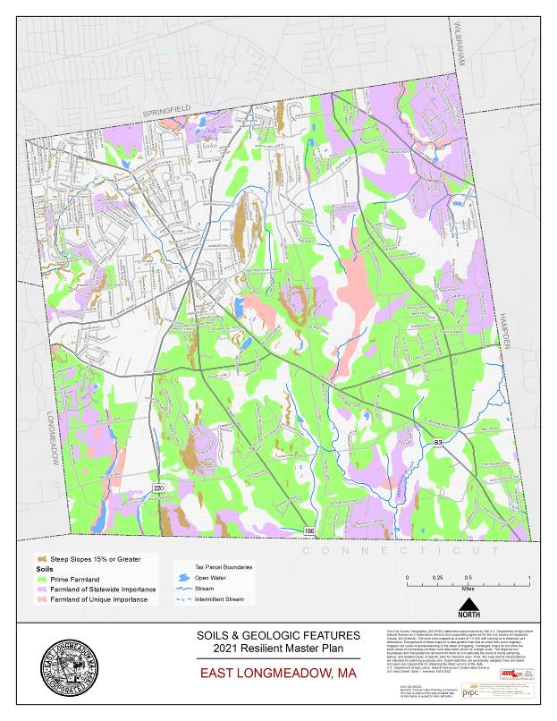

Wetland and Water Resources

Development in East Longmeadow has historically been dictated by its terrain and landscape, as its natural resources led to its development as an agricultural village, reliant on farming and its quarries.

The town is intersected by many streams which flow into the Connecticut River. Making up thirteen miles of streams, there are three large and two small watersheds in East Longmeadow: Pecousic, Watchaug, Freshwater and Jawbuck Brooks, and the Mill River and its tributary Schneelock Brook. The majority of these waters are on private land.

There are approximately 607 acres of wetlands in East Longmeadow. Wetland habitats in town occur primarily along the streams and tributaries as well as in lands adjacent to the major ponds in East Longmeadow. The wetlands, streams, rivers and lakes provide critical wildlife habitat and recreational opportunities. Wetland habitats in town occur primarily along the streams and rivers as well as in lands adjacent to major ponds.

The Massachusetts Wetlands Protection Act (MGL 131, Section 40) protects wetlands, water sources, and adjoining land areas by preventing or minimizing impacts to these resources.
Anyone proposing to remove, fill, dredge, build upon, degrade, discharge into, or otherwise alter resources or areas within the areas listed below must submit an application to the Conservation Commission for review:

- 200 feet of any perennial stream or river
- 100 feet from any freshwater wetland, wet meadow, marsh, vernal pool, reservoir, pond of any size, or lands subject to flooding or inundation by ground or surface water
- 100-year floodplains

The Wetlands Protection Act does not permit development or disturbance within 25 feet of any of the above resources. Isolated wetlands that have not been delineated by the State are not protected unless they are certified vernal pools.

Flood plains and flood hazard areas are designated areas next to rivers, streams and lakes that are likely to flood during large storms. These areas should be left undeveloped so as to prevent damage to structures and other properties. Some flood plains are productive agricultural land, having accumulated sediment during flood conditions. This is demonstrated by some parts of towns where there is land in the flood zone area and also is designated as Farmland Soil of Unique Importance.

Over 86 percent of respondents to the Master Plan Community Survey found very or somewhat important that the town should be protecting the natural environment. This could mean building further from waterways, using Low Impact Development (LID) to allow natural filtration of stormwater, and planning for natural disasters.

Map 6-2 Water Resources
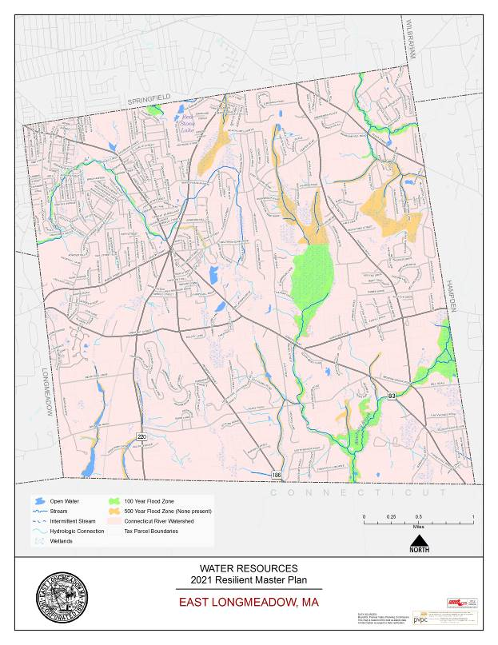

Critical Habitat Areas

The State’s Natural Heritage and Endangered Species Program (NHESP) is responsible for the conservation and protection of rare and endangered plant and wildlife species and the natural communities that make up their habitats. Map 6-3 shows areas in East Longmeadow that are part of this inventory, as well as locations of certified vernal pools that are protected through the Wetlands Act, and locations of potential vernal pools that have not yet been verified. If a potential vernal is checked and meets the criteria (https://www.mass.gov/service-details/vernal-pool-certification), it can be certified in accordance with the Wetlands Protection Act.

The NHESP has mapped Core Habitat and Critical Natural Landscapes throughout the Commonwealth that are significant for conserving biological diversity through the BioMap2, which classifies landscapes as Core Habitat (CH) or Critical Natural Landscape (CNL) as seen in Map 6-3.

East Longmeadow contains 599 acres of Core Habitats, with no areas of Critical Natural Landscape. Core Habitats are mostly located on the eastern side of the town: Core 942, Core 920, Core 1013, Core 1264 and Core 994. These landscapes, taken on the whole, provide vital habitat for species of conservation concern, that are threatened or of special concern, such as the Blue-spotted Salamander, Eastern Spadefoot, Four-toed Salamander, Northern Black Racer, Eastern Worm Snake, Climbing Fern, and the Lily-leaf Twayblade (BioMap2, 2012). For instance, Blue-spotted Salamander of species of special concern and is found in three of the Core Habitats crossing into Springfield, Wilbraham and Hampden. These salamanders thrive in mature deciduous and mixed deciduous-coniferous forests and woodland, using vernal pools, swamps, and marshes for breeding.

Map 6-3 Natural Heritage Inventory
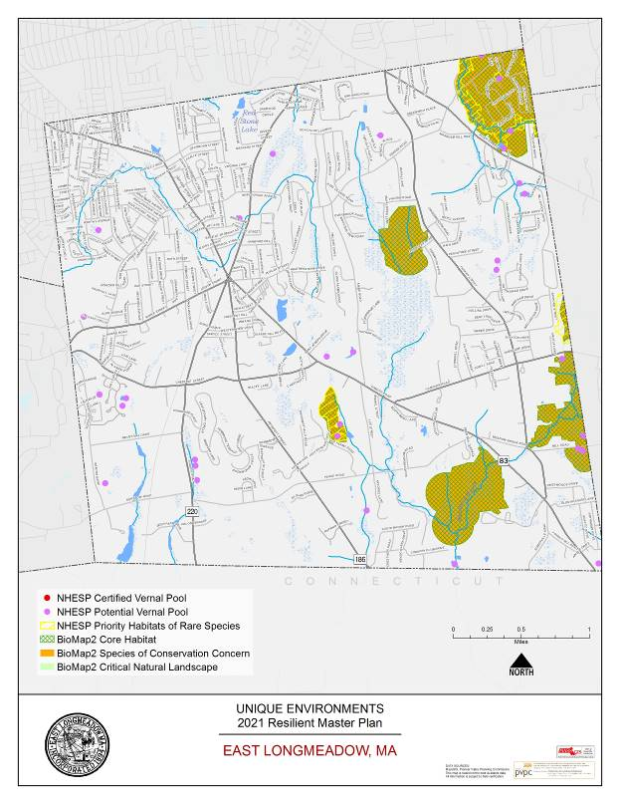

Open Space

A portion of the town of East Longmeadow is protected from future development, however, development can lead to fragmentation of woodlands and farmlands which jeopardize the benefits of the small-town character the town seeks to maintain. There are approximately 1,500 acres of land, or 18 percent of total land which is afforded some level of protection.

Figure 6-4 Open Space Ownership in East Longmeadow

Classification | Acres | Percent of Open Space in Town (%)
Town Owned – School/Recreation | 247 | 2.97
Town Owned – Conservation | 297 | 3.57
Town Owned – Other | 24 | 0.03
Significant Agricultural Lands | 408 | 4.90
Private – Recreation | 256 | 3.08
Private – Other | 267 | 3.21
Totals | 1,499 | 18.02

Figure 6-5 Significant Open Space and Recreational Land in East Longmeadow
Name | Acres | Owner
Watchaug Meadows | 281.8 | Town of East Longmeadow Conservation Commission
Brown/Koch Farm | 70 | Town of East Longmeadow Conservation Commission
Heritage Park | 46 | Town of East Longmeadow
Mary Swords Conservation Area | 40 | Town of East Longmeadow Conservation Commission
Jarvis Nature Sanctuary | 35.9 | Town of East Longmeadow Conservation Commission

Watchaug Meadows
Watchaug Meadows, extends south of Porter Road between Parker Street and Kibbe Road and south to Hampden Road. This area contains small water-filled quarries and drains north to the Mill River and South to the Scantic River, via Watchaug Brook. This conservation area is used for nature studies, hiking, and cross-country skiing. Brown Farm and the Koch property are located on Hampden Road.

Brown Farm and Koch Properties
Belonging to the Watchaug Meadows Conservation Area, the Brown Farm and Koch Properties has been identified as an area of opportunity for various components supporting the residents of East Longmeadow, according to a Conditions Assessment completed in 2013. There are current trails that have been identified and the Boy Scouts have installed exercise equipment and benches in addition to the mapping endeavor.

Mary Swords Conservation Area
This area is hardwood swamp with small but scenic quarries, open to the public. It is located on the low-lying lands east of Elm Street and north of Mapleshade Road.

Jarvis Nature Sanctuary
Jarvis Nature Sanctuary is a beautiful area for passive recreation consisting of 20 acres of brushy field with the other, approximately 16 acres in mixed hardwood and evergreen forest.

Many other conservation areas that provide limited to public access can be found in the town’s Open Space and Recreation Plan (2020).

Map 6-4 – Protected & Recreational Open Space
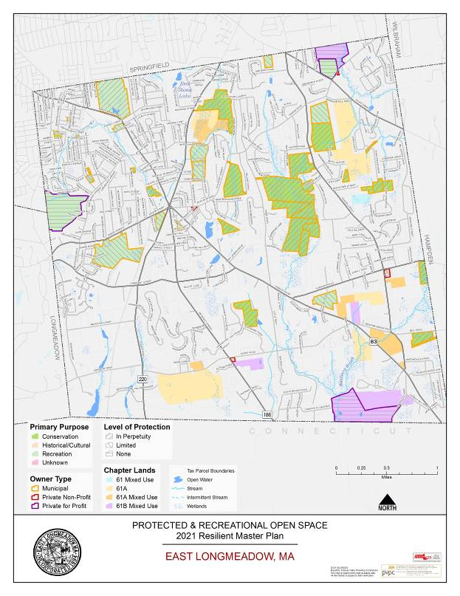

Lands in Current Use

The Protected Recreational and Open Space (Map 6-4) shows private landowner parcels that have been enrolled in the Massachusetts Current Use program. Also known as Chapter 61 lands, they are taxed according to their use. Chapter 61 lands are managed for harvesting of wood, Chapter 61A lands for agriculture, and Chapter 61B for recreational use. Most of the land that is managed for recreational purposes allows access to trails and ponds. The town has identified that understand and consider forest management to maintain a healthy forest and possibly provide revenue to the town, in addition to actively managing to provide for maintenance to the town’s trails.

Recreational Resources

In addition to the various passive recreation opportunities and the trails, the Town provides for recreation throughout town, both on private and public property, and opportunities for golfing in the area.

Heritage Park

Heritage Park is located in the northwest section of East Longmeadow on Main Street. The park has a recreational 4-acre warm water pond that can be used for ice-skating and is occasionally stocked for fishing. Additionally, there are two baseball fields, one soccer field, playground equipment, a pavilion and a dog park.

Pine Knoll Recreation Area

Pine Knoll, a 14 acre park that traverses Springfield and East Longmeadow, but that has over 9 acres in East Longmeadow that provides for a swimming pool, basketball court, badminton court, tennis court, sand volleyball court, and 3 modified soccer fields.

Center Field

Center Field, comprising 5.8 acres bounded by Maple Street, Shaker Road and Maple Court, has two baseball fields, 1 softball field and a small pond.

Multi-purpose school fields and recreation opportunities

The town’s school department, with assistance by the Department of Public Works to manage and assist with maintaining play fields and facilities, offers opportunities for the schools and their playfields to provide for the town’s residents: East Longmeadow High School, Birchland Park Middle School, Mapleshade Elementary School, Mountain View Elementary School, and Meadowbrook Elementary School.

Elmcrest Country Club

Located off Somersville Road, Elmcrest Country Club boasts an 18-hole golf course that opened in 1965.

Franconia Golf Course

Franconia Golf Course is an 18-hole golf course owned by the City of Springfield that is open to the public. The course opened in 1929.

Fenway Golf

Fenway Golf, located on Allen Street, has multiple golf activity opportunities through mini-golf, pitch and putt, driving range and batting cages. Pine Knoll is Fenway Golf’s 18-hole Par 3 Golf Course.

The majority of respondents to the East Longmeadow Master Plan Community Survey (80%) responded that it was somewhat or very important to increase recreation opportunity, playing fields and trails. Free response survey answers included improving parks, like Heritage, in addition to, field quality and recreation centers. The Parkland Acquisitions and Renovations for Communities (PARC) Grant Program can assist the town with acquiring and developing land for park an outdoor recreation purposes. These grants can be used by East Longmeadow to acquire parkland, build a new park, or to renovate an existing park.

As mentioned previously, preserving open space like farmland and forests is very important to the town (64.8%). Depending on the priorities identified by the Community Preservation Committee, Community Preservation Act funds can be utilized to acquire, create, and preserve open space, in addition to rehabilitating or restoring open space that has been acquire or created using those CPA funds – like Brown Farm and the Koch properties in Watchaug Meadows.

ISSUES & OPPORTUNITIES

Although some of East Longmeadow’s lands are protected via state conservation programs, the land that is not conserved may be vulnerable to impacts from human use. There is a sentiment to protect the farmlands, open spaces, scenic areas to maintain the small-town character that the town embraces. In addition to the support for the town’s open spaces and passive recreation opportunities, the town finds itself as a town wanting to expand its recreational options, as there has been many suggestions to support the youth and sports teams.

These sentiments suggests that planning for the protection of natural resources and open space, along with expanding and maintaining the recreation opportunities, should be major priorities for the Town.

Expanding and Improving Recreational Opportunities

The growth of youth sports has increased usage of existing playing fields throughout town during the spring, summer and fall seasons, resulting in general deterioration of playing surfaces and erosion. Other than restricting access and cutting programming, the options are creating a comprehensive field maintenance plan or building more fields, so some can be allowed to rest. The pandemic has generally allowed the fields to rest due to an abundance of caution of virus spread and social distancing and what did or did not happen in contact sports during this time. However, as the town finds itself recovering in more ways than one, youth sports will be revived and the town will need to address some of the issues due to overuse of playing fields. Efforts have been made in the last five years to improve play fields conditions. Due to soil compaction, all athletic play fields should be aerated a minimum of twice a year, and the DPW provides that service to provide a loosening of those soils. The DPW recently acquired a new tractor to support these efforts. The high school has a synthetic turf field for field hockey, football, lacrosse and soccer.

Fragmented Habitats

East Longmeadow’s development in certain parts of town has fragmented woodlands and farmlands and many of the natural resource areas that have been established in town. These changes can compromise the resource areas and change wildlife habitats, along with undermining the beauty of untouched landscape. Protecting the surrounding and the benefit this provides ensures an environmentally and economically sound future for the town. Fragmenting these large resource areas divides populations of native plans and animals and makes each part more vulnerable to the short-term impacts of floods, drought and disease, in addition to climate change which is absolute. Land left in the natural state for conservation and drainage reasons can also provide opportunities for appropriate recreational activities, including hiking and cross-country skiing.

Additionally, as farmland and important agricultural lands get divvied up and affected by development, it can become harder to farm efficiently. A recent approval for a new subdivision brings this issue to the forefront.

Connect Wildlife and Trail Corridors

Trails are available for public use on public and some private lands throughout East Longmeadow. A system of connected trails and corridors for wildlife habitat migration would add value to these resources. Continued maintenance of the town’s Open Space and Recreation Plan would provide detailed information on the habitat and natural resource areas in town and would result in a plan for improvements or protections to these resources going forward. The town completed an update in 2020, and will not be due for an update until 2027. A strategy of connecting parcels into larger blocks and corridors would deter fragmentation of landscapes and habitats, while also opening opportunities for continuous trails crossing East Longmeadow and linking up with trails in neighboring towns, as Enfield, Connecticut, has reached out to the town to explore this trail connection.

Community Resilience

Protecting the natural resources in East Longmeadow contributes to the Town’s resiliency in a number of ways:

- Minimizing disruption to natural ecosystems whenever possible helps to protect wildlife habitat, and promotes residents’ wellness by increasing opportunities to experience nature. Undeveloped land can provide storage for floodwaters.
- Evaluating the potential impacts of climate change can help the Town better plan and adapt to changing climactic conditions and their effects on other natural and man-made systems. This evaluation and planning could lead to specific projects that Town may wish to undertake to adapt systems to future changes in conditions.
- Increasing awareness around best practices for reducing stormwater runoff and pollution will help to protect water quality.
- Supporting viable wildlife and native plant populations helps maintain biodiversity. When protected land has covers variable terrain and contains multiple microclimates, it provides microhabitats which can help maintain species as the climate changes. Greenbelts and wildlife corridors facilitate migration.

Open Space and Natural Resources Goals & Recommendations

Goal 1. Maintain the Small Town Character of East Longmeadow as the Town Continues to Develop through Stewardship of Natural Resources, Open Spaces, Forests, Working Farms and Water Bodies.

- Maintain seven-year updates to the Open Space and Recreation Plan that considers priorities for acquisition or protection of open space. This plan should include the following:
  - A plan for connecting trails and greenways to provide corridors for recreation and wildlife
  - A multi-use trail system that ties into existing trails, parks, and cultural destinations and designates trails for motorized and passive recreation according to the proximity of critical habitat areas.
  - A plan for town-owned recreational land and the stewardship and maintenance of these properties.

Primary: Conservation Commission
Others: Planning Board
Priority/Timeframe: Ongoing
Resources: Volunteer time, Consultant

- Review subdivision regulations and evaluate addition of performance standards for sensitive natural areas.

Primary: Planning Board
Others: Conservation Commission, Building Department, Highway Department
Priority/Timeframe:
Resources:

- Require adequate vegetated buffers next to wetlands, streams and rivers to filter stormwater runoff and to allow room for river migration and expansion during heavy storms.

Primary: Conservation Commission
Others: Planning Board, Building Department
Priority/Timeframe:
Resources:

Goal 2. Improve the Viability of the Farming Community in East Longmeadow.

- Encourage agriculture through an Agricultural Commission. With a goal of promoting the agricultural economy in East Longmeadow, the town should work to create an Agricultural Commission. This Commission is appointed that encourage the pursuit of agriculture and help sustain the community’s farm businesses and farmlands.

Primary: Town Council
Others: Conservation Commission
Priority/Timeframe:
Resources:

- Explore a Right-to-Farm Bylaw. This General By-law encourages the pursuit of agriculture, promotes agriculture- based economic opportunities, and protects farmlands within the Town of East Longmeadow by allowing agricultural uses and related activities to function with minimal conflict with abutters and Town agencies.

Primary: Agricultural Commission
Others: Planning Board, Planning Department, Conservation Commission
Priority/Timeframe:
Resources:

- Employ Town policies to improve economic viability of the farm community. A variety of policies can be adopted to improve the economic viability of the farm community, including: streamlining permit requirements for accessory farm businesses or small-scale farm related commercial uses on agricultural lands enhancing farmers’ profits and preserve the land for future agriculture activity.

Primary: Agricultural Commission
Others: Planning Board, Planning Department, Conservation Commission
Priority/Timeframe:
Resources:

Goal 3. Provide a Well-maintained, Accessible Recreational Facilities to All

- Produce comprehensive maps and wayfinding of town open spaces and recreation facilities and resources identifying important features and amenities.

Primary: Recreation Department, Recreation Committee
Others: Planning Department, Department of Public Works
Priority/Timeframe:
Resources:

- Implement management strategies for upkeep, maintenance and enhanced access of/to all recreational resources, like Heritage Park. The school department and recreation department have prepared plans for the dual use facilities.

Primary: Recreation Department, Recreation Committee
Others: Conservation Commission
Priority/Timeframe: Ongoing
Resources: Volunteer time, staff time

- Improve access to existing recreational facilities and conservation trails. The town should work towards ensuring that all of its parks and recreation facilities are in compliance with Americans with Disabilities Act (ADA) accessibility requirements. Additionally, providing for senior accessibility to recreational space can be explored here. Heritage Park, can be an opportunity for increased senior programming due to the proximity to the senior center.

Primary: Recreation Department, Recreation Committee, Council on Aging
Others: Planning Board, Conservation Commission
Priority/Timeframe: Ongoing
Resources: Volunteer time, staff time

HISTORIC AND CULTURAL RESOURCES

As expressed on the Town website, East Longmeadow’s history was “one of steady progression.” Although incorporation as a Town didn’t occur until 1894, early land use included the presence of Native Americans and, by the 1740s, a growing population of Colonists who lived and worked in the area primarily utilizing the land for farming. The discovery of an abundance of sandstone, the development of the railroad system in the 1800s, and the introduction of streetcar lines by the early 1900s provided an avenue of rapid growth and attracted an influx of immigrants who “enriched and transformed the Town’s social and cultural framework.” These assets and the resulting population and economic growth also allowed East Longmeadow to gain independence as its own Town. Quarry use was discontinued by 1971, but the Town maintained agricultural and residential roots while continuing to attract industrial and commercial development. A variety of built historic resources exist today from pre-Colonial occupation through the mid-1900s, as well as early rural, agricultural, and industrial landscapes, many of which remain in use and valued by residents.

As of 2018, East Longmeadow had a population of more than 16,000 residents and today continues to pursue a balance between evolving as a modern Town while still working to protect what residents enjoy and value most. Representatives from the Town government and local organizations, with active and engaged volunteers, are interested in continuing to support the preservation of local historic and cultural resources while also utilizing these assets to inform, inspire, and engage the community.

Historic and cultural offerings include the collection and programs available through the Town-owned Historical Museum House, community events like the Independence Day Parade and Holiday Tree Lighting, potential revitalization and engagement related to the adaptive reuse of the East Longmeadow Train Depot, highly valued resources like local agricultural landscapes and products, the Redstone Rail Trail and Heritage Park, symbolic public art like the Quarryman statue, and work by the Town to define welcoming and accessible public gathering spaces in underutilized locations. Although residents primarily work in other nearby communities, there remains a sense of pride of place and an interest in having reminders of the Town’s roots and local cultural programming available for when they are at home in East Longmeadow.

While this East Longmeadow Resilient Master Plan discusses the connection between historic and cultural elements and a town’s strength, success, and resiliency, it is not unusual that previous Town planning initiatives didn’t include or only minimally referenced these resources. Past strategies and programs like Urban Renewal, mentioned as a development tool in the 1960 Master Plan for the central section of East Longmeadow, resulted in the major loss of historic built resources, including those constructed with stone from the local quarries. The outreach process for this current plan confirmed that the Town’s agricultural, railroad, and stone cutting origins and the stories of those who developed and lived in East Longmeadow still resonate with residents and are perceived as significant and relevant to planning and controlled future growth. There are opportunities, illuminated through this process, to determine best practices for documenting and strengthening protection of these resources, in addition to providing collaborative cultural programming for all residents to access and enjoy, and planning for future resiliency.

The strengths and opportunities related to East Longmeadow’s preservation and cultural resource offerings include existing inventoried properties in the Massachusetts Historical Commission (MHC) Massachusetts Cultural Resource Information System (MACRIS) database, a strong knowledge of local history by residents involved with the planning process and those who are part of the East Longmeadow Historical Commission, and a valuable collection of items and archives, primarily located in the John Peaseley House 87 Maple Street (1852, ELG.5), now known as the Historical Museum House, and the East Longmeadow Public Library Local History Room. Community Preservation Act (CPA) funding is another strong resource for accomplishing local projects as historic preservation is one of the required funding categories and many CPA communities sponsor projects that incorporate preservation, open space, and recreation. Related challenges are that the MACRIS inventory for the Town is generally outdated, doesn’t meet current documentation standards, and is missing some significant local resources. This can result in a lack of protections, evident as many potential assets have already been altered, are deteriorated, or have been lost to demolition. A lack of documentation also limits opportunities to promote awareness and potentially seek funding for preservation. Related to the Town’s CPA program, the East Longmeadow Community Preservation Committee (CPC) would also benefit from further development of a formal Community Preservation Plan to prioritize funding and promote outreach to help maximize the impact of this program. Additionally, clearly identifying challenges with accessibility to buildings, sites, and programming as well as developing vulnerability and emergency planning for built resources and collections are also presented as opportunities in this Resilient Master Plan.

OVERVIEW
Known as the “Inward Commons,” East Longmeadow was included in the 1600s Springfield land grant and borders with Connecticut were defined in a 1642 survey. By 1713, this area was established as part of Longmeadow Parish with a Colonial population developing here around 1740. In 1865 East Longmeadow was designated as a separate Parish within Longmeadow and was formally incorporated as the Town of East Longmeadow, effective July 1, 1894. Due to its origins as a part of Springfield and Longmeadow and a lack of Colonial period civic, industrial, and commercial operations, there is minimal formal documentation of the origins of East Longmeadow’s land use.

The land within current Town borders was early utilized as an intermediate corridor between the central uplands and the Connecticut River and potentially included Native American sites along the upper Pecousic Brook around Indian Spring. According to a 1982 MHC Reconnaissance Survey of East Longmeadow, “the presence of a considerable amount of agricultural land and a network of suspected Native trails suggests there was probably some Native period settlement.” The primary area of interest was identified as “the land surrounding the town center and bordered by Westwood and Mapleshade Avenues to the north and west and Chestnut Street to the south” as there are suspected early transportation routes in those areas. The current amount of rural, agricultural, and larger parcels of industrial land presents a potential of remaining Native archaeological sites in East Longmeadow. Native American artifacts from the area are on display at the Historical Museum House, and available for viewing when this facility is open and staffed.

Slavery, legal in Massachusetts until 1780, brought enslaved and later freed African Americans to Western Massachusetts. There are records of Longmeadow residents owning slaves, to include Rev. Stephen Williams of Springfield (Longmeadow), who discussed the sale of one of his slaves in a diary entry. Late 1700s census data also notes the presence of African American laborers in the area. The Georgian style Elijah Burt House 201 Chestnut Street (ca. 1728, ELG.14, NR listed 1976), recognized as the Town’s oldest building, relates to an early stagecoach route but also to the region’s Underground Railroad network. By the 1800s, many African Americans within Hampden County were either employed as day laborers or working as independent yeoman farmers with possible settlement in East Longmeadow.

By the late 1700s, East Longmeadow’s center began to form with radial highways from the Meeting House. This infamous rotary was later highlighted by Ripley’s Believe It or Not for being a seven street intersection with no traffic lights and remains in this unique form today. Also around this time period, an early Baptist Settlement, later known as the “Baptist District,” developed due to a growing diversification of religious beliefs and is identified in MACRIS as Baptist Village (late 1700s, ELG.A). This is currently the Town’s only inventoried AREA and today has a probable loss of context due to demolitions and alterations over time. The prominent First Congregational Church of East Longmeadow 7 Somers Road (1828, 1859; ELG.3, NR listed 1978), is a nineteenth century ecclesiastical building which remains today as a focal point near the Town Center. The Romanesque Revival Style East Longmeadow Town Hall and Library 60 Center Square (1882, 1957, 1966; ELG.1) is a public building constructed with local stone donated from the Norcross Brownstone Company. It was planned to function as a combination schoolhouse and shared town hall prior to East Longmeadow’s separation from Longmeadow and continues to operate as the Town’s civic center. Today the East Longmeadow Public Library, established by 1897, is also located at 60 Center Square in a building completed in 1957 with later additions and hosts the Local History Room on the second floor with limited public access.

In addition to agricultural operations, “East Longmeadow owes its development principally to its valuable quarries of red sandstone, which have given to the town a wide fame.” These sandstone outcroppings, along with a railroad connection to Springfield by the late 1800s, expedited the Town’s independence from Longmeadow. East Longmeadow sandstone was used in the construction of the Springfield Armory Buildings and is the foundation under the Armory perimeter fence, now part of the Springfield Armory National Historic Site. In the early 1900s, these quarries were nationally recognized for contributing to the construction of fine residences and significant public buildings across the country, to include Boston’s Trinity Church, buildings at Harvard, Princeton, and Yale Universities, the Waldorf Astoria hotel in New York City, and the Smithsonian. During the heyday of operations, the Town’s most prominent quarries were the Taylor, Salisbury, McGregory, Billings, Kibbe, Pine Kibbe, Worcester, and Maynard, and James & Marra, of Springfield, which ran another large operation with about 75 employees.

The largest East Longmeadow quarry industry was carried out by the Norcross Brownstone Company, organized in 1901 from an earlier firm conducted by the Norcross Brothers and having more than 100 employees. The Norcross Brothers firm is very significant as it worked directly with renowned architect Henry Hobson Richardson (1838-1886) and consequently relates to Romanesque Revival style buildings across the country constructed with its stone. The James Franklin Norcross House 89 Maple Street (ca. 1879, ELG.4)6) (known as the Norcross Center) serves today to provide a connection to this history. The remaining quarry sites, the Historical Museum House, and the Quarryman Statue School and High Streets (1994, ELG.923) are also good resources for East Longmeadow to utilize for programming related to the Town’s heritage. Other areas and buildings related to the community’s growth, like the East Longmeadow District #4 Schoolhouse 35 School Street (1868, ELG.11) (known as the Little Red Schoolhouse), to the presence of early immigrant populations, like the Adolphus Swedish Evangelical Lutheran Church 30 Somers Road (1891, ELG.2, and to residential areas developed during the Town’s early growth can also be highlighted to help tell East Longmeadow’s story.

INVENTORY AND EXISTING CONDITIONS

The MHC is the State Historic Preservation Office (SHPO), organized in 1971 related to the 1966 National Historic Preservation Act. According to the MHC, “Local Historical Commissions are an important part of municipal government in Massachusetts. Almost all cities and towns in Massachusetts have established a local historical commission. Historical Commissions are responsible for community-wide preservation planning.” The East Longmeadow Historical Commission’s Mission Statement is described as follows:

The purpose of the Historical Commission is to acquire, organize, preserve and maintain material assets of interest that pertain to the history of East Longmeadow, to make these assets accessible to the public and promote historical awareness within the community.
To research, record and recommend places of historical value and interest; advise and assist on historical preservation issues; and seek to change or create legislation to better protect our historical resources.

The East Longmeadow Historical Commission currently has a presence on the town website, and has six members out of the available seven positions. Prior to the 2020 Covid19 Pandemic, meetings were held on the second Monday from September through June, as advertised on the Town website. Since public meeting restrictions were authorized in the Spring of 2020, the Commission has not met virtually or otherwise as of early 2021 but remains interested and ready to engage in future preservation work.

Local historic preservation should begin with planning and documentation to formally identify an area’s remaining archaeological and built historic resources, structures, objects, areas, and landscapes with potential significance on a local, state, and national level. Documentation of existing conditions and historical narratives will then provide public record in the MACRIS database. If resources are found eligible and listed in the State and National Registers of Historic Places, additional funding opportunities may be available to support preservation, resiliency, outreach, and adaptive reuse.

The identification and documentation of historic and archaeological resources is listed as the first goal in the 2018-2022 Massachusetts State Historic Preservation Plan. Comprehensive state documentation of East Longmeadow’s cultural resources was done through a 1982 MHC Reconnaissance Survey Town Report and a 1984 report on the Historical and Archaeological Resources of the Connecticut River Valley which identified multiple remaining historic resources within the Town. In particular, the 1984 report’s chapter on building stone identifies the quarry sites as the area’s most significant remaining resources and notes a need for their thorough documentation. The “diversity of interests” with the quarry industry and railroad connection to Springfield, along with the natural geographical separation allowed East Longmeadow to separate from “West” Longmeadow and become a self-sufficient town and relates to a national context of architectural styles and building methods from the period of operations.

There was a major initiative by the East Longmeadow Historical Commission to document the Town’s historic resources in the 1970s. The 1982 Reconnaissance Survey noted that this earlier inventory work was adequate at that time to identify existing 18th and 19th century resources but that later 19th and early 20th century resources should be inventoried as well. There does not appear to have been much inventory work done since then. As of early 2021, there are 74 inventory points for East Longmeadow in the MACRIS database and five listings on the Massachusetts State Register and National Register of Historic Places. This can be compared to 1,648 inventory points in Longmeadow, 234 in Wilbraham, and 118 in Hampden. Renewed planning for and execution of formal documentation to include all of East Longmeadow’s historic and cultural resources, including quarry and agricultural properties, will support the Town and Local Historical Commission planning process, is in accordance with the state’s current preservation plan, and could lead to increased awareness of and opportunities for preservation, funding, and cultural programming.

OPPORTUNITIES AND CHALLENGES

East Longmeadow contains historic and cultural resources that are generally perceived as significant and valued by residents. Feedback during the 2021 Resilient Master Planning process indicated that the Town Hall, First Congregational Church, Norcross Center, Historical Museum House, Little Red Schoolhouse, Quarryman Statue, rehabilitated Railroad Depot, and agricultural and former quarry properties continue to stand out as the most locally significant built historic and cultural resources. The MACRIS documentation for the Historical Museum House includes a 1973 Needs and Objectives for Funds document with Immediate and Future categories. Nearly 50 years later, it can be said that many if not all of these needs were addressed and this could serve as a framework for determining current and future needs and objectives. Many historic and cultural resources currently remain which are not comprehensively documented and formally recognized as assets and generally do not have protection through by-laws and ordinances or by review for state or federally funded projects.

To help focus efforts, supporting the East Longmeadow Historical Commission in the development of an overall Preservation Plan to include identifying significant and irreplaceable institutional, residential, commercial, industrial, and agricultural buildings and sites as well as structures will benefit the Town in determining the best way to proceed with documentation, protection, and potential use for the public benefit. Planning for targeted updates of the existing 1970s inventory to current standards and to include more resources that were not previously documented could be one approach. Recommended resources to focus on are individually significant resources, up to at least the mid-20th century; those which relate to underrepresented groups (Native Americans, African Americans, and the immigrant populations who helped develop East Longmeadow as a Town); quarry areas; agricultural properties to include all related outbuildings; areas that retain at least some context from the period of construction (ex. Somers Road); burial grounds; and structures like stone walls. Identifying all of these resources and planning for inclusion within or updates on MACRIS would help to determine next steps for protection and/or to seek potential funding sources to complete project goals. Utilizing local and regional and state agencies as well as existing guidance such as publications related to best practices for the preservation of local burial grounds could also be helpful for planning and prioritization.

Existing historic resources can also be considered assets to support cultural programming and community needs. An example of this is the adaptive reuse of the Pleasant View Grade School 328 North Main Street (1915, ELG.10) as the Pleasant View Senior Center, housing the East Longmeadow Council on Aging. The Historical Museum House, the Norcross Center, the Little Red Schoolhouse, and the East Longmeadow Train Depot are also examples of historic resources that have been or will be repurposed. The Little Red Schoolhouse was moved to the previous site of the undocumented and now demolished Center School. This building, which has public space available through the Town Recreation Department, serves as the meeting site for the Local Historical Commission and other local groups and has also been used as a space for cultural programming. Willow Barn Designs is an example of a local business which operates out of a ca. 1900 former residential building on Maple Street which maintains the exterior appearance of a historic residence and is in proximity to the Redstone Rail Trail. The Apple Place on Somers Road and connected to farmland that has been utilized for more than 200 years has become very effective with utilizing social media for outreach and developing new ways to attract visitors. Exploring the potential use of by-laws and ordinances, façade improvement programs, options for preservation zoning, and the Environmental Protection Agency’s Brownfields Program could also provide avenues to help slow down the process of further deterioration and loss of East Longmeadow’s irreplaceable built history while allowing for more scenarios of potential adaptive reuse.

East Longmeadow passed CPA in 2006 and this strong funding source to “improve a community’s character and quality of life” has supported local projects but does not have a developed plan and does not have projects listed on the Community Preservation Coalition database. CPA is categorized as a “smart growth tool that helps communities preserve open space and historic sites, create affordable housing, and develop outdoor recreational facilities. [It] also helps strengthen the state and local economies by expanding housing opportunities and construction jobs for the Commonwealth's workforce, and by supporting the tourism industry through preservation of the Commonwealth’s historic and natural resources.” Developing an East Longmeadow-specific Community Preservation Plan will help to positively support the impact of this resource.

Cultural opportunities can start with local partners and build on previous and current local and regional initiatives. The East Longmeadow Library has a strong tradition of cultural programming and getting sponsorship from local and regional partners. The Library’s mission is “to provide free and equal access to information, resources, and technology. Its purpose is to help educate and enrich our community in response to the intellectual, educational, and cultural needs and input of its patrons.” The library building was expanded around 2003 and currently has two meeting rooms. There were more than 450 local meetings and non-profit events held there in 2016.

The Historical Commission is involved with overseeing the collection, public access, and maintenance of the Museum building. A “Friends for Historic Preservation Group” referenced in the 1970s and an East Longmeadow Historical Commission Associate Member program may be useful past initiatives to consider revisiting to engage more members of the community in supporting and helping with outreach for these resources. Perhaps students could be engaged with these groups as Junior Associate Members and could earn hours for community service.

The East Longmeadow Cultural Council is also a valuable resource and supports a variety of local programming on a limited budget. Funding from this Council recently supported programs like the Independence Day Parade, Rotary Summer Concert Series, plays and music programs at the Senior Center, library programs, and New England ghost stories at the Norcross Center. Exploring the creation of a local cultural district designation with assistance from the Massachusetts Cultural Council would serve to enhance this resource and make broader connections among like-minded community and cultural groups.

East Longmeadow connections as well as other communities’ cultural programming could provide inspiration as well. The East Longmeadow High School’s Fine Arts Department could be a good resource to work with teachers and engage students in volunteer programs to support local cultural sites and potentially become involved in public art projects within the town. Recent creations by local artisans like the 2020 3D sidewalk chalk art by Amy Reyor (@artonroosevelt) at Shelburne Falls Coffee Roasters on Shaker Road and the Community Paints and Seating Area project coordinated by the Town Planner could also serve as inspiration for the positive impact increased public art could have in East Longmeadow. Town artistic alumni include William Wegman, David Brega, and Doug Brega. Perhaps these connections, as well as partnerships with East Longmeadow industries, could lead to inspiration and plans for future cultural programming or displays to benefit all residents and add beauty to currently unappealing and underutilized locations. Partnerships with neighboring municipalities could help to jointly celebrate the aspects of shared history.

Other local examples of utilizing outdoor spaces for public entertainment venues could also serve to inspire. Public areas can be enhanced by vibrant murals appearing on exterior building walls and street banners with historic images or saluting local Veterans are additional ideas seen in neighboring communities. Encouraging and facilitating partnerships among groups with similar missions, and cultivating strategic outreach campaigns to promote understanding and encourage participation in the preservation of East Longmeadow’s historic and cultural resources could also help support a small volunteer base that is already over extended and encourage increased community engagement.

A 2016 Hazard Mitigation Plan did not consider impacts to historic resources and collections or the potential for historic resources to have cross-over relevance to support disaster planning and recovery efforts. There have been more than 15 tornadoes in Hampden County since the 1950s. East Longmeadow has worked on previous initiatives related to emergency and resiliency planning such as the CERT training. Including valued historic and cultural resources and stakeholders in this process will help to support a more positive outcome in the event of an emergency. Stakeholders should prioritize resiliency planning and develop emergency response plans for significant built cultural resources and collections and develop existing conditions and long-term maintenance plans for significant public and private resources. If buildings become eligible through historic designation, apply for grant funding to support preservation and resiliency. Identify the roles cultural resources can play as Disaster Response Locations, as facilities like libraries and other public buildings can often be very effective in this role and work to provide these locations with the necessary resources.

Historic and Cultural Resources Goals & Recommendations

Goals: Promote our unique heritage and history as a quarry town; Align zoning policies to community needs and wants; Invest in the redevelopment of our Town Center and industrial zone

- Develop an East Longmeadow Preservation Plan to note the past, present and future of historic preservation in East Longmeadow and prioritize local preservation goals. Initial objectives could be to add at least one more member and potentially, an alternate, to the Commission to fill all seven spots and support the existing Commission members, as well as determining protocol for virtual meetings and public notice when in-person meetings are not an option.

In addition to updating previous inventory work and planning for documentation of resources that haven’t been inventoried such as newer buildings, agricultural properties, and quarry sites, focusing on also documenting historically underrepresented local groups could be another goal. The Longmeadow Historical Society provides an example of an organization actively working to document the history of early African American residents and making this information available online. Documenting the barns of East Longmeadow could also be a beneficial program to raise awareness of the Town’s remaining agricultural buildings. The Trustees of Reservations “Barns of the Highland Communities” project may be inspirational and the Vermont’s Agency of Commerce and Community Development has a model example for encouraging property owners and volunteers to get involved with historic barn documentation.

This preservation plan could also help to identify best practices for outreach using the existing local archival and object collection and ways to generate local support by outreach and programming. Some examples in other communities include virtual themed historical talks through Facebook Live or Zoom platforms, neighborhood and cemetery tours, and virtual Story Mapping to support engagement in local history. Initiating a building sign program, using other programs throughout the commonwealth as a model, would help to provide a “uniform type of marking of East Longmeadow’s historic sites and buildings,” as identified in the 1976 plan to “help to identify these buildings and sites, and bring them and their significance to the attention of the public” and could further help to foster a sense of local pride about these resources. Adding to existing wayfinding and interpretive signs, like those currently along the Redstone Rail Trail can help tell the story of East Longmeadow in public areas.

Primary: East Longmeadow Historical Commission
Others: Town Planner, Other Town Agencies and Stakeholders
Timeframe: Seek training and develop an initial outline by the end of 2021
Resources: PVPC, MHC, Preservation MA, National Barn Alliance, and other preservation plans and programs for reference

- Consider By-Laws and Ordinances to Preserve Remaining Resources While there are good examples of buildings being saved and adaptively reused, such as the East Longmeadow Train Depot many other buildings locally and architecturally significant have been lost over time such as quarry-related buildings and structures, early buildings from the Town center, like the 1889 Center School, the Grain and Feed Store, the Hunn Block, St. Michael’s Catholic Church, agricultural and quarry properties, the World War I and World War II Veteran Honor Rolls formally in front of Town Hall, and possibly other resources currently identified in MACRIS that need to be updated as demolished. Some of the properties that remain are locally iconic and provide a sense of the visual and built history of East Longmeadow but there are not protections to ensure long-term endurance. For example, the Historical Museum House is identified as a site that should be preserved in the 1976 Town plan but there are no long-term protections for this building. This can be compared with the Norcross Center property which has a Preservation Restriction. There are a variety of potential by-laws and ordinances which the MHC has identified as tools to help provide protection for historic and cultural resources and the areas that surround them. Affirmative Maintenance Bylaws, Agricultural Preservation Bylaws, Archaeological Protection, Architectural Preservation Districts, Demolition Delay, Design and Site Plan Review, Scenic Roads, Local Historic Districts, and Village Center Zoning are just some examples of tools that are being utilized in other cities and towns. Preservation Restrictions (PR) also support the protection of a building’s character defining features. Community Preservation Funds are sometimes awarded to provide endowments for these types of restrictions and funds awarded under the historic preservation category also generally require a PR or some other type of protection like the establishment of a Local Historic District which involves the MHC. A Town cannot hold a Restriction on its own property so a different PR holder would need to be identified. If Agricultural Preservation or Conservation Restrictions are considered in the future for East Longmeadow properties which include historic resources, these elements should also be identified and explicitly protected.

Primary: Town Planner
Others: East Longmeadow Historical Commission, Property Owners
Timeframe: Begin to identify options by the end of 2021, ongoing
Resources: PVPC, MHC

- Update the current East Longmeadow Community Preservation Plan to guide the East Longmeadow Community Preservation Committee outreach process and outline future funding priorities. This plan should be accessible to the public and updated annually. The Community Preservation Coalition (CPC) has reference articles and resources on its website, including a CPA Databank of projects across the state and CPC staff have indicated that they may be available to provide local technical assistance training in the process to develop an updated and more detailed plan for East Longmeadow’s Community Preservation Committee.

Primary: Community Preservation Committee
Others: Town Planner
Timeframe: by the end of 2021
Resources: Community Preservation Coalition

Goals: Provide intergenerational programming and facilities that meet the needs of families, seniors, disabled residents, and youth; Improve accessibility and increase resources for disabled individuals and their families

- Evaluate Accessibility of Existing Historic and Cultural Resources and Programming Prepare or update any existing Americans with Disabilities Act (ADA) Self-Evaluation and Transition Plan to include historic and cultural resources and programming in order to help identify current conditions, outline future needs, and determine action steps to aim to accommodate current ADA standards for accessible design in a manner compatible with preservation, if possible.

Primary: East Longmeadow ADA
Others: Town Planner, East Longmeadow Historical Commission, East Longmeadow Council on Aging, all stakeholder property owners
Timeframe: Identify self-evaulation initial needs by the end of 2021
Resources: PVPC, MHC, NPS, Massachusetts Office of Disability, New England ADA Center, National Center on Accessibility, other regional examples of plans related to historic and cultural resources

Goals: Welcome cultural, commercial, and entertainment options that enrich our community’s sense of place; Promote local volunteerism and community involvement with Town initiatives

- Pursue the Creation of an East Longmeadow Cultural District The Town Planner and East Longmeadow Cultural Council can work with their state representative from the Massachusetts Cultural Council (MCC) to begin mapping cultural assets and exploring the potential of an East Longmeadow Center Cultural District to promote creative place making. A cultural district must have well-defined boundaries and must be walkable and accessible. For a cultural district to be feasible there must initially be a partnership of stakeholders with a clear vision, goals, a marketing plan, and proposed district management. There needs to be at least one community input meeting prior to applying to the Mass Cultural Council. Cultural for-profit or not-for-profit entities outside of the district boundaries can also be involved and they can be promoted in district materials. There is a rolling application process and the designation is in effect for five years with options to renew after successful compliance with annual reporting requirements. A district could include wayfinding and interpretive signage as well as public art. The 1976 Master Plan, identified the Historical Museum House as a potential focal point in a “landscaped mall” in context with other historic buildings. This area now includes an access point to the Redstone Rail Trail and the restored historic East Longmeadow Train Depot as a commercial venue. There are already some interpretive signs along the Redstone Rail Trail which could inspire an expanded form of this type of cultural engagement. In addition to heritage tourism, perhaps there could also be ties to local agritourism with the development of an East Longmeadow Farmers Market to complement other successful regional markets. Planning should include consideration for ADA compliance to make East Longmeadow’s historic and cultural resources available to anyone who would like to enjoy them.

Primary: East Longmeadow Cultural Council
Others: Town Planner, Library Director and Board of Trustees, Friends of Norcross Center, Inc., EL HS Fine Arts Department, Rotary Club, East Longmeadow ADA, other stakeholders
Timeframe: Outreach to the MA Cultural Council as soon as possible as there is a queue for assistance
Resources: PVPC, MA Cultural Council Rep and District Coordinator

- Foster in-town and regional partnerships for programming Develop a collaborative group of stakeholders to plan ongoing and key seasonal events and programmatic offerings. Outline goals through 2030 and foster local, regional, and national partnerships to strengthen East Longmeadow’s existing historic and cultural resources. Regular local events are successful when local groups have worked together, such as the planning process for the Independence Day Committee. The group should be made up of representatives from stakeholder organizations, to include agricultural establishments as the Town does not appear to currently have an Agricultural Commission. Establish meetings, at least on a quarterly basis, with representatives from these key groups and provide public information on related websites about programming to keep stakeholders and residents informed. Explore avenues to support programming, music, and food trucks, near cultural sites to encourage visitation and provide local entertainment. Identify some locations that could host larger groups such as ecclesiastical buildings, schools that could host larger groups for cultural programming and serve as a gathering spot. The 1960 Master Plan identified the need for a multi-generational Cultural-Social Center and this continued need for Town gathering spaces still exists today about 60 years later, as emphasized in the outreach process. Bordering communities could also be potential partners for local and regional historical interpretation.

Primary: Town Planner initially to connect stakeholders
Others: Library Director and Board, Cultural Council, Historical Commission, Conservation Commission, Recreation Department, Friends of Norcross Center, Inc.; Community Partnership Council of East Longmeadow, Wilbraham, and Hampden, East of the River Five Town Chamber of Commerce (ERC5), local business leaders and groups like the Rotary Club and Lions Club, local agricultural representatives
Timeframe: Establish a committee of interested stakeholders to meet and define goals prior to the end of 2021-2022
Resources: MA Cultural Council, Agricultural Marketing Resource Center, Massachusetts Association of Agricultural Commissions, Community Foundation of Western MA, Pioneer Valley History Network, Mass Humanities, Massachusetts History Alliance,

Goal: Plan for energy efficiency, green initiatives, and resiliency to climate change

- Plan for resiliency of built resources (physical structure for severe weather and planning for emergency response) A list of priority buildings to focus on could include the Town Hall/Library Complex, First Congregational Church, the East Longmeadow Historical Museum, the Norcross Center, the East Longmeadow Train Depot and some of the buildings that date back to the 1700s and 1800s. Include representatives from organizations that manage or are involved with the Town’s built resources and collections of historic and cultural resources on groups like the Local Emergency Planning Committee. Encourage Citizen Corps Council Community Emergency Response Team (CERT) Training involvement by stakeholders to bolster preparedness and identify a chain of command in the event of an emergency. CERT training takes about 20 hours to complete and provides critical skills in emergency preparedness and response. Gain awareness of and reach out to programs like the Coordinated Statewide Emergency Preparedness for Cultural Heritage in Massachusetts (COSTEP MA) to ensure best practices in this process.

Consider developing a best practice in building maintenance guide to make available to local property owners with a particular emphasis on special considerations for the preservation for older buildings, using the Secretary of the Interior’s Standards for the Treatment of Historic Properties and National Park Service Technical Preservation Services as a reference.
Primary: Town Planner, Emergency Management Director, and East Longmeadow Building Commissioner/Zoning Enforcement Officer
Others: Emergency Management Director, Historical Commission, Library Director, Property Owners (if not municipally owned), Local Emergency Planning Committee, local police and fire department representatives
Timeframe: Prepare list of priority built resources by the end of 2021
Resources: COSTEP MA, MEMA, PVPC, MHC, NPS

- Plan for Resiliency of Collections (physical collections and planning for emergency response) Include plans to both preserve and digitize existing physical and archival collections. The East Longmeadow CPC has previously funded digitization of some of the Town’s local records. Bolster local archives with determining best practices for long-term storage, digitization as backup for paper files, as well as a way to make these resources more accessible to the public. Pursue creative forms of memory catching like oral histories of local residents and volunteer transcriptions and ensure the long term stability of these collections like the work underway to digitize local recorded oral histories from the 1970s. Utilize state resources like the Roving Archivist program to help with planning. Libraries throughout the region are currently working on digitization projects and developing an emergency response plan and there could be similar planned initiatives for all historic and cultural resources in the Town if they are not already underway.

Primary: East Longmeadow Library Director and Board
Others: Town Planner, Historical Commission, Town Clerk, local emergency response representatives
Timeframe: Prepare a list of priority collections by the end of 2021
Resources: COSTEP MA, MHC, Preservation MA, MA State Historical Records Advisory Board (Preservation Grants for Veterans’ Collections, Sites and Memorials; Regrant Program; Roving Archivist Program), MA Libraries Board of Library Commissioners (ex. Conserving & Digitizing Historical Resources LSTA Grant), MA Cultural Council, Simmons School of Library and Information Science West, Mt. Holyoke College; New England Museum Association; Community Preservation Committee

CLIMATE RESILIENCE AND SUSTAINABILITY

While the reality of the climate crisis can feel overwhelming, the Town of East Longmeadow is taking thoughtful, well-researched, deliberate actions to enhance community resilience. Resilience is the ability to absorb or avoid damage without suffering complete failure and is an objective of design, maintenance and restoration for buildings and infrastructure, as well as communities. Resilience is the ability to respond, absorb, and adapt to, as well as recover in a disruptive event. A resilient structure/system/community is expected to be able to resist an extreme event with minimal damages and functionality disruptions during the event; after the event, it should be able to rapidly recover its functionality similar to or even better than the pre-event level.

Sustainability is defined as “meeting the needs of the present generation without jeopardizing the ability of future generations to meet their own needs.” This resilient Master Plan, and this chapter, lay out a course of action for East Longmeadow to be both resilient and sustainable.

OVERVIEW

East Longmeadow recognizes the fact of increasingly severe and unpredictable weather events resulting from our changing climate caused by the dramatic increase in Greenhouse Gas (GHG) emissions and commits to both reducing GHG emissions and taking action to increase the resilience of the Town’s people, natural and built environment, and infrastructure. An immediate focus on building energy efficiency could result in a 20% reduction in the Town’s overall GHG emissions and is a well-supported action given the Commonwealth’s existing funding and other resource programs, including the Green Communities certification program, the Massachusetts Clean Energy Center offerings, and the Mass Save program. A focus on building energy efficiency has proven a win-win strategy for reducing energy costs and creating local jobs and it also produces a ripple effect across the lifetime and operating costs of buildings.

Replacing lights, water heaters, and HVAC systems, and adding insulation, can each reduce a building’s GHG emission by a few percent, but these components add up to even more than the sum of their parts. When a building is well insulated, its lights are efficient, and its room temperatures well controlled, it needs a much smaller HVAC system to provide heating and cooling meaning that a building owner who decides to take the next step and go net-zero energy can invest in a much smaller photovoltaic system and less-expensive battery storage. Building retrofits not only save energy and reduce carbon emissions, but they also improve occupants’ health, comfort, and productivity, as well as community resilience.

Likewise, green infrastructure, “a network providing the “ingredients” for solving urban and climatic challenges by building with nature” offers a multi-benefit and sustainable supplement to most existing gray infrastructure. The main components of green infrastructure include stormwater management, climate adaptation, less heat stress, more biodiversity, food production, better air quality, sustainable energy production, clean water and healthy soils, as well as the more anthropocentric functions such as increased quality of life through recreation and providing shade and shelter in and around the community. Green infrastructure also serves to provide an ecological framework for social, economic and environmental health of the surroundings.

Adopting the proposed Green Infrastructure and Climate Resiliency Policy (at end of chapter) combined with becoming a certified Green Community are the top two priority actions recommended to advance East Longmeadow’s sustainability and climate resiliency. East Longmeadow is also integrating climate resilience and sustainability throughout this resilient Master Plan, and across all the essential infrastructure on which the town depends: transportation, gas, electricity, water and sewage, communications, and myriad support systems and people.

INVENTORY AND EXISTING CONDITIONS

Engagement: resilient Master Plan Committee, Visioning workshop, Focus Group, 2020 community survey

East Longmeadow’s vision includes a focus on sustainable growth and a commitment to “Plan for energy efficiency, green initiatives, and resiliency to climate change.” Throughout the engagement activities and events we learned that there is a significant amount of energy for sustainability and climate initiatives among the youth of East Longmeadow and there is an opportunity to capitalize on this energy through the East Longmeadow high school requirement for public service. Trees and maintenance of the urban forest emerged as a priority, especially making the connection between trees, tree canopy and public health. As heard throughout the resilient Master Planning process, multi-generational activities and projects are favored in the community. Expanding recycling and composting was suggested as was the need for more community gardens so residents who do not have access to a yard can grow their own food. Complete streets, expanding the terrific trail network and generally making it easier to walk everywhere were also expressed throughout the planning process.
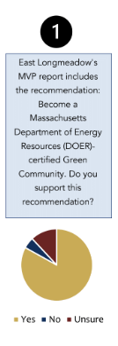
As expected, the need for culvert repair, maintenance and in some places re-sizing and/or replacement was also brought up as was the stormwater management requirements related to the federal MS4 permit, and the need to integrate green infrastructure into town public works as part of climate resilience; these issues are further addressed in the Public Facilities and Services chapter.
Key takeaways clean energy/energy efficiency

The town currently has a moratorium in place on large scale solar projects and has a number sited in the community. Massachusetts law allows home owners to place small-scale solar on their homes and this is increasingly happening in the community. In addition, the town has agreements with Altus Power, LLC that generates 3.5 megawatts of power per year located in the Town of Hampden to purchase solar renewable energy credits. The town has not moved forward on Green Communities certification previously, but there is interest now, especially as the Stretch code is no longer a stretch and has become the standard to which most homebuilders build. The ‘stretch code’ has been adopted in 288 cities and towns across the Commonwealth including 35 in the Pioneer Valley. The town does have a robust energy efficiency program at municipal and school buildings, taking advantage of utility offerings to reduce energy use, save money, and replace aging inefficient equipment and windows. The town is also taking advantage of National Grid’s LED streetlight conversion program. The town’s lack of municipal EV charging stations was identified.

Review of Existing Plans

East Longmeadow has several plans that include recommendations for climate action and sustainability: Hazard Mitigation plan 2016, Municipal Vulnerability Preparedness (MVP) Community Resilience Building workshop findings and priority actions 2019, the Open Space and Recreation plan 2020, and the Complete Streets ‘plan’. These plans were reviewed as part of this process and the relevant recommendations (and/or actions to achieve comparable ends updated for current technology/knowhow) are being carried forward into this plan, some in this chapter and others throughout the plan.
Areas of Concern highlighted in the MVP CRB workshop
- Infrastructure: pole-based electricity and communication lines, town and state-owned roads
- Drinking, Storm, and Wastewater Infrastructure: dams, culverts, and bridges, sewage pump stations, drinking water, and stormwater infrastructure
- Natural Resources: food systems, invasive species, habitat change, erosion, management and/or loss of open space and farmland
- Social Vulnerabilities: changing age-related demographics, residents with limited mobility, residents with limited English language capacity, low-to-moderate income populations, emergency shelter network, emergency communications platform (Rave)
- Built Environment: older/energy inefficient housing stock, lack of affordable housing
The top priorities included in the soon to expire Hazard Mitigation plan included a focus on culvert assessment and replacement, backup generators and understanding how the climate crisis will affect the town including a new awareness of possible drought concerns.

The OSRP identifies the land that needs to be protected for stormwater management = green infrastructure and the Complete Streets ‘plan’ advances efforts to make it easier and safer to walk and bike, GHG emission free forms of transportation that also improve public health.

Climate Data

The ResilientMA website includes the following data about projected weather changes including severe heat and increased flooding likely to affect East Longmeadow. It also shows the variability in extreme weather based on the amount of GHG emissions produced in the next 60 years.

HIGH EMISSIONS SCENARIO
MEDIUM
EMISSIONS SCENARIO
The scenarios of how emissions change in the future become vastly different as we look further out towards the end of the century. The International Panel on Climate Change (IPCC) considers a range of scenarios from the extremes of approximately 3.6°F (RCP2.6) to between 7°F (RCP8.5). RCP = REPRESENTATIVE CONCENTRATION PATHWAYS, essentially defined by their cumulative measure of human emissions of GHGs from all sources, expressed in Watts per square meter. This variability tells us that mitigation (as in mitigating our current contributions to GHG emissions) is so important to help shape a less disastrous future. Both the Commonwealth of Massachusetts and the Pioneer Valley have committed to net zero GHG emissions by 2050 and it is recommended that East Longmeadow set the same goal.
CT River Basin Climate Projections by 2100:
- Increase (↑) in:
  - Average temperatures
  - Min and max temperatures
  - # of days with temps over 90, 95, and 100
  - Cooling degree days (65 and above)
  - Winter precipitation
  - Frequency of heavy precipitation (winter)
- Decrease (↓) in:
  - # of days below 32 and 0
  - # of heating degree days (65 and below)
  - Fall precipitation (potential)

The rise of average temperatures is well documented. Maximum and minimum temperatures are also expected to increase throughout the end of the century, and that will be true for annual and seasonal projections. Summer and fall temperatures expected to see the greatest increases:
- Summer mid-century increase of 2.8 °F to 7.5 °F (3-9% increase); end of century increase of 3.8 °F to 13.4 °F (5-17% increase).
- Fall mid-century increase of 3.7°F to 7.2°F (6-12% increase); end of century increase by and 4.2 °F to 12.2 °F (7-20% increase).
Even what seems like a very small rise in average temperatures can cause major changes in other factors, such as the relative proportion of precipitation that falls as rain or snow, and impacts on species and ecosystem health. New species, that may become invasive, will be entering/have entered the region due to climate change, species hierarchies in ecosystems will change, and climate induced stress in an ecosystem will facilitate invasive pathways.
Beyond the general warming trend, projections show increases in the number of days with extreme heat throughout 2090. The model looked at daily max temps over 90 °F, 95 °F, and 100 °F. Generally, extreme heat is considered to be over 90 °F, because at temps above that threshold, heat-related illnesses and mortality show a marked increase. We currently see roughly 6 days per year over 90 (Temps recorded at Barnes Muni Airport in Westfield hit 90 10 times this year in July alone (closest weather station to Longmeadow)). There are projections of 10 to 35 more 90+ days by mid-century, and 15 to 76 more by 2100. Summer daytime high temperatures rarely go above 95°F in today’s climate. By mid century, we can expect 3 to 15 more days over 95 in the CT Basin.
We also know that changes to the frequency of extreme heat days will be most pronounced in the summer, with an increase of 12-60 more days by 2090. Why is this important? Heat waves can lead to illness and death, particularly among older adults, the very young, economically disadvantaged groups, and other vulnerable populations such as those in outdoor occupations. In addition more frequent days above 65°F and more frequent extreme high temperatures will drive an increase in cooling degree days, change patterns of energy use and increase net electricity demand which could strain the grid enough to force an outage. An analysis conducted for The New York Times by the Climate Impact Lab, says we saw about 7 days per year over 90 degrees in 1970, compared to 9 days per year in 2015, by the time you would be 80 years old in 2050, you will likely see 21 days over 90 degrees.
The flip side of that increased heat in the summer months is that there will be fewer days below 32° and 0°, with the greatest changes to be seen in the fall (10-16 fewer days below 32° by 2050) and spring (6-14 fewer days). We think about cold weather in terms of the need for heating shelters, and concern about winter storms knocking out power – these concerns don’t necessarily change with fewer days below freezing. However, fewer very cold days may impact the life cycle of certain insects and other species, such as ticks. East Longmeadow may see earlier insect emergence and expansion in the geographic range and pop size of tree pests such as the hemlock woolly adelgid, emerald ash borer, and southern pine beetle.
This can also impact agricultural operations - unusually warm winters like the ones we have had recently lead to early release from dormancy in perennial plants and damage from late winter or spring cold. In 2016 peach crops in the northern half of the Northeast were affected in this way with almost total losses. Grapes, apples, cherries, and other fruit crops in this region suffered widespread losses following cold conditions after warm winters in 2010 and 2012.
Roads - This trend may also indicate an increase in the frequency of the freeze frost cycle, something that we have seen in recent years wreaking havoc on highway departments as it leads to increased maintenance needs and increased costs in anti-icing measures in areas that previously rarely had mid-winter thawing and freezing rain.
Annual precipitation in in the basin is expected to increase by +1.3 to +6.2” by 2050s and by up to 8.3” by the end of the century. Rainfall is expected to increase in spring and winter months in particular. Understanding that both winter precipitation and winter temperatures could increase in future decades, we can expect more of this precipitation to fall as rain instead of snow. There are all sorts of human and environmental impacts that could result from this change including reduced snow cover for winter recreation and tourism, less spring snow melt to replenish aquifers, higher levels of winter runoff, and lower spring river flows for aquatic ecosystems. Interestingly, this may leave some infrastructure more vulnerable to damages from deep freezes. Pipes are especially vulnerable to freezing if they are exposed to outside air. “Wind chill,” can play a major role in accelerating ice blockage, and thus bursting, in water pipes.
One of the most pronounced changes in climate in NE —more than any region of the U.S. - during the past several decades has been a 71% increase in the frequency of extreme precipitation events since the mid-1990s. The climate projections suggest that the frequency of high-intensity rainfall and storm events will continue to trend upward. Again, we see the greatest changes in the spring and winter. These are the types of storms that cause flooding, erosion, and pollutant runoff from agricultural activities. Flooding that results from a single intense downpour can cause widespread damage to property and critical infrastructure. High-intensity rainfall events mobilize pollutants such as sediments and nutrients and pose a threat to surface water quality. Other effects of more intense downpours include: more inland flooding as soils become saturated and stop absorbing more water; rise in creek and river flows; and failure of storm water systems as their capacity is exceeded.
Rainfall is expected to increase in spring and winter. Conversely, we will see increasing consecutive dry days in summer and fall. When coupled with variable precipitation patterns and higher temperatures, increasing consecutive dry days in summer and fall can deplete groundwater and intensify droughts, like the one we experienced across the Commonwealth in the summer of 2016. More frequent droughts could also exacerbate the impacts of floods by damaging vegetation that could otherwise help mitigate flooding impacts. Droughts can also weaken tree root systems, making them more susceptible to toppling during high wind events. Also increases the risk of wild fire.
To summarize, some of the more daunting climate challenges facing East Longmeadow are:
- More extreme storm events/precipitation
- More extreme heat
- Warm winters and spring cold

Input from Town Staff

The Town staff have not yet had a chance to review and comment upon this draft. Their input will be added.

OPPORTUNITIES AND CHALLENGES

Opportunities refer to favorable external factors that could give the town a competitive advantage implementing the strategies (actions) recommended in this chapter. Massachusetts commitment to climate action and sustainability, combined with the region’s commitment are significant opportunities for East Longmeadow to act on this plan’s recommendations for energy efficiency, green initiatives and resiliency to climate change. Just as the research for this plan was wrapping up Governor Baker signed the 2021 Massachusetts Climate Legislation. This amendment to and strengthening of the 2008 Global Warming Solutions Act will ensure availability of funding in Massachusetts for energy efficiency (reduction in GHG emissions) and clean energy generation for the foreseeable future and beyond.. This amended legislation combined with the States existing commitment to climate adaptation manifest in the MVP program, are significant opportunities for East Longmeadow as they do line up funding for many of the specific actions/strategies identified in this plan. Additional favorable factors facilitating advancement of this plan include the enthusiasm and support for climate action and resilience expressed by the vast majority of residents, town officials and staff, business owners, students and visitors and workers who participated in this resilient master plan development process.
The co-benefits of climate action and resilience are also compelling factors that enhance the likelihood of East Longmeadow’s success implementing the strategies. Co-benefits include: saving money; improving public health; creating good-paying locally owned jobs; more money circulating in the local economy; improved air and water quality; enhanced public safety; reduced maintenance costs; reduced risks and an improved ability to accurately project municipal budget needs into the future.
Challenges refer to factors that have the potential to make it difficult for the town to succeed with implementation. As many people have observed, challenges, depending upon how one looks at them, can be transformed into opportunities. This plan could be thought of as a challenge, as it lifts up more than 100 actions the town needs to take to move toward the chosen sustainable future, possibly making the implementation of them all less likely than if there were fewer of them. The presence of these recommendations, and their publication, delivery to the state agency that funded this plan, and enshrinement in the records of the Planning Board and Town Council when they vote to adopt this plan could turn that ‘challenge’ into an opportunity. Many communities dramatic and measurable success enhancing sustainability and climate resilience while boosting local revenues, increasing tourism and the community’s visibility and desirability (eg Asheville NC, Northampton MA) provide the evidence to rebut any proposed challenge to implementing the actions/strategies identified in this plan.

SUSTAINABILITY GOALS AND STRATEGIES

Goal 1. Promote the use of green street facilities and green infrastructure in public and private
development as a cost-effective and sustainable practice for stormwater management
in current and future projects wherever possible. This includes: road construction and
reconstruction projects; sewer projects; and new development and redevelopment
projects.

- Adopt the proposed Green Infrastructure and Climate Resiliency policy.

Primary:
Others:
Priority/Timeframe:
Resources:

- Take advantage of State programs such as the new One Stop for Growth to secure funding to implement the projects that result from adoption of the policy.

Primary:
Others:
Priority/Timeframe:
Resources:

- Conduct a parking inventory to identify under- and over-utilized spaces and options to consolidate to reduce impervious cover and/or integrate solar canopies over the necessary parking.

Primary:
Others:
Priority/Timeframe:
Resources:

- Conduct an alternatives and cost analysis for redesigning the manual outfall at the Heritage Park Lake outfall.

Primary:
Others:
Priority/Timeframe:
Resources:

Goal 2. Promote climate resiliency in public buildings and infrastructure-both green and gray-
and in private development.

- Adopt the proposed Green Infrastructure and Climate Resiliency policy.

Primary:
Others:
Priority/Timeframe:
Resources:

- Update the Town’s Hazard Mitigation plan to maintain eligibility for FEMA BRIC funds

Primary:
Others:
Priority/Timeframe:
Resources:

- Complete a planning and feasibility study for building a microgrid for town facilities; install behind-the-meter solar on all public buildings, create a microgrid, install battery storage at Town Hall to provide emergency power and maybe at the library.

Primary:
Others:
Priority/Timeframe:
Resources:

- Conduct culvert assessment and prioritization plan to NAACC standards, to follow up with grant applications for culvert action.

Primary:
Others:
Priority/Timeframe:
Resources:

- Conduct a road conditions assessment and inventory and subsequent maintenance/improvement plan for upkeep.

Primary:
Others:
Priority/Timeframe:
Resources:

- Engage with an engineer consultant to update the road master plan and standard details.

Primary:
Others:
Priority/Timeframe:
Resources:

- Conduct a dam removal study for Jawbuck Dam (town-owned) and outreach to private dam to understand maintenance and safety concerns.

Primary:
Others:
Priority/Timeframe:
Resources:

- Update stormwater management bylaw to MS4 Permit standards.

Primary:
Others:
Priority/Timeframe:
Resources:

- Make infrastructure improvements to water supply system. Look into former public well locations as a potential future drinking water resilience resource to reduce vulnerability to loss of SWSC lines.

Primary:
Others:
Priority/Timeframe:
Resources:

- Create a town tree committee and develop a long-term planting plan. Collaborate with Springfield's new nursery.

Primary:
Others:
Priority/Timeframe:
Resources:

Goal 3. Lead by example with respect to achieving maximum energy efficiency in municipal
buildings, operations and fleet.

- Become a certified Green Community which includes energy efficiency audits at all municipal buildings and infrastructure and implementation of work to reduce energy use (paid for by the state), assuring as of right permitting for research and development/manufacturing related to clean energy; adopting a fuel efficient vehicle policy and the stretch building code.
Primary:
Others:
Priority/Timeframe:
Resources:

- Support mixed-use housing development where appropriate and in accordance with the neighborhood character, not to detract from the local economy or amenities.

Primary:
Others:
Priority/Timeframe:
Resources:

- To hold on to staff institutional knowledge, create a manual for each building/department that is continually updated

Primary:
Others:
Priority/Timeframe:
Resources:

- Continue discussions with National Grid on resiliency and responsiveness.

Primary:
Others:
Priority/Timeframe:
Resources:

- Encourage businesses to practice good maintenance policies for their back-up generators/institute emergency plans, using Town policy as a model.

Primary:
Others:
Priority/Timeframe:
Resources:

Goal 4. Take care of vulnerable residents.
- Identify where vulnerable residents live for check-ins, and partner with the Council on Aging and utilities as necessary to complete this list.

Primary:
Others:
Priority/Timeframe:
Resources:

- Ensure sign-up for Rave Reverse 911 communications system is easily accessible (i.e., not buried on the Town website) and sign-up information is sent in the mail and posted in relevant locations such as medical offices, places of worship, public gathering spaces, etc.
Primary:
Others:
Priority/Timeframe:
Resources:

- Conduct an outreach campaign to achieve 100% participation for Rave, understanding Rave’s ability to circumvent permissions and contact all registered numbers in case of emergency.
Primary:
Others:
Priority/Timeframe:
Resources:

- Improve drainage and identify areas at high risk for mosquito gestation; increase public awareness around mosquitos and vector-borne disease.
Primary:
Others:
Priority/Timeframe:
Resources:

- Create a new "Green Committee" to work on trails and open space, host events to promote sense of place and teach wayfinding.
Primary:
Others:
Priority/Timeframe:
Resources:

- Develop community gardens near where people who do not have their own yards live.
Primary:
Others:
Priority/Timeframe:
Resources:

- Collaborate with the utility to promote Mass Save no cost Home Energy Assessments and Business Energy Assessments and the related no cost air sealing and insulation home/business improvement work, targeting vulnerable residents and businesses to save them money and reduce their GHG emissions.

Primary:
Others:
Priority/Timeframe:
Resources:

Town of East Longmeadow Green Infrastructure and Climate Resiliency Policy DRAFT

Section 1. Goals

The goals of this Town of East Longmeadow policy are to:

- Promote the use of green street facilities and green infrastructure in public and private development as a cost-effective and sustainable practice for stormwater management in current and future projects wherever possible. This includes: road construction and reconstruction projects; sewer projects; and new development and redevelopment projects.
- Promote climate resiliency in public buildings and infrastructure and private development.

Section 2. Definitions

Green Infrastructure: Keeps rain close to where it falls, using structures to improve on-site infiltration, such as rain gardens, green roofs and permeable pavements, to promote cleaner, slower, and smaller storm flows to nearby rivers and streams.
Green Streets: Green Streets are a subset of Green Infrastructure in which the street handles significant amounts of stormwater on site through use of vegetated and/or soil-infiltration facilities. Green Streets can include landscaped street-side planters or swales or tree box filters or porous pavement that capture stormwater runoff and allow it to soak into the ground as soil and vegetation filter pollutants.

Section 3. Policies

WHEREAS,

The Town of East Longmeadow recognizes:

- Stormwater runoff from streets, roads, parking lots, and other impervious urban surfaces is a significant source of water pollution to our rivers, streams and water bodies;
- The local impacts of climate change in East Longmeadow include more frequent 100-year floods and more severe storms; an increase in insect populations and insect-borne diseases; rising water tables and increases in invasive species.
- Green Streets can provide cost-effective infrastructure solutions to reduce and manage stormwater runoff and flooding from more intense storm and flooding events and can reduce localized flooding from surcharging, providing some adaptation to climate change.
- Green Streets can improve water quality by filtering stormwater, removing contaminants, including total suspended solids (TSS), organic pollutants /oils, and heavy metals, and cooling the stormwater before it encounters groundwater or surface water bodies, which benefits watershed health.
- Green Streets foster unique and attractive streetscapes that protect and enhance neighborhood livability, integrate the built and natural environments, enhance the pedestrian environment, and introduce park-like elements into neighborhoods.
- Green Streets encourage the planting of landscapes and trees which contribute environmental benefits such as reduced summer air temperatures, reductions in global warming through carbon sequestration and air pollution screening.
- Green infrastructure can reduce the long-term costs of gray infrastructure maintenance, and complement gray infrastructure with hybrid systems of gray, piped infrastructure combined with green, vegetated infrastructure.
- Green infrastructure will be an investment in East Longmeadow’s village centers. The costs for installing green infrastructure may be initially higher, but long term costs of climate changes, storm damages and flooding will be mitigated. Green infrastructure, when built in tandem with grey infrastructure, extends the lifespan of both green and grey infrastructure. Green infrastructure reduces water pollution more cost effectively than grey infrastructure alone.
- Recharge of groundwater sources is a key mitigation activity under the Massachusetts Water Management Act regulations 310 CMR 36.00.

NOW, THEREFORE BE IT ORDERED,

The Town of East Longmeadow policy is to promote the use of green street facilities and green infrastructure in public and private development through regulation, capital investment, and management mechanisms as a cost-effective and sustainable practice for stormwater management in current and future projects when technically and economically feasible. This includes road development and reconstruction, bicycle and pedestrian projects, stormwater projects, and other development and redevelopment.

It is the Town of East Longmeadow policy to:

- Incorporate and maintain green street facilities and green infrastructure into all publicly funded development, redevelopment, and enhancement projects, to the extent technically and economically feasible.

To achieve this, where feasible, East Longmeadow will:
  - Evaluate new municipal projects to determine if they will make the town more climate resilient and green, and will provide long-term benefits to the town.
  - Install new and replacement culverts that are open-bottom culverts designed for fish and wildlife passage, and sized to handle larger storm events expected with climate change.
  - As streets and parking lots are replaced, re-paved or installed, utilize green streets and parking lot designs with tree box filters, permeable pavement, and curbless planted medians and shoulders.
  - Purchase electric or hybrid municipal vehicles.
  - Install EV charging stations and priority EV parking spaces
  - Support “Solarize” neighborhood programs to incentivize group solar panel purchases
  - Conduct and periodically update energy audits and upgrades in energy efficiency for all municipal buildings, and utilize Mass Energy Insight data to track and reduce energy use.
  - Green existing and new municipal buildings, schools and facilities, using, but not limited to, such techniques as rain gardens, green roofs, rainwater harvesting and porous pavements.
  - Install LED lighting for traffic lights, street lights and municipal buildings.
  - Install green stormwater infrastructure in public green spaces.
  - Work toward East Longmeadow generating its own green power with solar or wind installations.
  - Work with power companies to bury powerlines to reduce vulnerability to storm-related power outages.
  - Work to make improvements to municipal buildings, schools and municipal infrastructure including:

- Resiliency improvements for flooding;
- Green roofs, rainwater harvesting, and re-use for watering;
- Plant trees, shrubs and vegetation around municipal facilities;
- Install bioswales, rain gardens, porous pavements and bioretention to infiltrate stormwater on site and reduce flooding;
- Reduce impervious surfaces and replace with greenspace;
- Install complete streets including bike lanes, sidewalks, and pedestrian infrastructure;
- Energy efficiency and weatherization improvements.

- Ensure that regulations require and incentivize all development to incorporate green streets and green infrastructure features. To achieve this, East Longmeadow will enforce current stormwater regulations, and work toward adoption of zoning best practices for:
- On-site stormwater retention, low impact development and minimized impervious surfaces;
- Tree protection and planting;
- Complete streets and green parking;
- Green roofs;
- Solar access and streamlined solar permitting.

- Ensure coordination and communication between town boards and departments, in particular Town Council, Public Works Department, Building Department and Planning Department to ensure implementation of this policy, as well as fully addressing competing priorities.

Section 4. Amendments

This policy may be amended at any time with the approval the East Longmeadow Town Council.

Section 5. Effective Date/Authorization

This policy will become effective for when it is approved by vote of East Longmeadow Town Council.

Approval by East Longmeadow Town Council:

____________________________________ _______________________ Town Council, Date

PUBLIC SERVICES AND FACILITIES

The Public Services and Facilities element of a master plan helps guide decisions and develop a plan relevant to public buildings, utilities and infrastructure in order to meet future needs for the community. Police, fire and public works, along with the infrastructure that is necessary for these services, are vital for the town to function properly. Likewise, local decisions about how and what public services and facilities are funded and built will be critical in determining the direction the town takes in future development and continued governance.

The Town’s ability to provide adequate facilities depends on effective capital planning and a commitment to implementation by the town, asset management policies, and the revenues for the town to use to support those operations and maintenance requirements. East Longmeadow receives little funding from non-local sources and relies on its residents and businesses for financial support, in addition to grants that the town would need to administer.

Some Key Findings:

- Generally, residents are satisfied with the level of public services they receive from the town.

- The Town takes advantage of state programs that exist to help fund building and infrastructure improvements in East Longmeadow, like the Municipal Vulnerability Preparedness program which helps towns plan for and implement resiliency projects that respond to climate change risks. This plan suggests the town explore the Green Communities program and designation that will help fund energy efficiency upgrades to municipal buildings, taking better advantage of cost savings even as DPW and facility managers have identified where they can be efficient.

- East Longmeadow has an aging population that is overwhelmingly interested in aging in place. Public services and facilities will need to be expanded and adjusted to meet the needs of this demographic.

Map 8-1 Infrastructure Map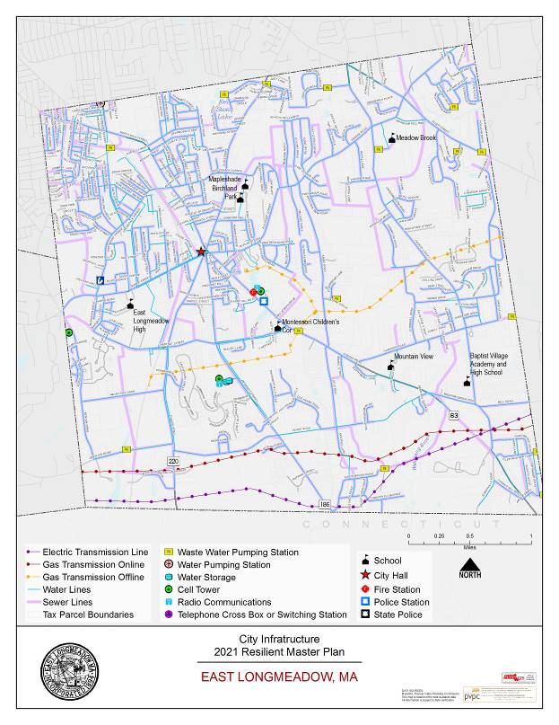

INVENTORY & EXISTING CONDITIONS

INFRASTRUCTURE

Public Water

East Longmeadow receives its public water from the Springfield Water and Sewer Commission (SWSC), where it is treated before distribution. The drinking water supply originates from a surface water supply, Cobble Mountain Reservoir, located in Blandford, Massachusetts. An additional surface water supply that feeds into Cobble Mountain Reservoir, contributes to the system’s combined water supply capacity of 25 billion gallons.

The reservoir water flows to the West Parish Filters Treatment Plant, in Westfield, Massachusetts, filtering through slow and rapid sand filtration, treated to inhibit corrosion of home plumbing, adjusted for pH, and disinfected before it flows to the underground storage tanks in Agawam. Clean drinking water is supplied, at an annual average rate of 35 million gallons per day to Springfield, Agawam, East Longmeadow, Longmeadow, and Ludlow, through 617 miles of underground piping network of large transmission mains and small sized distribution mains.

In East Longmeadow, there are four connections to the Springfield water supply system: Elm Street, Harkness Avenue, North Main Street, and Dwight Road.

Wastewater

The Sewer Division of the East Longmeadow Department of Public Works is responsible for the safe and efficient transmission of the raw sewage from its underground pipe network to the treatment plant located at Springfield’s Bondi’s Island. Sewage flows in pipes either by gravity or through forced pressure created by a network of pump stations throughout town. The Sewer Division oversees maintenance of more than 114 miles of pipe and the upkeep of seventeen pump stations.

Dams

There are several dams that are relics of the agricultural activity in town, including two on Freshwater Brook, north and south of Denslow Road; one in Jawbuck Brook in the Deer Park Industrial Park; and two on the Bluebird Estates property.

The Massachusetts Department of Conservation and Recreation Office of Dam Safety is the agency responsible for regulating dams in the state. To be regulated, these dams are in excess of 6 feet in height and have more than 15 acre feet of storage capacity. The dam regulations enacted in 2005 transferred significant responsibilities for dams from the state to dam owners, including the responsibility to conduct dam inspections.

East Longmeadow has five dams located in town. Although, the 2016 Hazard Mitigation Plan identified that the Blue Bird Acres Pond dam is no longer a dam. According to the Office of Dam Safety, the dams included:

Dam Name | Owner | Hazard Potential
Blue Bird Acres Pond Dam | No Record for Privately Owned Non-Jurisdictional Dam | N/A
Heritage Park Pond Dam | Town of East Longmeadow | N/A
Wetstone Pond #1 Dam | JSTW Limited Partnership | Low
Wetstone Pond #2 Dam | No Record for Privately Owned Non-Jurisdictional Dam | N/A
Wetstone Tobacco Co. #3 | Town of East Longmeadow | Low

Low hazard dams in East Longmeadow and two non-jurisdictional. The failure of a low hazard dam would not cause any personal injury and is not anticipated to affect a significant amount of the land area in East Longmeadow.

Telecommunications/IT

The availability of broadband technology plays a major role in advancing development, where as the saying goes, “Be Wired or Be Fired”. Companies are less likely to move to a community that does not have dependable broadband service. Especially during the COVID-19 pandemic, broadband and high-speed internet connections are necessary for those residents who needed to work from home.

Currently, East Longmeadow has moderate broadband internet coverage, with sixteen internet providers with six providers serving residents. There has been identified issues with internet service and its reliability, especially with 83.4 percent of survey respondents saying it was very or somewhat important to improve internet access and speeds. Additional comments suggested that the town should explore adding internet/cable options as a general development goal. It has been identified that there is existing fiber optic line as there was a former MassMutual project that installed this fiber optic line between their Springfield and Enfield headquarters.

MUNICIPAL FACILITIES & SERVICES

Town Hall, 60 Center Square

The Town Hall is located at 60 Center Square in East Longmeadow, a two-story building consisting of two connected structures. The original two-story town hall building was constructed in 1882 with brownstone masonry. An addition was added to the original building in 1967, composed of steel. The Town Hall is not fully accessible and in compliance with 521 CMR Massachusetts Architectural Access Board Regulations. There is no elevator in the building.

Most of the town government, its boards and commissions, are based at the Town Hall at 60 Center Square. Some of the departments are listed below:
- Building Department
- Department of Public Works
- Tax Collector/Treasurer
- Town Clerk
- Town Council
- Town Assessor
- Health Department
- Planning and Community Development Department
- Town Manager

The hours of operations for each department and board vary. Some town services are available online, through the Town’s website. Residents can access municipal information, download permit and application forms, and pay bills online.

The community survey seems to indicate general satisfaction with the majority of town services. The sentiment regarding town services seem to align with many of the issues and opportunities captured elsewhere in this plan.

Town Administration

The East Longmeadow Charter sets up the local government into the legislative branch and the executive branch. The legislative branch is led by an elected seven member Town Council. The Council is elected to meet, deliberate, act and vote in the exercise of the corporate business of the Town. The Council hires and evaluates the Town Manager. The Town Manager represents the executive branch who creates budgets, oversees day to day operations in town government.

Council on Aging (COA) and Senior Center, 328 N. Main Street

With an aging Baby Boomer population and people living longer than previous generations, the number of residents living over the age of 60 will be higher than in previous generations. As a result, communities need to ensure that town services and the built environment meet the need of this growing population. In 2019, 22 percent of the total East Longmeadow population, were age 65 years old or older. This is up from 19 percent in of the population in 2010.

The Council on Aging, an essential town department, serves the senior residents and the rest of the community by organizing and hosting social and health-related activities and keeping seniors informed about available programs and resources. The Council on Aging operates its programming in a 100-year-old school, shared with the Recreation Department. The COA is supported by over 100 volunteers.

Some of the activities that the Council of Aging supports include book clubs, field trips, exercise opportunities, social hours, meals, etc. The Council on Aging provides Senior Van Service Monday through Friday between 9 AM – 3 PM with the Tri Town Trolley, a program to take seniors to various appointments, as well as shopping.

East Longmeadow Housing Authority, 81 Quarry Hill

The mission of the East Longmeadow Housing Authority is to provide decent, safe, affordable housing for the low-income elderly, veterans, disabled and families. The Authority offers priorities to East Longmeadow residents and veterans. The Authority was established in 1959 and provides housing for over 219 low-income tenants, and runs four housing programs which include Elderly, Congregate, Massachusetts Rental Voucher Program and Family.

The Housing Authority oversees 188 elderly/handicapped units located at the Village Green, Inward Commons, Quarry Hill, and the McLaren House.

East Longmeadow Police Department, 160 Somers Road

The East Longmeadow Police Department is established by the citizens to provide the town with a high level of safety, security, and service. As an enforcement agency of local government, the police department has the responsibility for the preservation of public peace and for the effective delivery of a wide variety of police service.

The police station has been identified as a facility that can be improved as it a “bunker-style” facility form the 1970s and needs upgrades. The Police and Fire Chiefs have suggested a public safety building that combines both the police and fire services.

East Longmeadow Fire Department, 150 Somers Road

The mission of the East Longmeadow Fire Department is to protect lives, environment, and property by providing a fire safe community through preparedness, a coordinated public education program, inspection services for development.

The fire station at 150 Somers Road serves as the emergency operations center. The Fire Chief has suggested that the fire station is “tired” despite having recent roof and furnace upgrades. A public safety complex could be explored to house both police and file operations.

East Longmeadow Public Library, 60 Center Square

Since its founding in 1896, the East Longmeadow Public Library has grown from its location in the Board of Selectmen’s Office in Town Hall to the two-story building it is in today.

The new public library building which is currently where library operations take place opened in February 2004, conveniently located in the center of town, adjacent to the historic Town Hall. In its seventeen years in operation, an acoustic deficiency has been identified in the library where sounds converge in certain areas.

The town’s public library was constructed along Main Street in 1892 and is named in memory of Edgar Sheffield Porter, the son of summer resident Josephine Porter. The library is a community asset that is in the vicinity the town offices, general store, post office, Watson Park, all contributing to the look and feel of the traditional rural town center. The library is open Monday through Wednesday 9:30 AM – 8:00 PM, Thursday and Friday from 9:30 AM – 5:00 PM, and Saturday from 9:30 AM – 4 PM. The Historical Commission has a local history room, housed in the East Longmeadow Public Library.

The town library, led by the Library Director and the Board of Trustees, offers programming, books and media resources for the community. The East Longmeadow Public Library is a member of the Central and Western Massachusetts Automated Resource Sharing (CW/MARS) network. With this digitization process, residents have access to 8.1 million items waiting to be enjoyed in the shared catalog. The library relies on funding from the town for its operation, along with foundations, state grants and individual giving.

During the pandemic, the library has become even more important, especially in collaboration with the school system. Library services for school-aged children is the most heavily utilized programming resource; however, the library has identified a gap for programming for teenagers and “tweens.”

This past year the library expanded its services by providing curbside pick-up. Continuing its important role in the community, 2020 has been a year where over 1 million audio and e-books were checked out in the CW/MARS system that the library belongs to – the highest year ever for digital checkouts.

Transfer Station, 170 Somers Street

Bulky items and yard waste are accepted by the town at the Transfer Station at 170 Somers Street, behind the Police Station. The transfer station is open two days a week to residents with a valid transfer station sticker.

The DPW Director’s Office and the operations for the department are mostly run at Town Hall. The DPW’s list of responsibilities includes divisions: Utilities, Sewer, Water, Highway, Stormwater, and Building Facilities Management.

Some of the area’s concerns that the DPW would be responsible for is the storm sewer system, which can be overtaxed when a storm event hits. The town is subject to the U.S. Environmental Protection Agency (EPA)’s Municipal Small Storm Sewer System (MS4) regulations, regulating and managing stormwater runoff for pollution and erosion control. The town continues to explore and understand, in accordance with its Community Resilience Building Workshop Summary of Findings in 2019, the ability y of the Town to integrate the use of Low Impact Development (LID) and green infrastructure (GI) techniques within town practices and bylaws that govern development.

The transportation infrastructure of which DPW continues to maintain includes undersized culverts and storm sewer systems that have contributed to local street flooding on Elm and North Main Streets. Some ideas of green infrastructure like rain gardens and permeable pavement can be installed to reduce the strength and volume of water entering the undersized culverts. These types of mitigating features that the DPW reviews are in their purview.

The community survey provoked free response comments stating that roads were important for the general development goals of the town and improving the roads and sidewalks of the town is very important. Road maintenance is addressed is in the Mobility element of this Plan.

East Longmeadow Public Schools (ELPS)

East Longmeadow operates its own school system, governed by a 5-member School Committee. According to the MA Department of Elementary and Secondary Education, East Longmeadow has a total of 2,404 enrolled students across the five schools listed below in the 2020-2021 school year, a year marked by instruction during the COVID-19 pandemic. There is an expected increase in enrollment next academic year because of the pandemic-related start to the 2020-2021 being a remote instructional model.

- Birchland Park Middle School (Grades 6-8)
- East Longmeadow High School (Grades 9-12)
- Mapleshade Elementary School (Grades 3-5)
- Meadow Brook Elementary School (Grades PK-2)
- Mountain View Elementary School (Grades 3-5)

The accountability rating system designated ELPS as making substantial progress towards State designated targets. According to the 2019 Annual Report for the Town, ELPS students graduate at the rate of 98.5 percent in four years, completing their degree, and go onto higher education at 87 percent going to a two- or a four-year college. Other graduates go into other fields of endeavor building off their education in the ELPS schools with 3.2 percent joining the military and 2.3 moving into work apprenticeships or beginning to work in a job.

East Longmeadow Public Schools just began accepting school choice students this year. Fifteen students were added to ELPS enrollment, with 12 from Springfield. At least 9 ELPS students sought education outside the district, choosing TEC Connections Academy Commonwealth Virtual School District, a virtual academy. Out of the surrounding communities, East Longmeadow sent four students to Longmeadow School District.

There was conversation regarding the school district, particularly the high school facility, at the visioning session, as well as in the focus groups, in that the facility itself should be updated to reflect the needs of the community. The school district has prioritized replacement or renovation of the high school building as stated in a statement of interest to the Massachusetts School Building Authority. A School Facilities Master Plan was completed in 2013. The Plan outlined work to repair or replace the existing building, built in 1960 and has outdated space for instruction.

ISSUES & OPPORTUNITIES

Services for Current and Future Needs

Despite the challenges of town government and tight budgets, East Longmeadow seems to be effective at meeting many of its local needs. Needs have come to the forefront, not only with regards to budget items, but operationally for the DPW, Recreation Department, and the Fire and Police Departments. The Town Hall, at the moment, seems to operate satisfactorily, however, it may not be the most accessible building providing services to the residents. A community center has been mentioned in this master planning process where possibly a consolidation of various services in an efficient, welcoming community space, namely Council on Aging and Recreation Department activities, could help East Longmeadow deliver intergenerational services in an efficient way.

Building Maintenance and Accessibility

As a small town with finite resources, the continued maintenance and operations of public buildings can be a strain. Additionally, several of the town’s properties are in need of substantial capital improvements. The Town Hall does not have an elevator and can be a challenge for those wanting to access town staff who deliver services. Some other facilities like the high school, fire and police stations, recreation department and senior center, have been suggested as facilities where improvements can be realized to bring service delivery efficiently.

Community Development Block Grants can be used to fund accessibility upgrades where identified, but not general building maintenance.

Maintaining the Master Plan

The East Longmeadow Resilient Master Plan, when adopted by the Planning Board, should be maintained over time. A master plan is designed to be blueprint and will evolve over time as recommendations are implemented and conditions change in the town. A Resilient Master Plan Implementation Committee should be formed to engage boards, committees, and town staff, adhering to metrics established by the Master Plan, promoting the Master Plan and referring to it when decisions are being made. The town should celebrate implementation as the actions are achieved.

Municipal Vulnerability and Hazard Mitigation Planning

According to the community survey, 42.6 percent of the respondents considered the production of more electricity from solar, wind, or hydro, an issue that needs immediate attention. This type of response may suggest that the town prioritize energy efficiency, reducing emissions, and responding to the impacts of climate change. New development should support adaptation to anticipated climatic changes and should align with statewide and regional goals towards reduction of greenhouse gas emissions. It is well established that climate change is currently adding and will increasingly add stress to the municipal infrastructure and facilities that keep towns like East Longmeadow running, both day-to-day, and in the crisis times of natural emergencies.

The Federal Emergency Management Agency (FEMA) and the Massachusetts Emergency Management Agency (MEMA) define Hazard Mitigation as any sustained action taken to reduce or eliminate long-term risk to people and property from natural hazards such as flooding, storms, high winds, hurricanes, wildfires, earthquakes, etc. Mitigation efforts undertaken by communities will help to minimize damages to buildings and infrastructure, such as water supplies, sewers, and utility transmission lines, as well as natural, cultural and historic resources.

Planning efforts make mitigation a proactive process. Pre-disaster planning emphasizes actions that can be taken before a natural disaster occurs. Future property damage and loss of life can be reduced or prevented by a mitigation program that addresses the unique geography, demography, economy, and land use of a community within the context of each of the specific potential natural hazards that may threaten a community. Preparing a Local Natural Hazards Mitigation Plan before a disaster occurs can save the community money and will facilitate post- disaster funding. Costly repairs or replacement of buildings and infrastructure, as well as the high cost of providing emergency services and rescue/recovery operations, can be avoided or significantly lessened if a community implements the mitigation measures detailed in the Plan. FEMA requires that a community adopt a pre-disaster mitigation plan as a condition for mitigation funding.

East Longmeadow developed a Hazard Mitigation Plan (HMP) in 2016 with assistance from the Pioneer Valley Planning Commission. This plan will be due for an update in the coming year as MEMA requires that HMP plans be updated every five years.

Recognizing that climate change will continue to exacerbate the threats and hazards Massachusetts communities face, the Executive Office of Energy and Environmental Affairs (EOEEA) created the Municipal Vulnerability Preparedness (MVP) grant program. East Longmeadow’s Resilient Master Plan is being funded through this program. This program provides funding for towns to plan for and implement climate-change resiliency projects. The town remains eligible to apply for action grants to fund resiliency projects.
Community Resilience

The community services and facilities, and the government’s responsiveness, plays an important role in the town’s ability to adapt and be resilient in the face of an emergency.

- The siting of future town-owned facilities can play a role in reducing greenhouse gas emissions from vehicles, especially if located in a walkable or easily accessible neighborhood where the visitors do not have to rely on a vehicle to get there.

- A Green Communities designation can continue East Longmeadow on the path of facilities being retrofitted with energy efficient lighting, appliances, heating and cooling systems, windows and doors, and much more to reduce power consumption.

- Community facilities can also be used to generate power. This includes solar canopies over parking lots, or solar installations on flat roofs, which the town continues to permit.

- The Town could incorporate healthy community policies around transportation, energy, and healthy eating as a way to set an example to residents and increase awareness.

- Inclusiveness, transparency, and encouraging involvement in town government helps to build trust and common bonds across residents.

Public Services and Facilities Goals & Recommendations

Goal 1. Maintain high quality educational facilities, services and access to exemplary education for children of East Longmeadow

- Invest in facilities and staff to ensure the town’s education system continues to prosper and adapt to modernizations throughout society. The town should continue to support the East Longmeadow Public Schools Facilities Plan, providing for continued advocacy for a revitalized high school building.

Primary: School Committee
Others: Superintendent, Town Council
Priority/Timeframe: Ongoing
Resources:

Goal 2. To continue providing efficient and fiscally responsible town services and community facilities

- Improve town outreach and communication internally, and externally to residents for purposes of civic engagement and emergency response preparedness.

Primary: Town Manager
Others: Department Heads, Town Council
Priority/Timeframe: Ongoing
Resources:

- Support services for senior, disadvantaged residents, and veterans.
  - Strengthen the programs at the Council on Aging to include continued outreach services, health, nutrition and recreation programs.
  - Provide intergenerational opportunities for engagement with school-aged residents and seniors.

Primary: Town Council
Others: Town Manager, Council on Aging, Veterans’ Agent
Priority/Timeframe: Ongoing
Resources:

- Establish mechanisms and policies linking the Master Plan to staff, board and commission work plans, budgets, and capital projects.
  - Sunset the Resilient Master Plan Committee charged with this Master Plan development, replace with Resilient Master Plan Implementation Committee reporting to the Select Board.
  - Use the Master Plan recommendations and implementation table as a guide of decision making.
  - Convene an annual all Town Boards, Committees and Commissions Meeting to share progress on implementing the Master Plan and discussing change of priorities and plans.

Primary: Resilient Master Plan Implementation Committee
Others: Planning Board, Town Council
Priority/Timeframe: Ongoing
Resources: Consultant

- Create a Citizens’ Academy. Promote citizen engagement by providing classes, information, and events where participants learn about the different functions of local government including volunteering opportunities and service on town boards, committees and commissions. Public Service Announcements can be created to help with information sharing.

Primary:
Others: IT Department, Town Manager, Planning Department
Priority/Timeframe: Ongoing
Resources:

Goal 3. Improve public facilities and infrastructure

- Plan for and implement building and maintenance improvements. The town should continue to plan for both short- and long-term capital needs through a transparent and inclusive capital planning process.

Primary: DPW
Others: Town Council, School Committee
Priority/Timeframe: Ongoing
Resources:

- Complete feasibility study for public services complex.

Primary: Town Council
Others: Fire Department, Police Department
Priority/Timeframe:
Resources:

IMPLEMENTATION

Implementation is a critical step in the Master Plan process. The Implementation Plan is a step-by-step guide for East Longmeadow to follow over the coming years to ensure that the Master Plan recommendations are put into action. Implementing the Master Plan will require a concerted and ongoing effort on the part of the town’s elected and appointed officials, volunteers and dedicated citizens. The actions that the town takes now will create a lasting legacy for future generations.

We exist in an ever changing world with ever expanding and increasing social and technological advances requiring that planning must be an iterative process whereby a community should continually evaluate and respond to new external and internal circumstances and challenges as well as changes in the goals and desires of its residents. This Master Plan has a planning horizon of approximately 15 years: that is, planning needs are evaluated and recommendations are made based on their projected benefit over the same timeline. However, the Implementation Plan only has a much shorter timeframe in the sense that most of the Master Plan strategies are targeted to be commenced within the next three-six years. The Planning Board should periodically revisit the Master Plan to determine whether its goals and general strategies are still appropriate to the town. The town should facilitate a public review of the document, modify the goals and strategies as necessary, and prepare a new Implementation Plan for the subsequent six years. The town should consider reviewing the status of its Master Plan around 2030, at which time conditions in the town could have changed and a new plan will be needed to address the challenges that these conditions present.

Implementation Action Plan

The Implementation Action Plan summarizes all of the Master Plan strategies in a matrix format that identifies the approximate timeline and the group(s) responsible for implementing each one. The strategies are divided according to the element in the master plan that is addressed. Most of the actions will cost little or no money to implement because they can be brought about by Town Meeting vote or other action to change local policies. In some cases, the town may need to devote staff resources or hire a consultant to assist with this process (e.g., to help prepare zoning changes). If the town is able to hire a professional planner, this staff person may take the place of a consultant in many of these recommendations. Some of the actions that involve facility or infrastructure improvements will require the expenditure of funds, which may come from the town, the state, and/or other sources.

In the “Priority” column of the Action Plan matrices, actions are classified as either “High” (indicating action within 12 months), “Medium” (indicating action within 12-36 months), and “Low” (indicating action within 3-6 years). Many of these strategies are ongoing, indicating action that should be continually repeated and expanded as necessary. All items and strategies within this Master Plan are important however, and the priority designation is simply a means to prioritize generally among all the actions contained within the plan. A number of actions will require state involvement and/or major capital expenditures may require more than six years to implement. Many strategies are linked to one another, requiring much effort in the early phases to lay the groundwork for future progress. The feasibility of implementing certain strategies will be dependent on the town’s ability to set the foundation with a number of the shorter-term strategies and allow the longer-term strategies build from those efforts.

MATRIX TO BE PRESENTED ONCE GOAL SETTING AND RECOMMENDATIONS ARE COMPLETED IN PREVIOUS CHAPTERS.

https://ops.fhwa.dot.gov/publications/fhwahop15025/index.htm
“Town History,” https://www.eastlongmeadowma.gov/133/Town-History
Ibid.
Alfred M. Copeland, Our County and its People. A History of Hampden County, Massachusetts. Boston: Century Memorial Publishing Co., 1902. 429-437. Archive.org, accessed 2021. https://archive.org/details/ourcountyitspeop03copel/page/528
Massachusetts Historical Commission. MHC Reconnaissance Survey Town Report East Longmeadow. Boston: MHC, 1982. https://www.sec.state.ma.us/mhc/mhcpdf/townreports/CT-Valley/elg.pdf
Joseph Carvalho III. Black Families in Hampden County, Massachusetts 1650-1865. Second Edition. United States: New England Historic Genealogical Society, 2011. ResearchGate.net, https://www.researchgate.net/publication/305045959_Black_Families_in_Hampden_County_Massachusetts_1650-1865_2nd_Edition , accessed 2021.
Ibid.
Ibid
Elijah Burt House 201 Chestnut Street (ca. 1728, ELG.14, NR listed 1976), https://mhc-macris.net/Details.aspx?MhcId=ELG.14, accessed 2021.
“Local History,” East Longmeadow Public Library, eastlongmeadowlibrary.org, accessed 2021.
Alfred M. Copeland, Ibid.
“Local Historical Commissions in Massachusetts. A Summary Sheet for New Commission Members.” https://www.sec.state.ma.us/mhc/mhcpdf/lhcsum.pdf , accessed 2021.
“Historical Commission,” eastlongmeadowma.gov, https://www.eastlongmeadowma.gov/564/Historical-Commission , accessed 2021.
Massachusetts Historical Commission. Historic & Archaeological Resources of the Connecticut River Valley: A Framework for Preservation Decisions Boston: MHC, 1984, 1988, 2007. https://www.sec.state.ma.us/mhc/mhcpdf/regionalreports/ctvalley.pdf
Alfred M. Copeland, Ibid.
“Terra Firma #10 – Mourning Glory: Preserving Historic Cemeteries” http://www.mass.gov/eea/docs/dcr/stewardship/histland/terra-firma10.pdf
“All About Us,” The Apple Place, https://www.theappleplace.net/our-story
“CPA: An Overview,” https://www.communitypreservation.org/about
Ibid.
“Library,” eastlongmeadowm.gov, https://www.eastlongmeadowma.gov/528/Library
Heather Morrison, “Springfield Artist Creates 3D Sidewalk Chalk Drawings to Bring Joy to People Walking By During Coronavirus Pandemic,” August 13, 2020. Masslive.com, https://www.masslive.com/coronavirus/2020/08/springfield-artist-creates-3d-sidewalk-chalk-drawings-to-bring-joy-to-people-walking-by-during-coronavirus-pandemic.html , accessed 2021.
Lauren LeBel, “Easthampton’s city hall parking lot transformed into entertainment venue,” thereminder.com, October 13, 2020, https://www.thereminder.com/localnews/easthampton/easthamptons-city-hall-parking-lot-transformed-int/
Beth Hoff, “Black Lives in Early Longmeadow,” Longmeadow Historical Society, longmeadowhistoricalsociety.org https://www.longmeadowhistoricalsociety.org/notes/TBT-27%20Black-Lives-in-Early-Longmeadow.html
https://www.umass.edu/architecture/sites/default/files/assets/architecture/preservation-barns-in-the-highland-communities.pdf
“Norcross, James Franklin House” 89 Maple Street (ca. 1879, ELG.46), Massachusetts Cultural Resources Information System (MACRIS), https://mhc-macris.net/Details.aspx?MhcId=ELG.46 , accessed 2021.
Massachusetts Historical Commission, Preservation Through Bylaws and Ordinances, Boston: Massachusetts Historical Commission, 2010.
“Community Preservation Coalition,” https://www.communitypreservation.org/
Thomas C. Jester and Sharon C. Park, “Making Historic Properties Accessible,” NPS Technical Preservation Services, https://www.nps.gov/tps/how-to-preserve/briefs/32-accessibility.htm
“Cultural Districts,” Mass Cultural Council, https://massculturalcouncil.org/communities/cultural-districts/
Community Emergency Response Team, https://www.eastlongmeadowma.gov/602/CERT
COSTEP MA https://mblc.state.ma.us/costepma/
National Park Service Technical Preservation Services, “How to Preserve Historic Properties,” https://www.nps.gov/tps/how-to-preserve.htm

